# University of Mumbai

PRACTICAL JOURNAL – ELECTIVE III



PSIT3P4a

Robotic Process Automation

SUBMITTED BY

Karkera Prateek Ramesh

SEAT NO 30102

SUBMITTED IN PARTIAL FULFILLMENT OF THE REQUIREMENTS FOR QUALIFYING M.Sc. (I.T.) PART-II (SEMESTER – III) EXAMINATION

2022-2023

Department of Information Technology

3RD FLOOR, DR. SHANKAR DAYAL SHARMA BHAVAN, IDOL BUILDING, VIDYANAGRI,

SANTACRUZ (E), MUMBAI – 400098.

**University of Mumbai**



**Department of Information Technology**

Certificate

This is to certify that Mr. **Karkera Prateek Ramesh Seat No. 30102** studying in **Master of Science** in **Information Technology Part II Semester III** has satisfactorily completed the Practical of **PSIT3P4a Robotic Process Automation** as prescribed by University of Mumbai, during the academic year **2022-23**.

Signature Signature Signature

Guide External Examiner Head of the Department Examined by Certified by

College Seal Date:

**INDEX**

|  |  |  |  |  |
| --- | --- | --- | --- | --- |
| **Practical No.** | **Date** | **Title of Practical** | **Page No.** | **Signature** |
| 1 | 17/08/2022 | 1. Create a Sequence based project. | 5 |  |
|  | 17/08/2022 | 1. Create a Flowchart based project. | 9 |  |
|  | 17/08/2022 | 1. Create an UiPath Robot which can empty a folder in Gmail solely on basis of recording. | 15 |  |
| 2 | 18/08/2022 | 1. Automate UiPath Number Calculation (Subtraction, Multiplication, Division of numbers). | 18 |  |
|  | 18/08/2022 | 1. Create an automation UiPath project using different types of variables (number, Boolean, generic, array, datatable). | 22 |  |
| 3 | 23/08/2022 | 1. Create an automation UiPath using decision statements. | 26 |  |
|  | 23/08/2022 | 1. Create an automation UiPath using looping statements. | 40 |  |
| 4 | 23/08/2022 | 1. Automate any process using basic recording. | 49 |  |
|  | 24/08/2022 | 1. Automate any process using desktop recording. | 53 |  |
|  | 24/08/2022 | 1. Automate any process using web recording. | 56 |  |
| 5 | 24/08/2022 | 1. Consider an array of names. We have to find out how many of them start with the letter “a”. Create an automation where the number of names starting with “a” is counted and the result is displayed. | 60 |  |
| 6 | 29/08/2022 | 1. Create an application automating the read, write and append operation on excel file. | 64 |  |
|  | 29/08/2022 | 1. Automate the process to extract data from an excel file into a data table and vice versa. | 76 |  |
| 7 | 14/09/2022 | 1. Implement the attach window activity. | 88 |  |
|  | 14/09/2022 | 1. Find different controls using UiPath. | 91 |  |
|  | 14/09/2022 | 1. Demonstrate the following activities in UiPath: 2. Mouse (click, double click and hover) 3. Type into 4. Type Secure text | 103 |  |
| 8 | 22/09/2022 | 1. Demonstrate the following events in UiPath: 2. Element triggering event 3. Image triggering event 4. System triggering event | 121 |  |
|  | 22/09/2022 | 1. Automate the following screen scraping methods using UiPath: 2. Full Test 3. Native 4. OCR | 136 |  |
|  | 13/10/2022 | 1. Install and automate any process using UiPath with the following plugins: 2. Java Plugin 3. Mail Plugin 4. PDF Plugin 5. Web Integration 6. Excel Plugin 7. Word Plugin 8. Credential Plugin | 145 |  |
| 9 | 15/10/2022 | 1. Automate the process of Send Mail Event | 202 |  |
|  | 15/10/2022 | 1. Automate the process of launching an assistant bot on keyboard event | 205 |  |
|  | 15/10/2022 | 1. Demonstrate the Exception Handling in UiPath | 207 |  |
| 10 | 05/11/2022 | 1. Automate the process of logging and taking screenshots | 210 |  |
|  | 05/11/2022 | 1. Automate any process using State Machine | 213 |  |
|  | 15/11/2022 | 1. Demonstrate the use of publish utility | 224 |  |
|  | 15/11/2022 | 1. Create and provision Robot using orchestrator | 228 |  |

**PRACTICAL 1**

**[A] AIM:** Create a simple sequence-based project.

**Step 1:** Open UiPath Studio and click on Blank to start a fresh project. Give it a meaningful name.

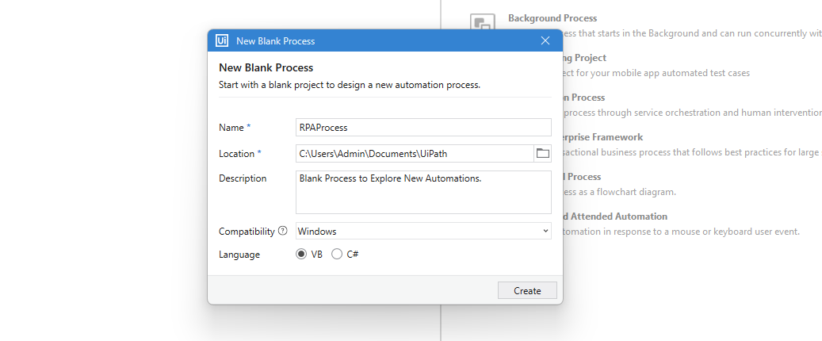

**Step 2:** Search for “Sequence” in the Activities panel and then drag and drop it onto the Designer Panel

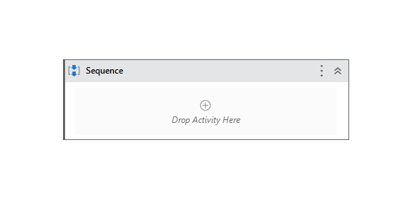

**Step 3:** Search for “Input dialog” in the Search panel of the Activities panel. Drag and drop the Input dialog activity inside the Sequence.

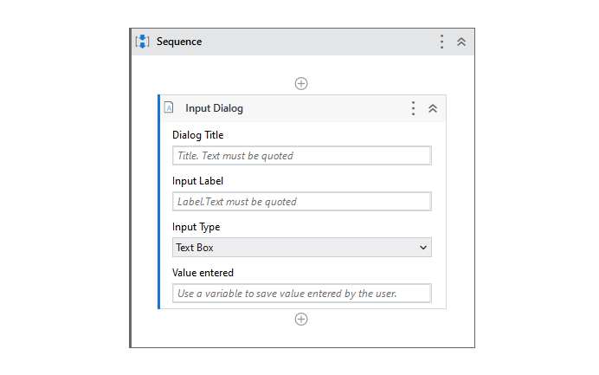

**Step 4:** Write the appropriate message on the Label of this Input dialog.

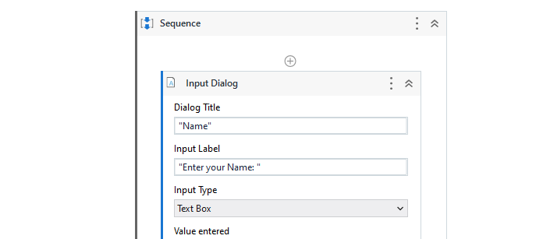

**Step 5:** Create a variable and give it the desired name.

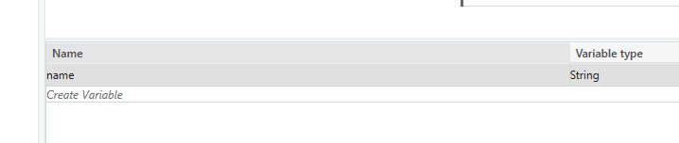

**Step 6:** Specify the variable in the Result property of the Input dialog box.

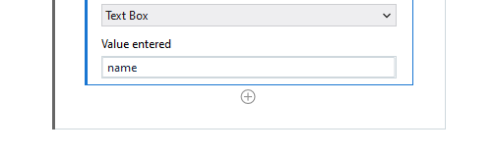

**Step 7:** Search for “Input dialog” in the Search panel of the Activities panel. Drag and drop the Message Box activity inside the Sequence.

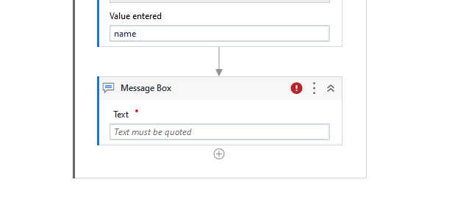

**Step 8:** Specify the variable name that we have created in the Text area of the Message box.

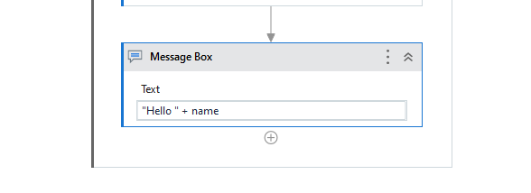

**Step 9:** Click the Run button and see the result.





**Conclusion:** The practical to create a simple sequence-based project was performed successfully.

**[B] AIM:** Create a flowchart-based project.

**Step 1:** Open UiPath Studio and click on Blank to start a fresh project. Give it a meaningful name.



**Step 2:** Search for “Flowchart” in the Activities panel and then drag and drop it onto the Designer Panel

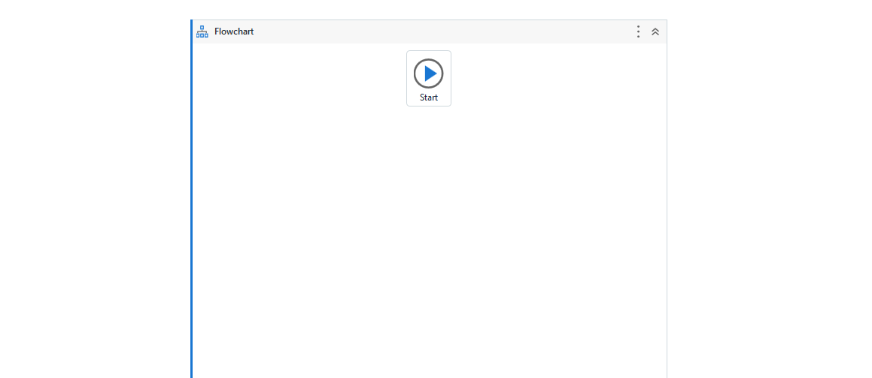

**Step 3:** Search for “Input dialog” in the Search panel of the Activities panel. Drag and drop two Input dialog activities inside the Flowchart.

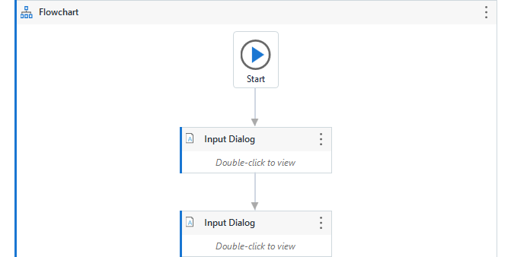

**Step 4:** Write the appropriate message on the Label of the Input dialogs.



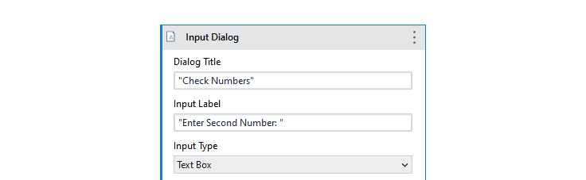

**Step 5:** Create variablesand specify the variables in the Result properties of the Input dialog boxes.

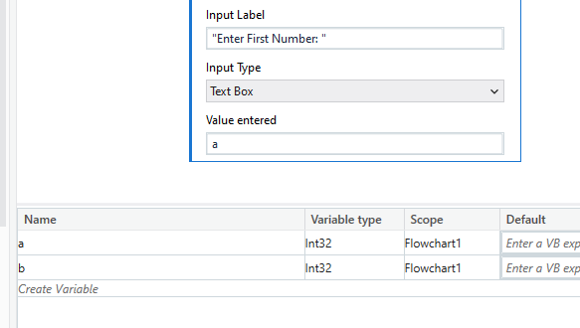

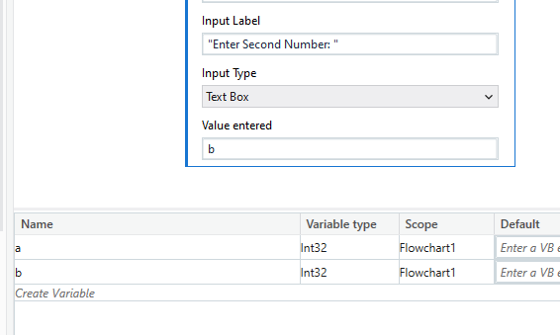

**Step 6:** Search for “Flow Decision” in the Search panel of the Activities panel. Drag and drop two Flow Decision Activity inside the Flowchart.



**Step 7:** Specify the condition for Flow Decision as “a > b”.

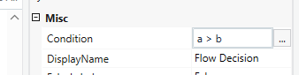

**Step 8:** Search for “Message Box” in the Search panel of the Activities panel. Drag and drop two Message Box activities inside the Flowchart, one on the True side and the other on the False side.

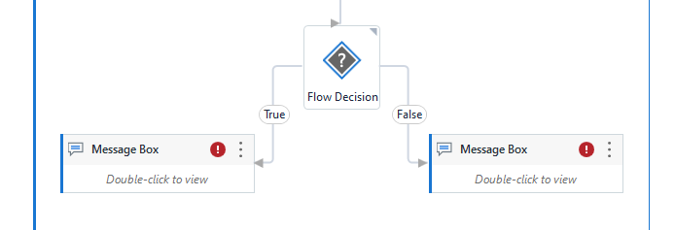

**Step 9:** Specify the True Condition in the Text area of the True Message box and the False Condition in the Text area of the False Message Box.

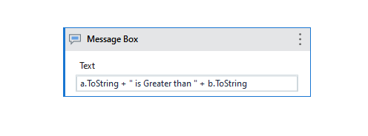

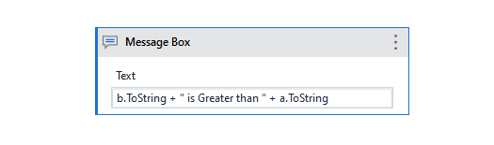

**Step 10:** Click the Run button and see the result.

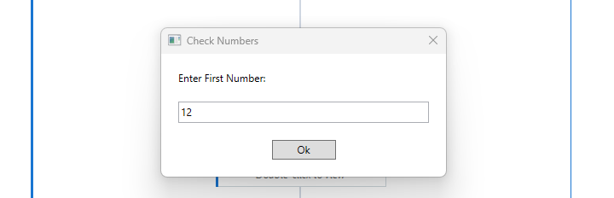

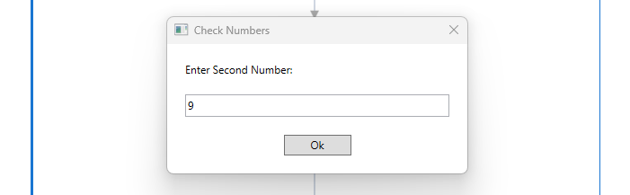

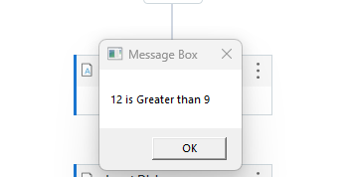

**Conclusion:** The practical to create a flowchart-based project was performed successfully.

**[C] AIM:** Create an UiPath Robot which can empty a folder in Gmail solely on basis of recording.

**Step 1:** Open UiPath Studio and click on Blank to start a fresh project. Give it a meaningful name.



**Step 2:** Search for “Sequence” in the Activities panel and then drag and drop it onto the Designer Panel



**Step 3:** Open Gmail.

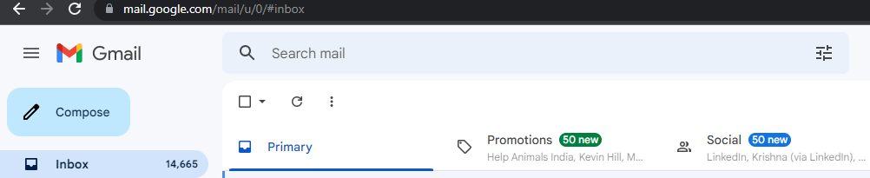

**Step 4:** Click on “App/ Web Recorder” Icon to record the following steps using the “Use Browser” Activity.

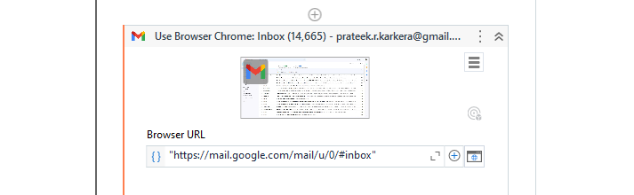

**Step 5:** Record the following steps Click on the “Bin”, then click on “Empty Bin” and Click on Yes to Confirm the Empty Bin action.Save and Confirm to return back to UiPath Studio. This will create a Recorder Sequence in the workspace.

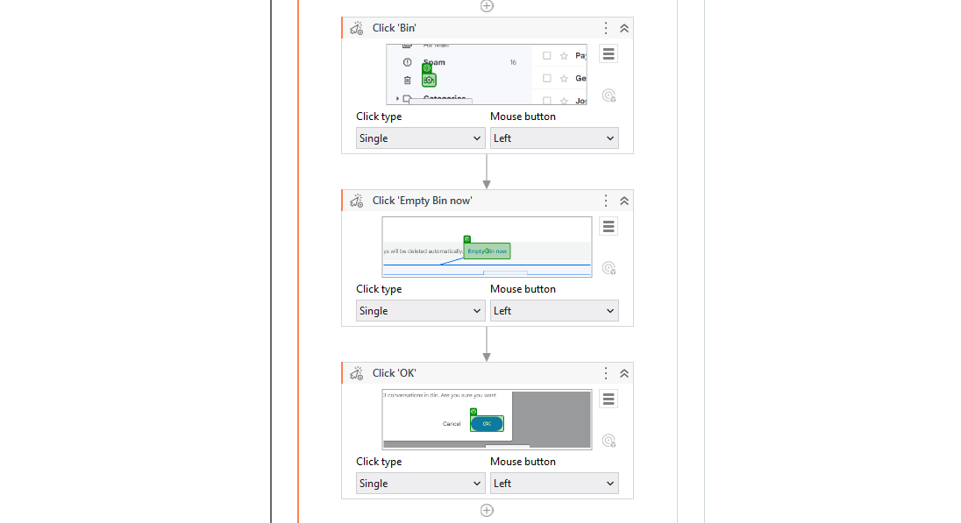

**Step 6:** Click the Run button and see the result.

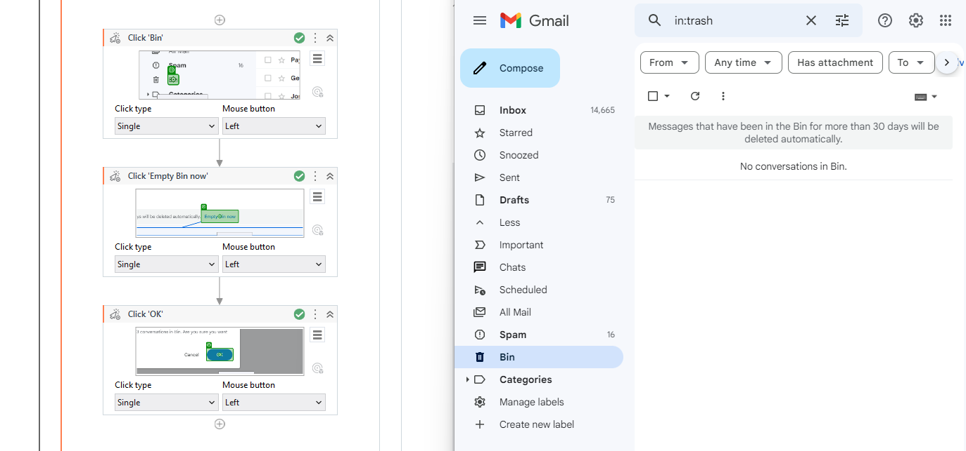

**Conclusion:** The practical to create an UiPath Robot which can empty a folder in Gmail solely on basis of recording was performed successfully.

**PRACTICAL 2**

**[A] AIM:** Automate UiPath Number Calculation (Subtraction, Multiplication, Division of numbers).

**Step 1:** Open UiPath Studio and click on Blank to start a fresh project. Give it a meaningful name.



**Step 2:** Search for “Sequence” in the Activities panel and then drag and drop it onto the Designer Panel



**Step 3:** Search for “Input dialog” in the Search panel of the Activities panel. Drag and drop two Input dialog activities inside the Sequence.

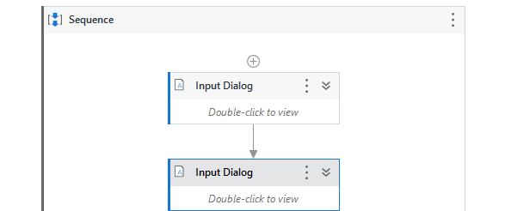

**Step 4:** Write the appropriate messages on the Labels of the Input dialogs. Create variables and specify the variables in the Result property of the Input dialog boxes.

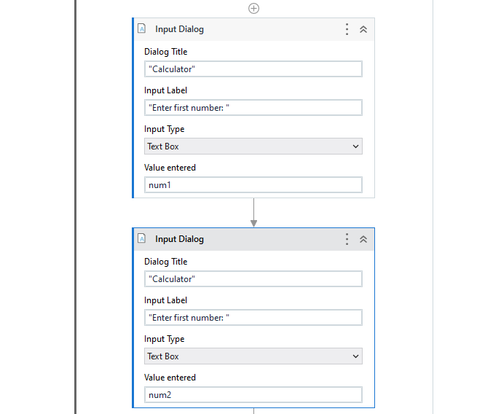

**Step 5:** Search for “Multiple Assign” in the Search panel of the Activities panel. Drag and drop the Multiple Assign activity inside the Sequence. Create and Assign variables for each of the Operations – Addition, Subtraction, Multiplication and Division.

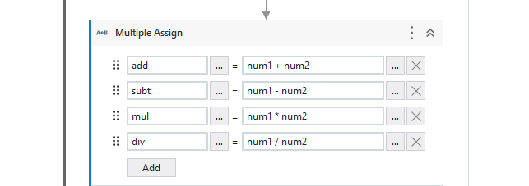

**Step 6:** Search for “Write Line” in the Search panel of the Activities panel. Drag and drop the Write Line activity inside the Sequence. In the textbox of Write Line Activity type the output for each of the Operations – Addition, Subtraction, Multiplication and Division.

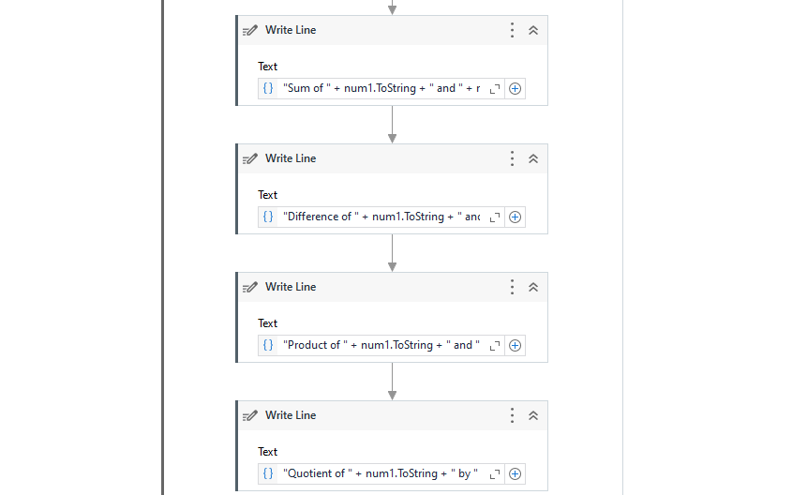

**Step 7:** Click the Run button and see the result.



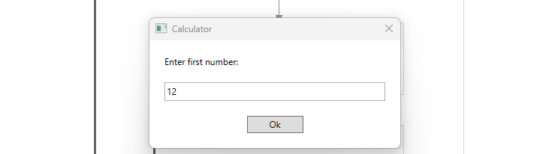

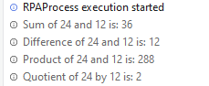

**Conclusion:** The practical to automate UiPath Number Calculation (Subtraction, Multiplication, Division of numbers) was performed successfully.

**[B] AIM:** Create an automation UiPath project using different types of variables (Integer, Double, Boolean, Array, String and Data Table)

**Step 1:** Open UiPath Studio and click on Blank to start a fresh project. Give it a meaningful name.



**Step 2:** Search for “Sequence” in the Activities panel and then drag and drop it onto the Designer Panel



**Step 3:** Search for “Multiple Assign” in the Search panel of the Activities panel. Drag and drop the Multiple Assign activity inside the Sequence. Create and Assign variables for each of the data types – Integer, Double, DateTime, Boolean, Array, String and Data Table.

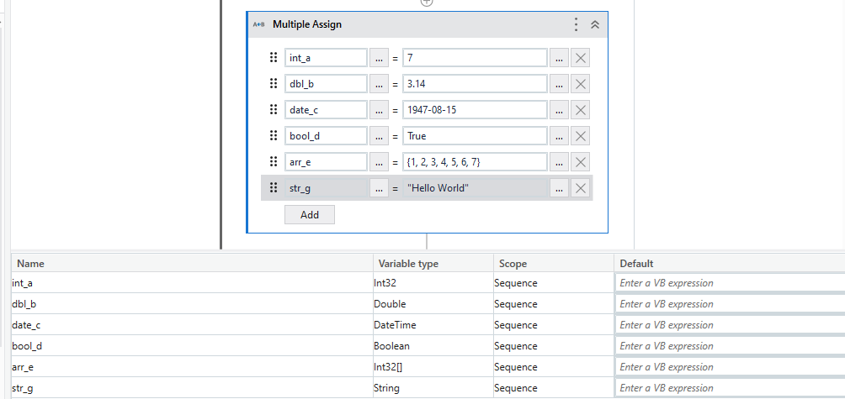

**Step 4:** Search for “Build Data Table” in the Search panel of the Activities panel. Drag and drop the Build Data Table activity inside the Sequence. Build the Data Table by clicking on the “DataTable” button and enter the values for the Data Table.

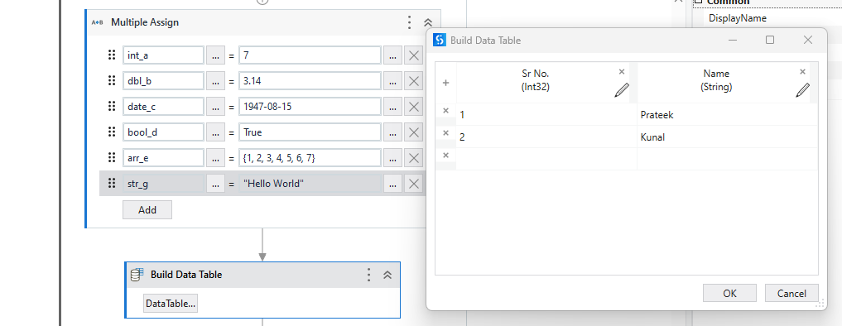

**Step 5:** Create a variable to store the output of the Data Table and specify assign the Output property of the Build Data Table activity with this variable.

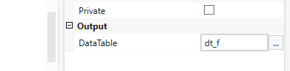

**Step 6:** Search for “Write Line” in the Search panel of the Activities panel. Drag and drop the Write Line activity inside the Sequence. In the textbox of Write Line Activity type the output for each of the Operations – Integer, Double, DateTime, Boolean, Array, String and Data Table.

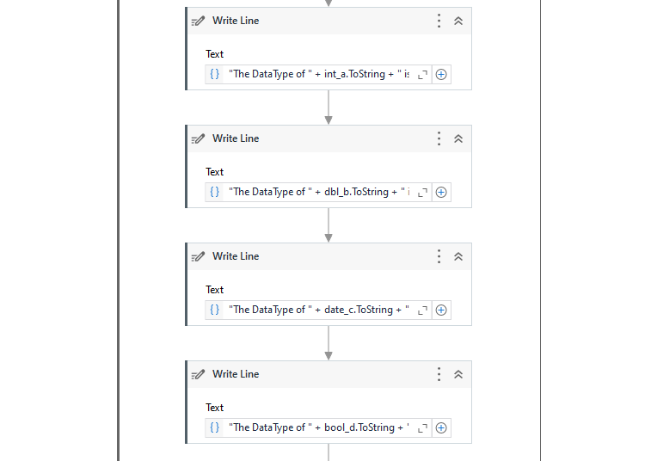

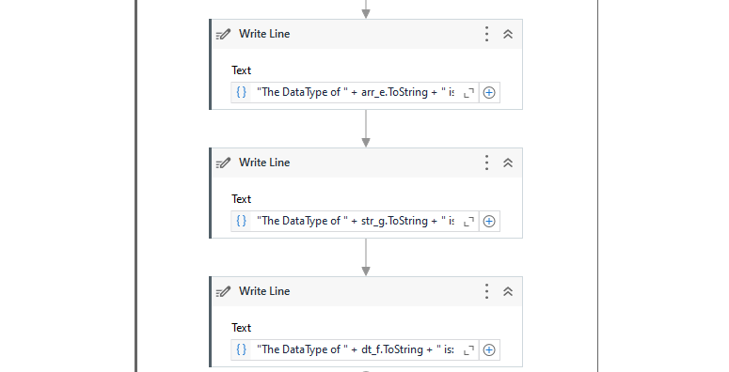

**Step 7:** Click the Run button and see the result.

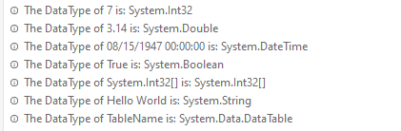

**Conclusion:** The practical to create an automation UiPath project using different types of variables (number, Boolean, generic, array, data table) was performed successfully.

**PRACTICAL 3**

**[A] AIM:** Create an automation UiPath Project using decision statements.

**I] If Statement**

**Step 1:** Open UiPath Studio and click on Blank to start a fresh project. Give it a meaningful name.



**Step 2:** Search for “Sequence” in the Activities panel and then drag and drop it onto the Designer Panel



**Step 3:** Search for “Input dialog” in the Search panel of the Activities panel. Drag and drop Input dialog activity inside the Sequence. Write the appropriate message on the Label of the Input dialog. Create a variable and specify the variable in the Result property of the Input dialog box.

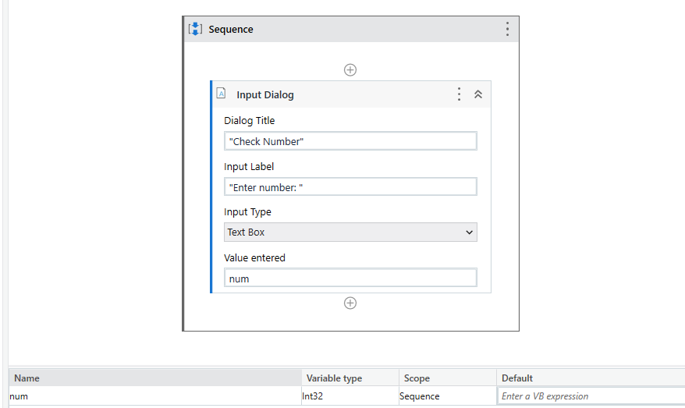

**Step 4:** Search for “If” in the Search panel of the Activities panel. Drag and drop the If activity inside the Sequence. In the condition part, enter the condition for Decision Statement.

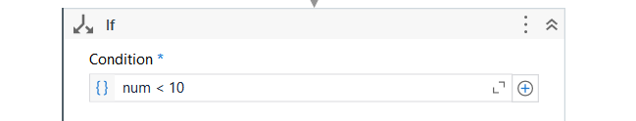

**Step 5:** Search for “Message Box” in the Search panel of the Activities panel. Drag and drop two Message Box activities inside the If Activity. In the Then section, enter the output if the condition is True and in the Else section, enter the output if the condition is False.

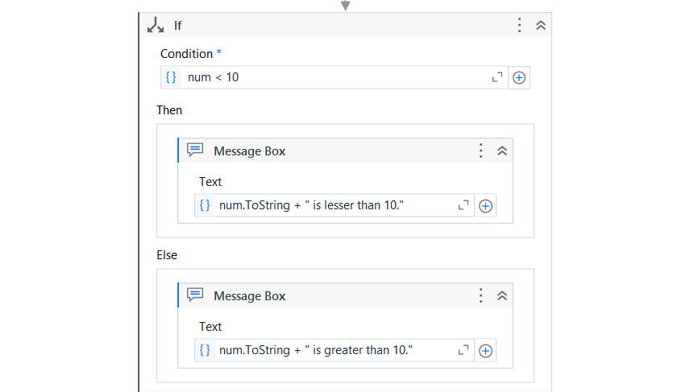

**Step 6:** Click the Run button and see the result.

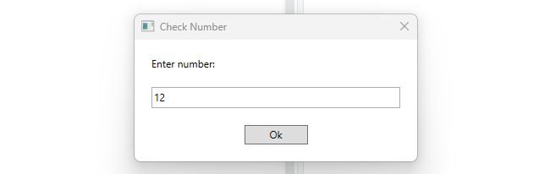

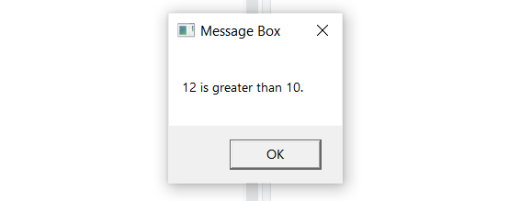

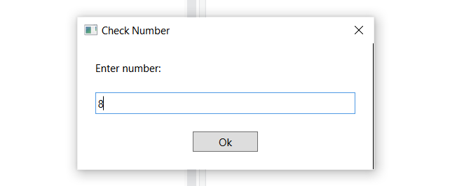

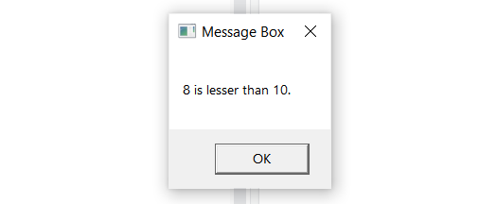

**II] Switch Case**

**Step 1:** Open UiPath Studio and click on Blank to start a fresh project. Give it a meaningful name.



**Step 2:** Search for “Sequence” in the Activities panel and then drag and drop it onto the Designer Panel



**Step 3:** Search for “Input dialog” in the Search panel of the Activities panel. Drag and drop Input dialog activity inside the Sequence. Write the appropriate message on the Label of the Input dialog. Create a variable and specify the variable in the Result property of the Input dialog box.



**Step 4:** Search for “Switch” in the Search panel of the Activities panel. Drag and drop the Switch activity inside the Sequence. In the condition part, enter the condition for Decision Statement.

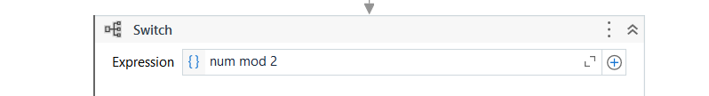

**Step 5:** Create two cases 0 and 1. Search for “Message Box” in the Search panel of the Activities panel. Drag and drop two Message Box activities inside the Activity. In the Case 0 section, enter the output for Case 0 and in the Case 1 section, enter the output for Case 1.

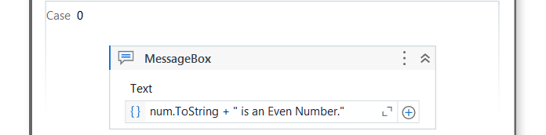

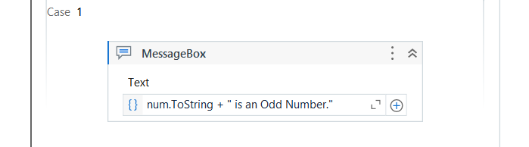

**Step 6:** Click the Run button and see the result.





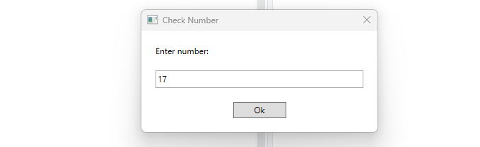



**III] Flow Decision**

**Step 1:** Open UiPath Studio and click on Blank to start a fresh project. Give it a meaningful name.



**Step 2:** Search for “Flowchart” in the Activities panel and then drag and drop it onto the Designer Panel



**Step 3:** Search for “Input dialog” in the Search panel of the Activities panel. Drag and drop two Input dialog activities inside the Flowchart.



**Step 4:** Write the appropriate message on the Label of the Input dialogs.





**Step 5:** Create variablesand specify the variables in the Result properties of the Input dialog boxes.





**Step 6:** Search for “Flow Decision” in the Search panel of the Activities panel. Drag and drop two Flow Decision Activity inside the Flowchart.



**Step 7:** Specify the condition for Flow Decision as “a > b”.



**Step 8:** Search for “Message Box” in the Search panel of the Activities panel. Drag and drop two Message Box activities inside the Flowchart, one on the True side and the other on the False side.



**Step 9:** Specify the True Condition in the Text area of the True Message box and the False Condition in the Text area of the False Message Box.





**Step 10:** Click the Run button and see the result.







**Conclusion:** The practical to create an automation UiPath Project using decision statements was performed successfully.

**[B] AIM:** Create an automation UiPath Project using looping statements.

**I] For Each Loop**

**Step 1:** Open UiPath Studio and click on Blank to start a fresh project. Give it a meaningful name.



**Step 2:** Search for “Sequence” in the Activities panel and then drag and drop it onto the Designer Panel



**Step 3:** Create an array variable. Set the Datatype as array of Int datatype and specify the array elements.

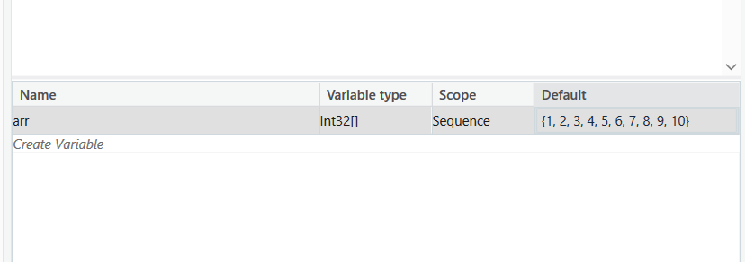

**Step 4:** Search for “For Each” in the Search panel of the Activities panel. Drag and drop the For Each activity inside the Sequence. Set the iterator item and the list item as our array variable.

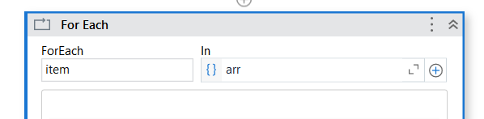

**Step 5:** Search for “Write Line” in the Search panel of the Activities panel. Drag and drop the Write Line activity inside the For Each Activity Body. Enter the output for the For Each Loop using Write Line Activity as “item.ToString”.

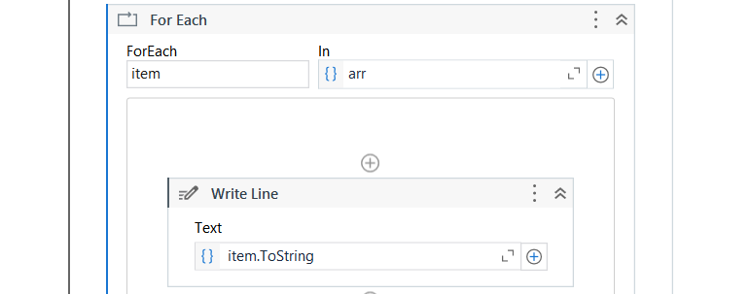

**Step 6:** Click the Run button and see the result.

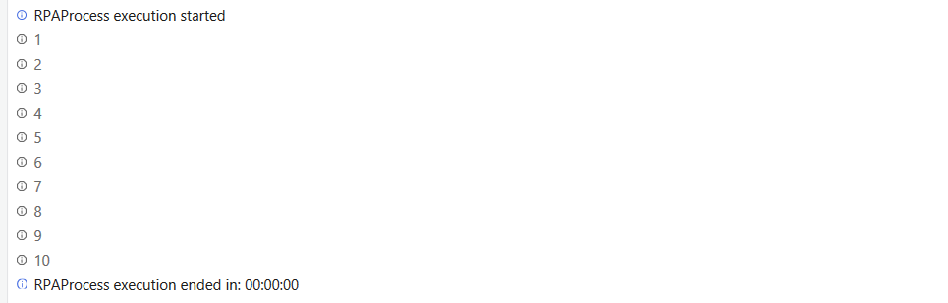

**II] While Loop**

**Step 1:** Open UiPath Studio and click on Blank to start a fresh project. Give it a meaningful name.



**Step 2:** Search for “Sequence” in the Activities panel and then drag and drop it onto the Designer Panel



**Step 3:** Create an integer variable and specify its value.

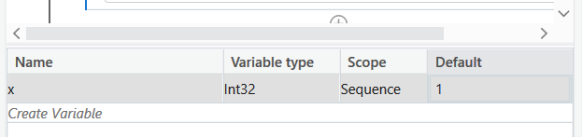

**Step 4:** Search for “While” in the Search panel of the Activities panel. Drag and drop the While activity inside the Sequence. Set the condition as “x<5”.

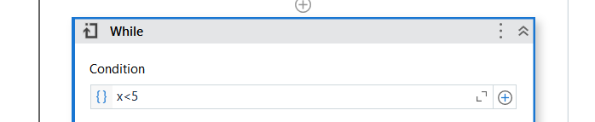

**Step 5:** Search for “Write Line” in the Search panel of the Activities panel. Drag and drop the Write Line activity inside the Activity Body. Enter the output for the Loop using Write Line Activity as “x.ToString”.

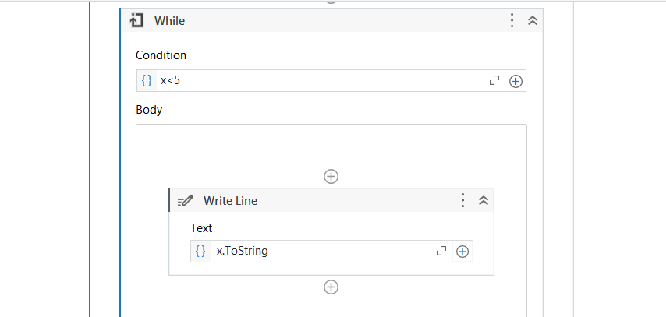

**Step 6:** Search for “Assign” in the Search panel of the Activities panel. Drag and drop the Assign activity inside the Activity Body. Assign the value for x as “x = x + 1”.

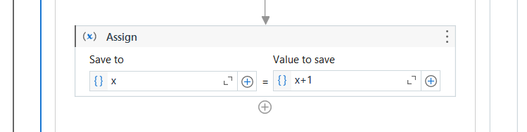

**Step 7:** Click the Run button and see the result.

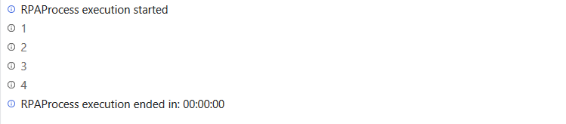

**III] Do-While Loop**

**Step 1:** Open UiPath Studio and click on Blank to start a fresh project. Give it a meaningful name.



**Step 2:** Search for “Sequence” in the Activities panel and then drag and drop it onto the Designer Panel



**Step 3:** Create an integer variable and specify its value.

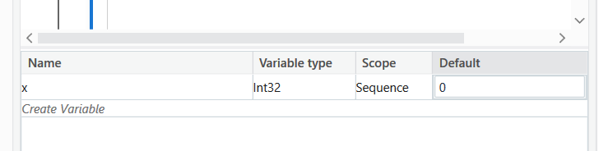

**Step 4:** Search for “Do-While” in the Search panel of the Activities panel. Drag and drop the While activity inside the Sequence. Set the condition as “x<5”.

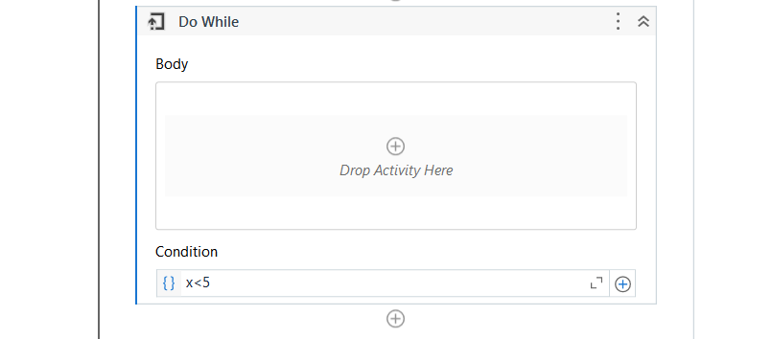

**Step 5:** Search for “Assign” in the Search panel of the Activities panel. Drag and drop the Assign activity inside the Activity Body. Assign the value for x as “x = x + 1”.

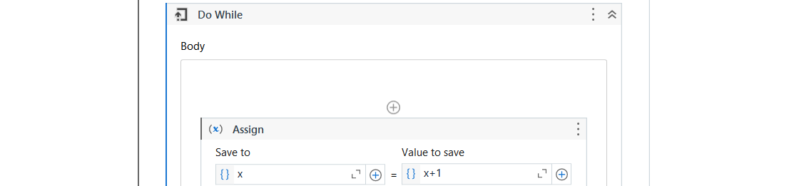

**Step 6:** Search for “Write Line” in the Search panel of the Activities panel. Drag and drop the Write Line activity inside the Activity Body. Enter the output for the Loop using Write Line Activity as “x.ToString”.

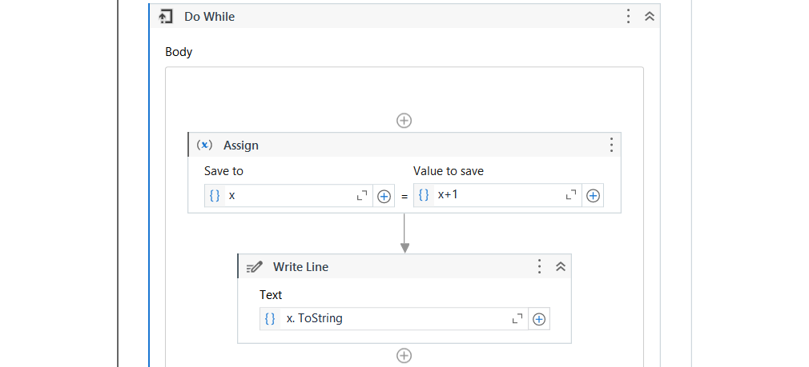

**Step 7:** Click the Run button and see the result.

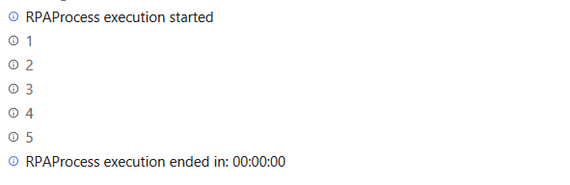

**Conclusion:** The practical to create an automation UiPath Project using looping statements was performed successfully.

**PRACTICAL 4**

**[A] AIM:** Automate any process using basic recording.

**Step 1:** Open UiPath Studio and click on Blank to start a fresh project. Give it a meaningful name.



**Step 2:** Search for “Sequence” in the Activities panel and then drag and drop it onto the Designer Panel



**Step 3:** Open Calculator.

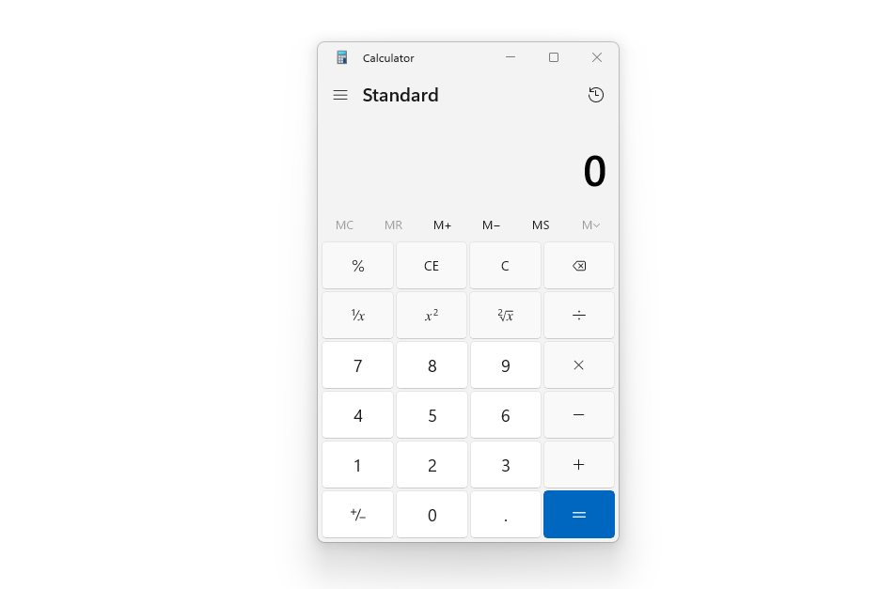

**Step 4:** Click on “App/ Web Recorder” Icon to record the following steps on the Calculator.

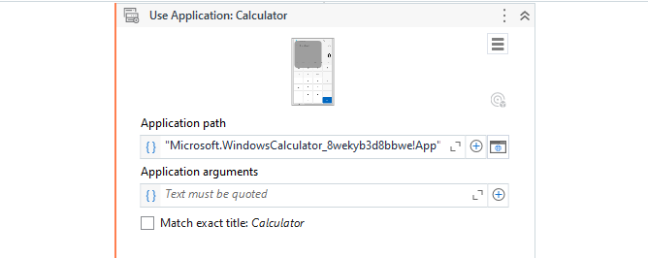

**Step 5:** Record the Performed Calculation. Save and Confirm to return back to UiPath Studio. This will create a Recorder Sequence in the workspace.

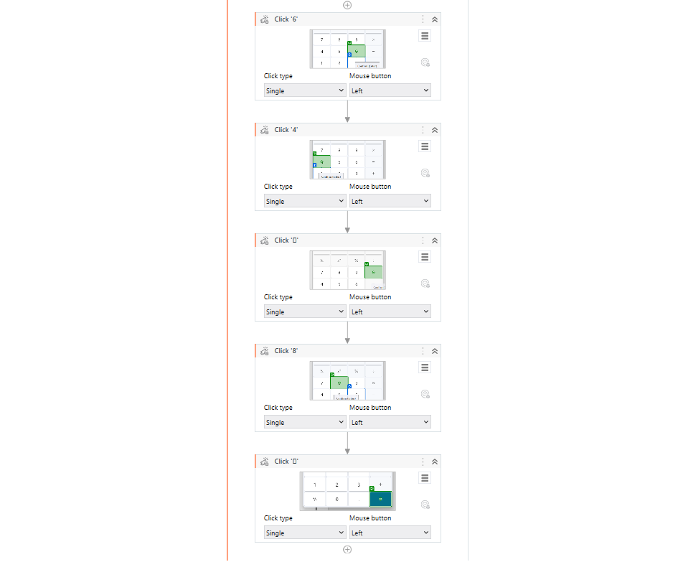

**Step 6:** Click the Run button and see the result.

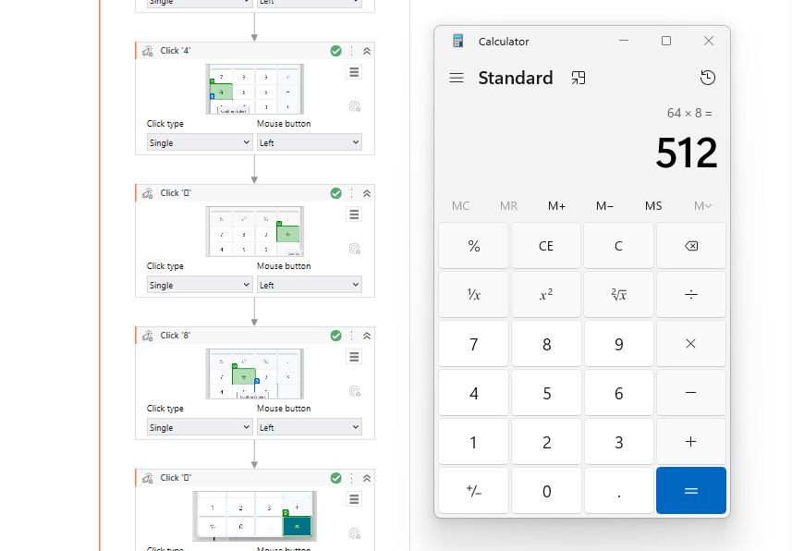

**Conclusion:** The practical to automate any process using basic recording was performed successfully.

**[B] AIM:** Automate any process using desktop recording.

**Step 1:** Open UiPath Studio and click on Blank to start a fresh project. Give it a meaningful name.



**Step 2:** Search for “Sequence” in the Activities panel and then drag and drop it onto the Designer Panel



**Step 3:** Open Gmail.



**Step 4:** Click on “App/ Web Recorder” Icon to record the following steps using the “Use Browser” Activity.



**Step 5:** Record the following steps Click on the “Bin”, then click on “Empty Bin” and Click on Yes to Confirm the Empty Bin action.Save and Confirm to return back to UiPath Studio. This will create a Recorder Sequence in the workspace.



**Step 6:** Click the Run button and see the result.



**Conclusion:** The practical to automate any process using desktop recording was performed successfully.

**[C] AIM:** Automate any process using web recording.

**Step 1:** Open UiPath Studio and click on Blank to start a fresh project. Give it a meaningful name.



**Step 2:** Search for “Sequence” in the Activities panel and then drag and drop it onto the Designer Panel



**Step 3:** Install the UiPath Web Automation Extension on your browser.

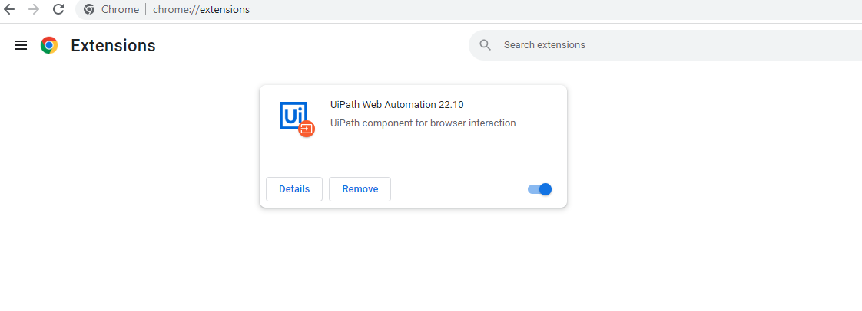

**Step 3:** Open www.google.com.

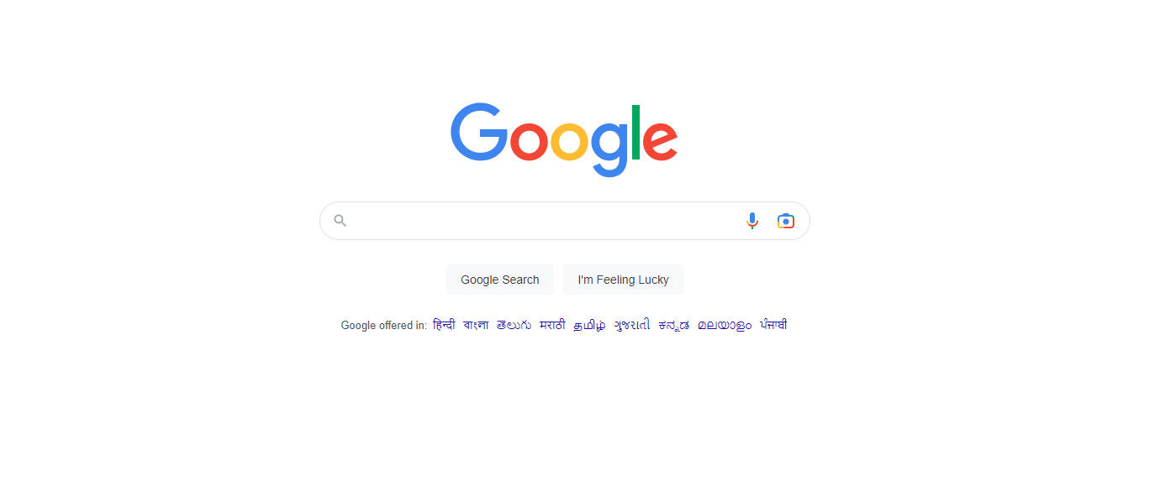

**Step 3:** Click on “App/ Web Recorder” Icon. This will record the following step.

**Step 4:** Chose the “Type into” action to type some text into www.google.com.

**Step 5:** Save and Confirm to return back to UiPath Studio. This will create a Recorder Sequence in the workspace.

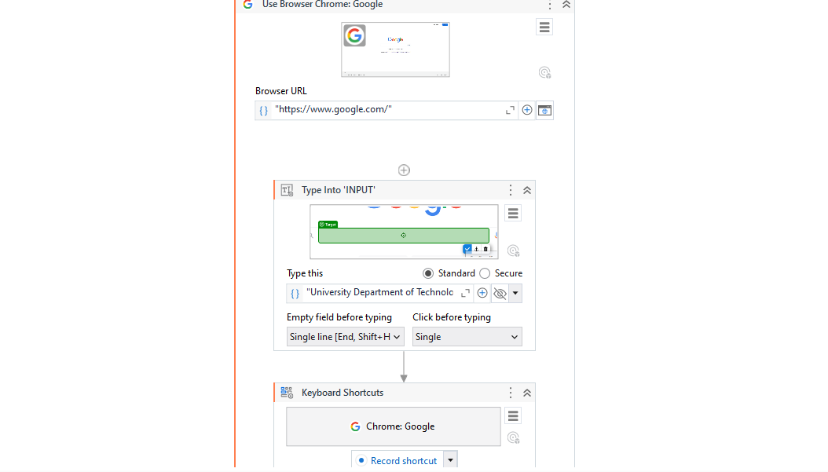

**Step 6:** Click the Run button and see the result.

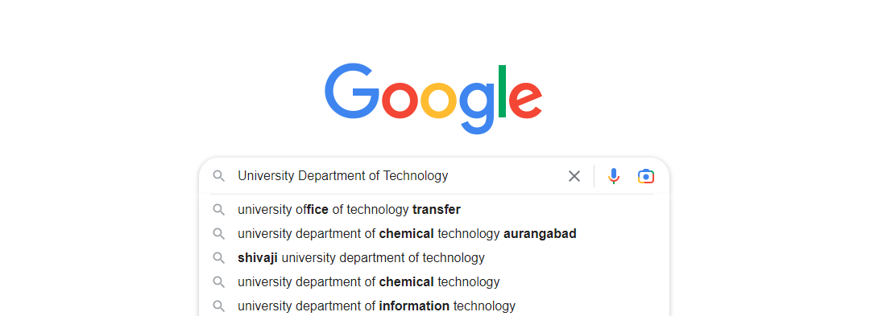



**Conclusion:** The practical to automate any process using web recording was performed successfully.

**PRACTICAL 5**

**AIM:** Consider an array of names. We have to find out how many of them start with the letter "a". Create an automation where the number of names starting with "a" are counted and the result is displayed.

**Step 1:** Open UiPath Studio and click on Blank to start a fresh project. Give it a meaningful name.



**Step 2:** Search for “Sequence” in the Activities panel and then drag and drop it onto the Designer Panel



**Step 3:** Create a count variable and set count variable as count = 0. Create an array variable. Set the Datatype as array of String datatype and specify the array elements.

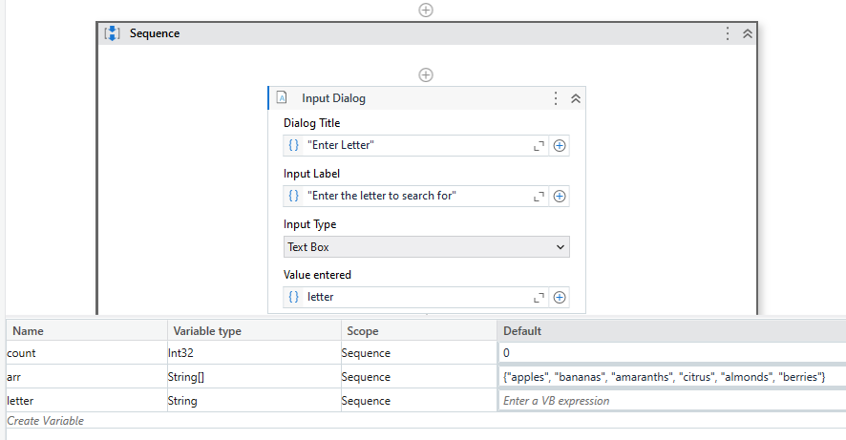

**Step 4:** Search for “Input dialog” in the Search panel of the Activities panel. Drag and drop Input dialog activity inside the Sequence. Write the appropriate message on the Label of the Input dialog for asking user input of the letter to search for. Create a variable and specify the variable in the Result property of the Input dialog box.



**Step 5:** Search for “For Each” in the Search panel of the Activities panel. Drag and drop the For Each activity inside the Sequence. Set the iterator item and the list item as our array variable.



**Step 6:** Search for “If” in the Search panel of the Activities panel. Drag and drop the If activity inside the Sequence. In the condition part, enter the condition as “item.StartsWith(letter), i.e. “a”. Search for “Assign” Activity and drag it into the Then section of If Activity. Assign count as “count = count + 1”.

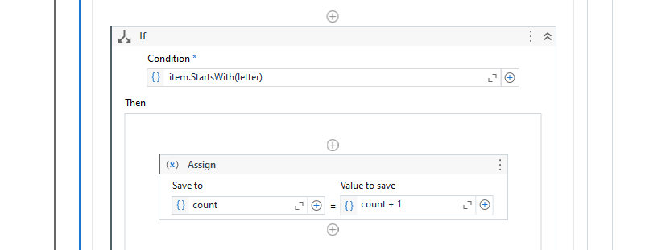

**Step 7:** Search for “Message Box” in the Search panel of the Activities panel. Drag the Message Box activity inside the sequence body and enter the output statement displaying the count of words starting with the letter “a”.

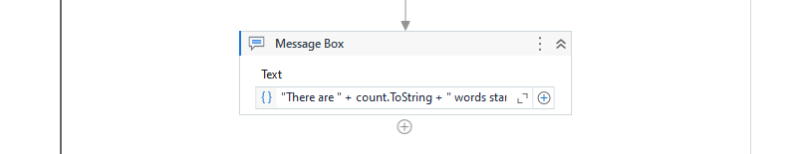

**Step 8:** Hit the Run button and see the result.

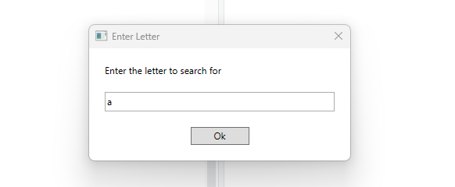

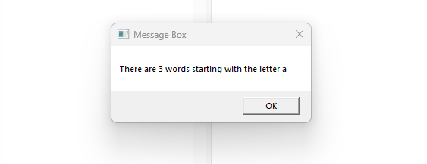

**Conclusion:** The practical to create an automation where the number of names starting with "a" is counted and the result is displayed was performed successfully.

**PRACTICAL 6**

**[A] AIM:** Create an application automating the read, write and append operation on excel file.

**I] Read Cell**

**Step 1:** Open UiPath Studio and click on Blank to start a fresh project. Give it a meaningful name.



**Step 2:** Search for “Sequence” in the Activities panel and then drag and drop it onto the Designer Panel



**Step 3:** Search for “Excel” in the Search panel of the Manage Packages Tab and install “UiPath.Excel.Acitivites”.

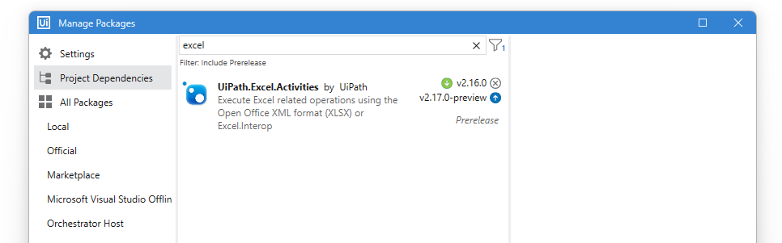

**Step 4:** Search for “Excel Process Scope” in the Search panel of the Activities panel. Drag and drop the activity inside the Sequence. Search for “Use Excel File” in the Search panel of the Activities panel. Drag and drop the activity inside the Excel Process Scope. Enter the Target File location and provide a Reference name.

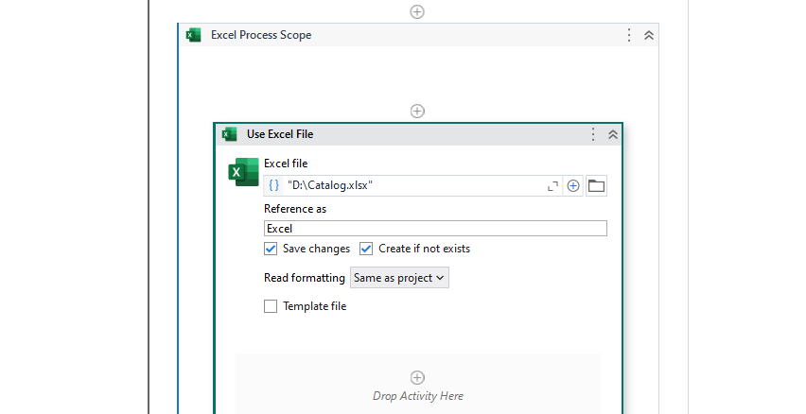

**Step 5:** Search for “Read Cell Value” in the Search panel of the Activities panel. Drag and drop the activity inside the Body. Enter the Sheet name and Cell Location to Read from. Create an output variable to store the value of the cell.

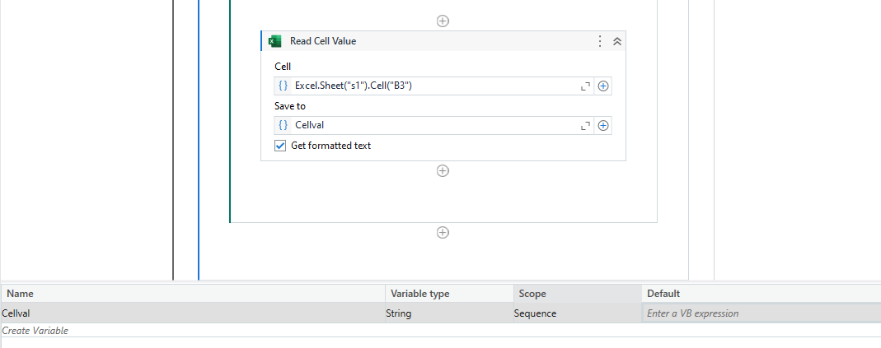

**Step 6:** Search for “Message Box” in the Search panel of the Activities panel. Drag and drop Message Box activity inside the Body. Enter the output variable to display the cell value.

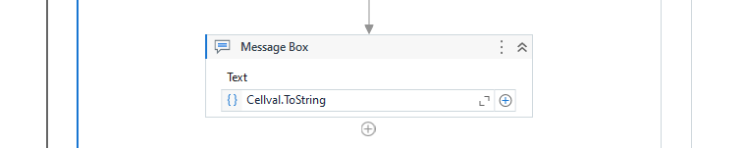

**Step 7:** Click the Run button and see the result.

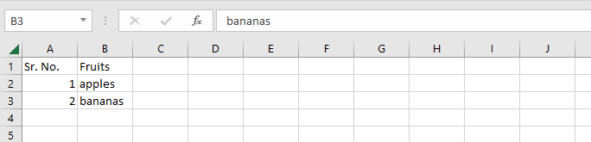



**II] Write Cell**

**Step 1:** Open UiPath Studio and click on Blank to start a fresh project. Give it a meaningful name.



**Step 2:** Search for “Sequence” in the Activities panel and then drag and drop it onto the Designer Panel



**Step 3:** Search for “Excel” in the Search panel of the Manage Packages Tab and install “UiPath.Excel.Acitivites”.



**Step 4:** Search for “Input dialog” in the Search panel of the Activities panel. Drag and drop two Input dialog activities inside the Sequence. Write the appropriate message on the Label of the Input dialogs. Create variables and specify the variables in the Result property of the Input dialog boxes.

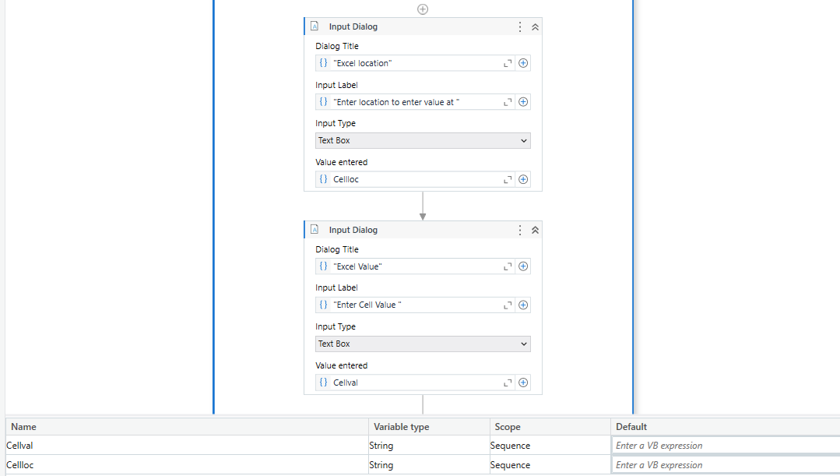

**Step 5:** Search for “Excel Process Scope” in the Search panel of the Activities panel. Drag and drop the activity inside the Sequence. Search for “Use Excel File” in the Search panel of the Activities panel. Drag and drop the activity inside the Excel Process Scope. Enter the Target File location and provide a Reference name.



**Step 6:** Search for “Write Cell” in the Search panel of the Activities panel. Drag and drop the activity inside the Body. Enter the Sheet name and Cell Location to Write to. Enter the cell value variable.

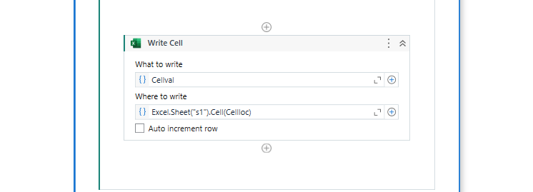

**Step 7:** Click the Run button and see the result.



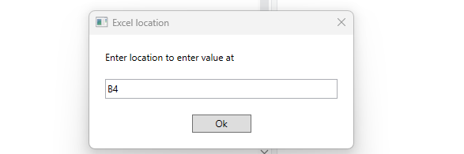

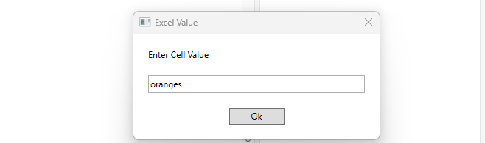

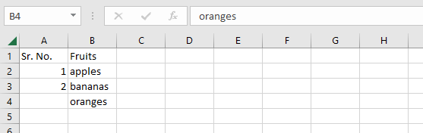

**III] Append Range**

**Step 1:** Open UiPath Studio and click on Blank to start a fresh project. Give it a meaningful name.



**Step 2:** Search for “Sequence” in the Activities panel and then drag and drop it onto the Designer Panel



**Step 3:** Search for “Excel” in the Search panel of the Manage Packages Tab and install “UiPath.Excel.Acitivites”.



**Step 4:** Search for “Build Data Table” in the Search panel of the Activities panel. Drag and drop the activity inside the Sequence. Enter the values for the DataTable and click “OK”.

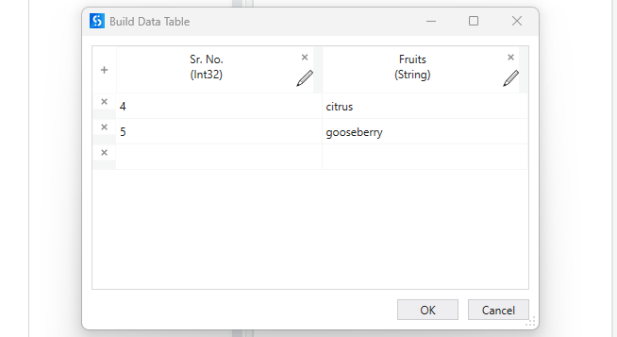

**Step 5:** Create a DataTable variable for Output.

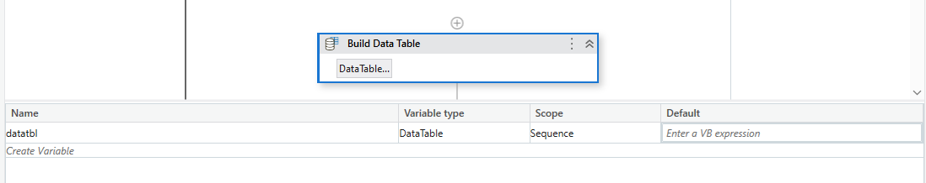

**Step 6:** Search for “Excel Process Scope” in the Search panel of the Activities panel. Drag and drop the activity inside the Sequence. Search for “Use Excel File” in the Search panel of the Activities panel. Drag and drop the activity inside the Excel Process Scope. Enter the Target File location and provide a Reference name.



**Step 7:** Search for “Write DataTable to Excel” in the Search panel of the Activities panel. Drag and drop the activity inside the Body. Enter the Sheet name and Range to Write To. Enter the output variable of “DataTable” type to write the range. Check “Append” and “Exclude Headers”.

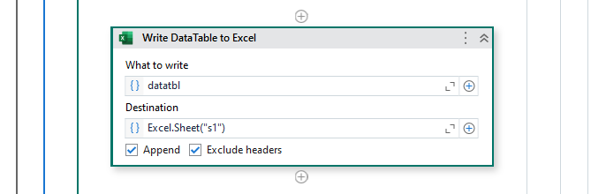

**Step 8:** Click the Run button and see the result.

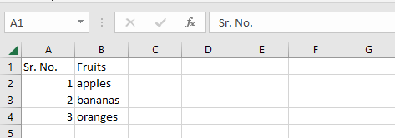

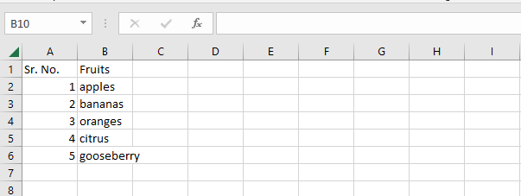

**Conclusion:** The practical to create an application automating the read, write and append operation on excel file was performed successfully.

**[B] Aim:** Automate the process to extract data from an excel file into a data table and vice versa.

**I] Read Range**

**Step 1:** Open UiPath Studio and click on Blank to start a fresh project. Give it a meaningful name.



**Step 2:** Search for “Sequence” in the Activities panel and then drag and drop it onto the Designer Panel



**Step 3:** Search for “Excel” in the Search panel of the Manage Packages Tab and install “UiPath.Excel.Acitivites”.



**Step 4:** Search for “Excel Process Scope” in the Search panel of the Activities panel. Drag and drop the activity inside the Sequence. Search for “Use Excel File” in the Search panel of the Activities panel. Drag and drop the activity inside the Excel Process Scope. Enter the Target File location and provide a Reference name.



**Step 5:** Search for “Read Range” in the Search panel of the Activities panel. Drag and drop the activity inside the Body. Enter the Sheet name and Range to Read from. Create an output variable of “DataTable” type to store the range.

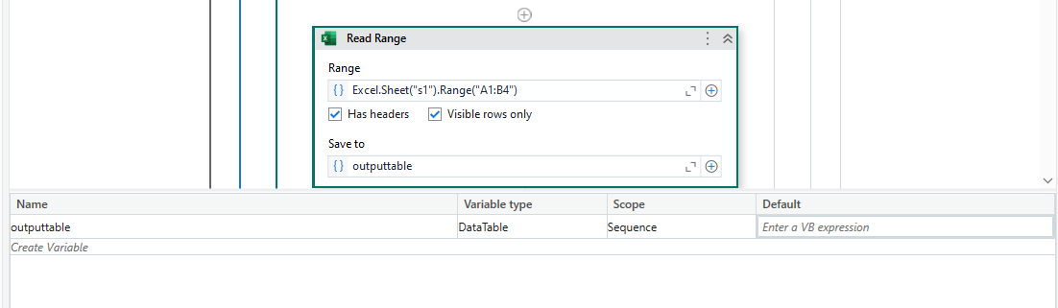

**Step 6:** Search for “Output DataTable” in the Search panel of the Activities panel. Drag and drop the activity inside the Body to convert the DataTable Output. Enter the DataTable variable and create a new text variable to store the output.

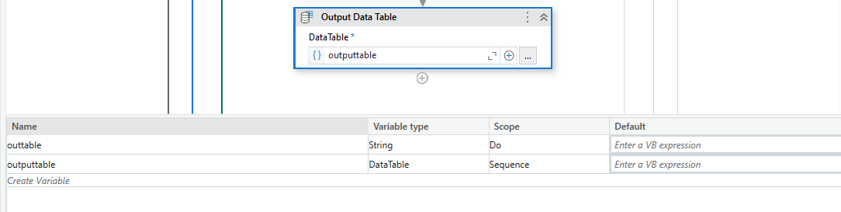

**Step 7:** Search for “Message Box” in the Search panel of the Activities panel. Drag and drop Message Box activity inside the Body. Enter the output variable to display the cell values.



**Step 8:** Click the Run button and see the result.

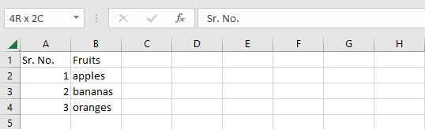



**II] Read Range using For Each**

**Step 1:** Open UiPath Studio and click on Blank to start a fresh project. Give it a meaningful name.



**Step 2:** Search for “Sequence” in the Activities panel and then drag and drop it onto the Designer Panel



**Step 3:** Search for “Excel” in the Search panel of the Manage Packages Tab and install “UiPath.Excel.Acitivites”.



**Step 4:** Search for “Excel Process Scope” in the Search panel of the Activities panel. Drag and drop the activity inside the Sequence. Search for “Use Excel File” in the Search panel of the Activities panel. Drag and drop the activity inside the Excel Process Scope. Enter the Target File location and provide a Reference name.



**Step 5:** Search for “Read Range” in the Search panel of the Activities panel. Drag and drop the activity inside the Body. Enter the Sheet name and Range to Read from. Create an output variable of “DataTable” type to store the range.



**Step 6:** Search for “For Each Row in Data Table” in the Search panel of the Activities panel. Drag and drop the activity inside the Body. Set “CurrentRow” as iterator and for our DataTable variable.

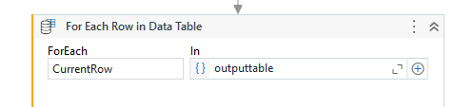

**Step 7:** Search for “WriteLine” in the Search panel of the Activities panel. Drag and drop activity inside the For Each Body. Enter the output to display the cell values.

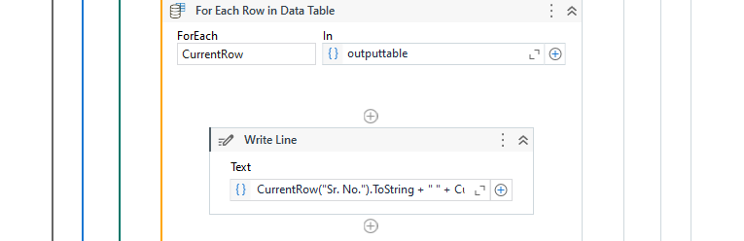

**Step 8:** Click the Run button and see the result.



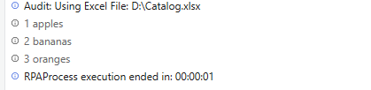

**III] Write Range**

**Step 1:** Open UiPath Studio and click on Blank to start a fresh project. Give it a meaningful name.



**Step 2:** Search for “Sequence” in the Activities panel and then drag and drop it onto the Designer Panel



**Step 3:** Search for “Excel” in the Search panel of the Manage Packages Tab and install “UiPath.Excel.Acitivites”.



**Step 4:** Search for “Build Data Table” in the Search panel of the Activities panel. Drag and drop the activity inside the Sequence. Enter the values for the DataTable and click “OK”.

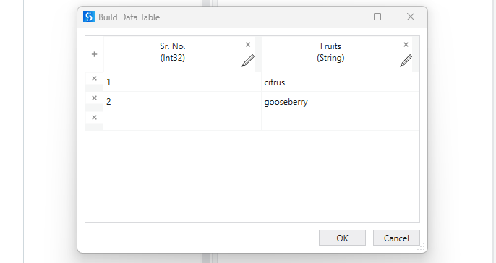

**Step 5:** Create a DataTable variable for Output.



**Step 6:** Search for “Excel Process Scope” in the Search panel of the Activities panel. Drag and drop the activity inside the Sequence. Search for “Use Excel File” in the Search panel of the Activities panel. Drag and drop the activity inside the Excel Process Scope. Enter the Target File location and provide a Reference name.



**Step 7:** Search for “Write DataTable to Excel” in the Search panel of the Activities panel. Drag and drop the activity inside the Body. Enter the Sheet name and Range to Write To. Enter the output variable of “DataTable” type to write the range.

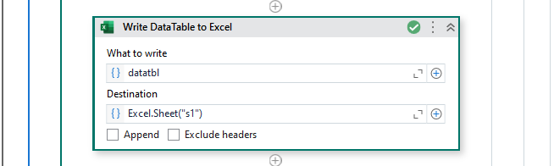

**Step 8:** Click the Run button and see the result.

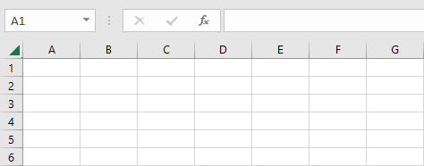

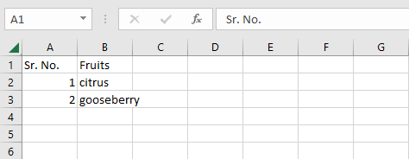

**Conclusion:** The practical to automate the process to extract data from an excel file into a data table and vice versa was performed successfully.

**PRACTICAL 7**

**[A] AIM:** Implement the attach window activity.

**Step 1:** Open UiPath Studio and click on Blank to start a fresh project. Give it a meaningful name.



**Step 2:** Search for “Sequence” in the Activities panel and then drag and drop it onto the Designer Panel



**Step 3:** Search for “Use Application/ Browser” and drag it inside the sequence workflow.Indicate the screen you want to include in the workflow.

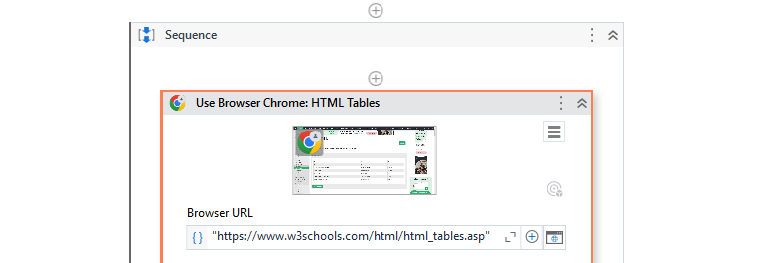

**Step 4:** Search for “Extract Table Data” and drag it inside the sequence workflow.Indicate the table to extract the Data from and Click on Save & Close.

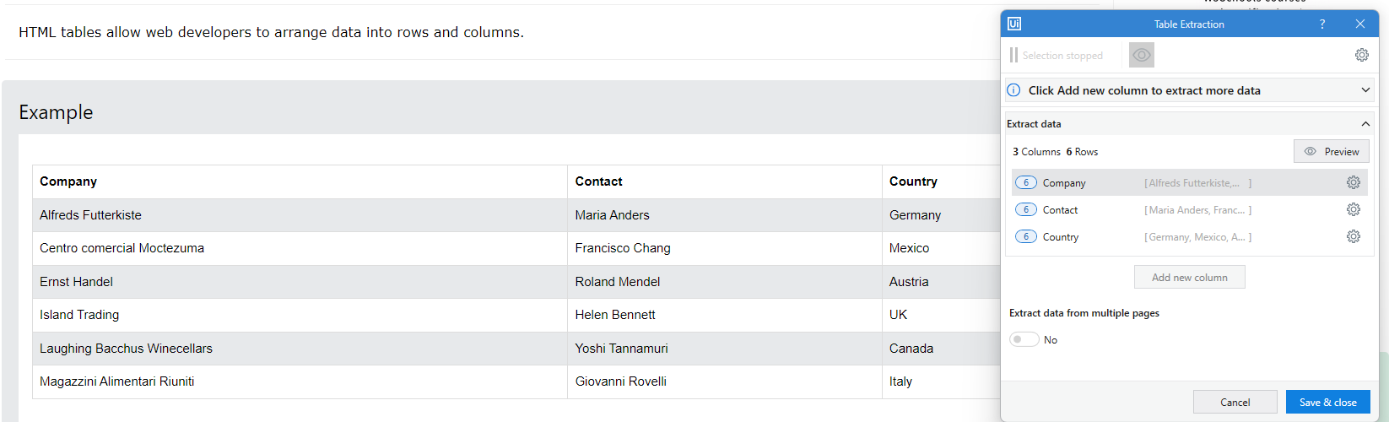

**Step 5:** Extract the data to the variable of datatype DataTable.

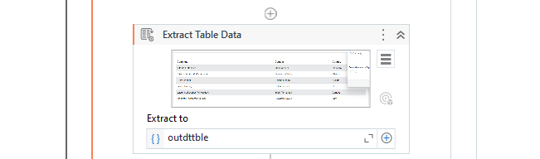

**Step 6:** Search for “Write Range Workbook” and drag it inside the sequence workflow.Enter the Sheet location, Sheet name and the Cell location to write data.

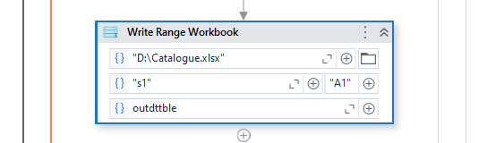

**Step 7:** Click the Run button and see the result.

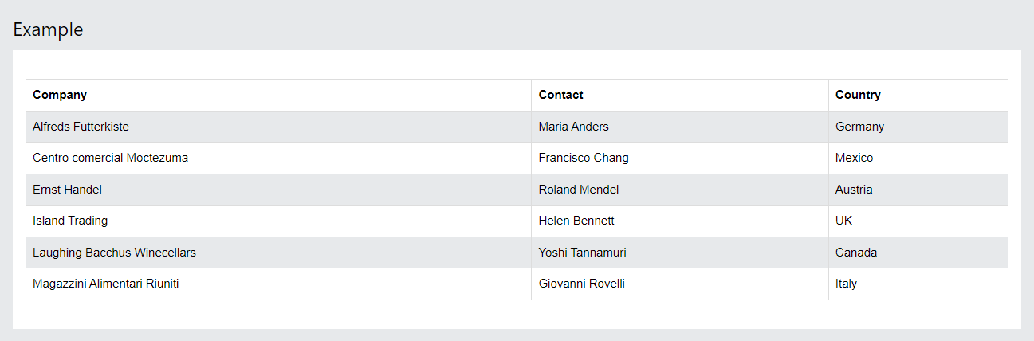

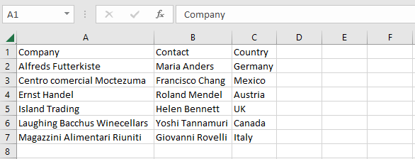

**Conclusion:** The practical to implement the attach window activity was performed successfully.

**[B] AIM:** Find different controls using UiPath.

**[I] Element Exists**

**Step 1:** Open UiPath Studio and click on Blank to start a fresh project. Give it a meaningful name.



**Step 2:** Search for “Sequence” in the Activities panel and then drag and drop it onto the Designer Panel



**Step 3:** Search for “CV Screen Scope” Activity in the Activities Panel and drag it inside the sequence workflow.Indicate the screen you want to include in the workflow.

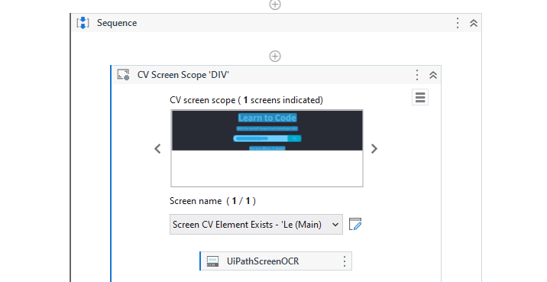

**Step 4:** Search for “CV Element Exists” Activity in the Activities Panel and drag it inside the sequence workflow.Indicate the Element you want to look for and Click on Save & Close. Create and set an output variable to store the Boolean Value Output.

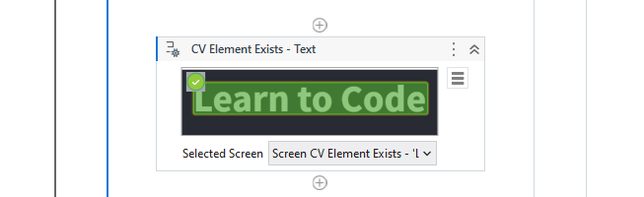

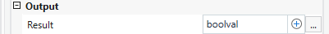

**Step 5:** Search for “If” Activity in the Activities Panel and drag it inside the sequence workflow.Set the condition as our Output Boolean Value.

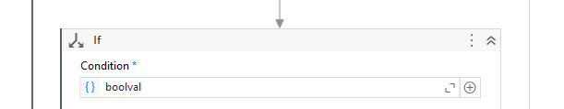

**Step 6:** Search for “Message Box” Activity in the Activities Panel and drag two message box activities, one inside the Then section and the other inside the Else section.Enter the Output for the Then Section and the Else Section.

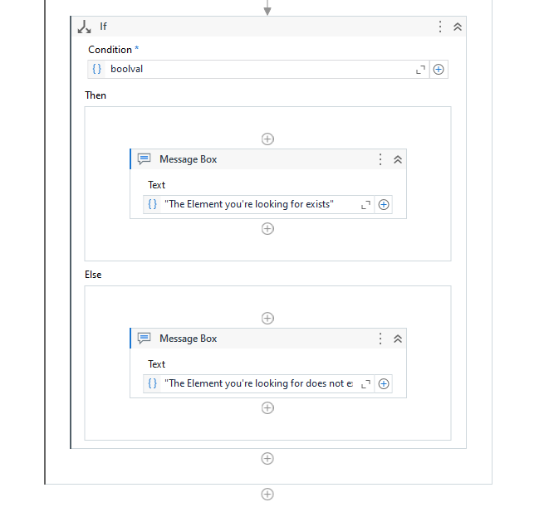

**Step 7:** Click the Run button and see the result.



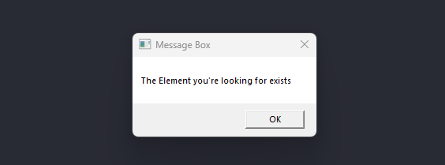

**[II] Find element**

**Step 1:** Open UiPath Studio and click on Blank to start a fresh project. Give it a meaningful name.



**Step 2:** Search for “Sequence” in the Activities panel and then drag and drop it onto the Designer Panel



**Step 3:** Search for “Use Browser/ Application” Activity in the Activities Panel and drag it inside the sequence workflow.Indicate the screen you want to include in the workflow.

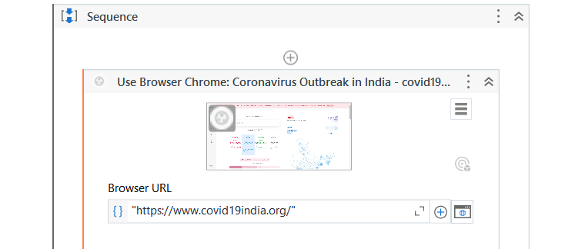

**Step 4:** Search for “Find Element” Activity in the Activities Panel and drag it inside the sequence workflow.Indicate the Element you want to look for and Click on Save & Close. Create and set an output variable to store the Attribute Value Output.

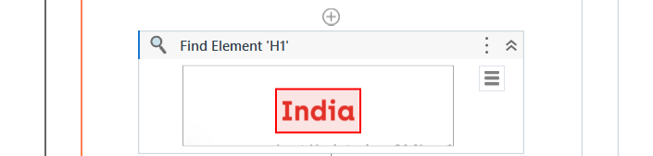

**Step 5:** Search for “Get Attribute” Activity in the Activities Panel and drag it inside the sequence workflow.Input element as the Find Element ouput, create and set an attribute value and and String output variable.

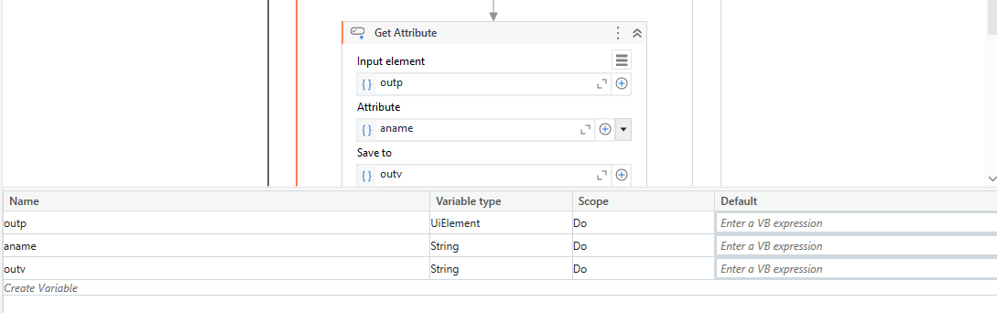

**Step 6:** Search for “Message Box” Activity in the Activities Panel and drag it inside the sequence.Enter the Output value.

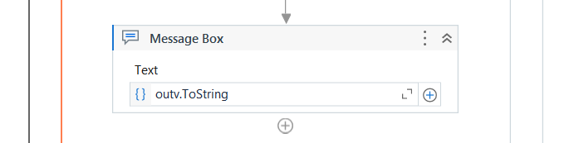

**Step 7:** Click the Run button and see the result.

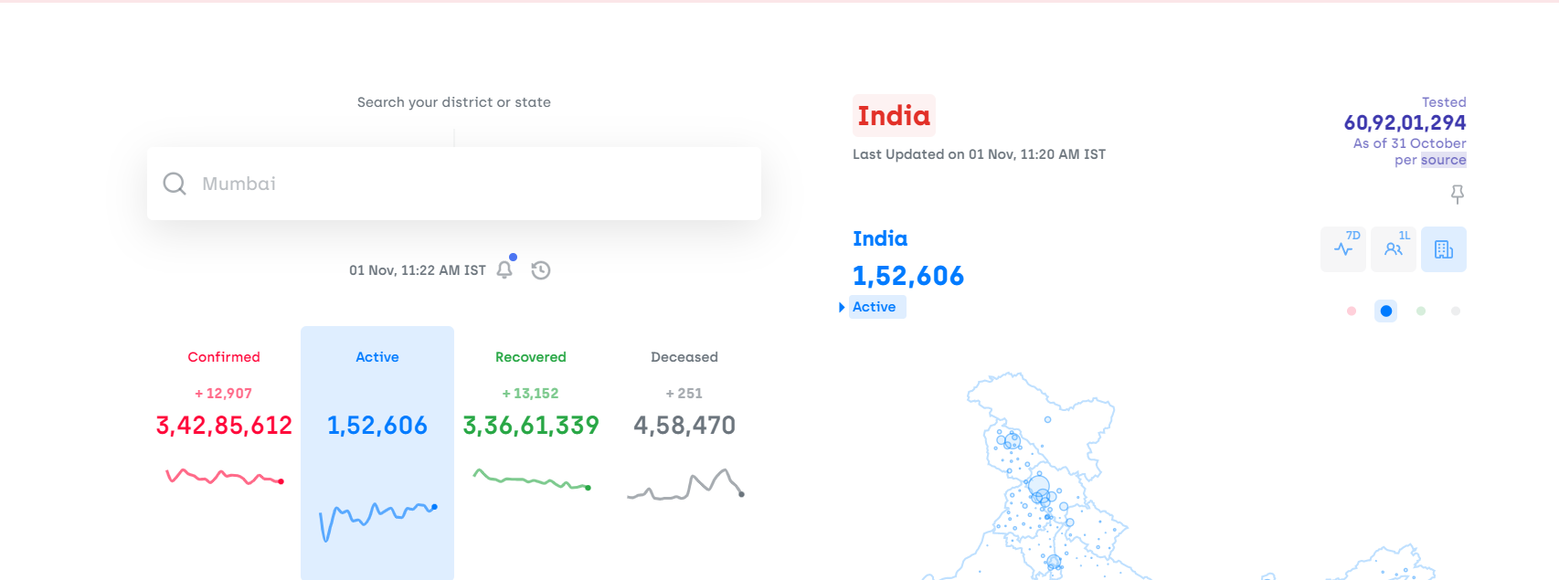



**[III] Find children**

**Step 1:** Open UiPath Studio and click on Blank to start a fresh project. Give it a meaningful name.



**Step 2:** Search for “Sequence” in the Activities panel and then drag and drop it onto the Designer Panel



**Step 3:** Search for “Use Browser/ Application” Activity in the Activities Panel and drag it inside the sequence workflow.Indicate the screen you want to include in the workflow.

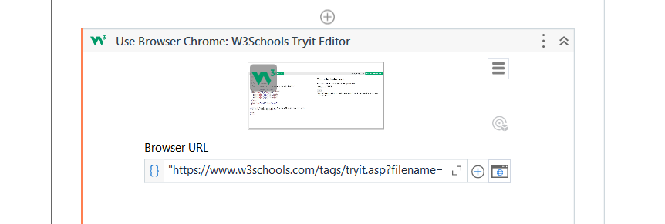

**Step 4:** Search for “Find Children” Activity in the Activities Panel and drag it inside the sequence workflow.Indicate the Element you want to look for and Click on Save & Close. Create and set an output variable to store the Attribute Value Output.

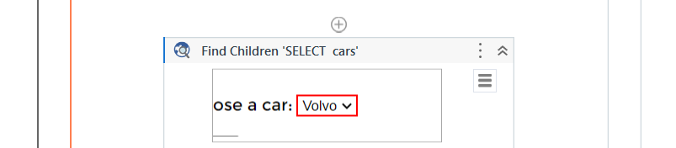

**Step 5:** Search for “Find Children” Activity in the Activities Panel and drag it inside the sequence workflow.Indicate the Element you want to look for and Click on Save & Close. Create and set an output variable to store the Attribute Value Output.



**Step 6:** Search for “Get Attribute” Activity in the Activities Panel and drag it inside the sequence workflow.Input element as the Find Element ouput, create and set an attribute value and and String output variable.

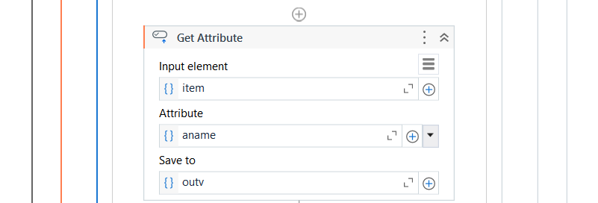

**Step 6:** Search for “Write Line” Activity in the Activities Panel and drag it inside the sequence.Enter the Output value.



**Step 7:** Click the Run button and see the result.

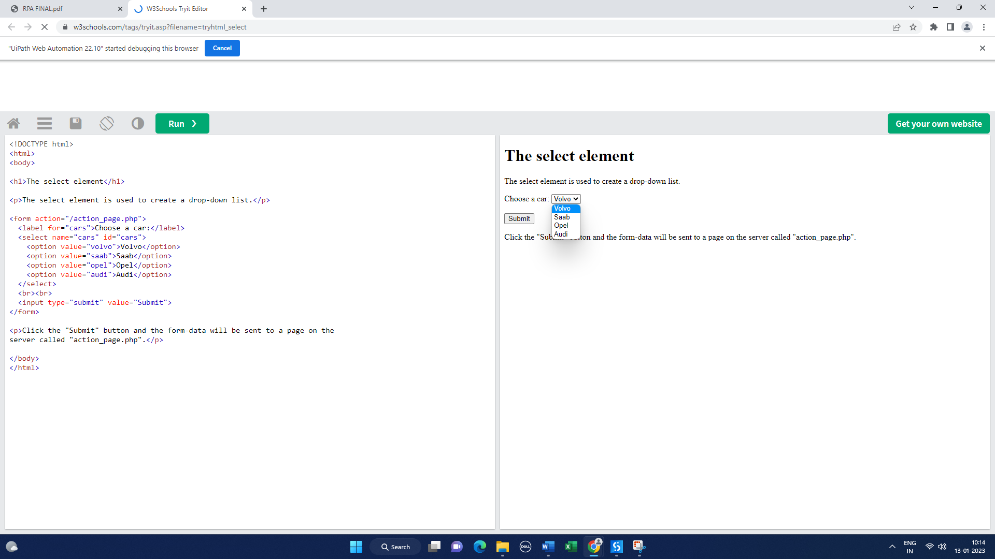

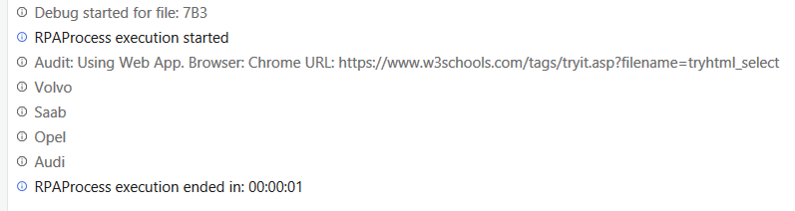

**Conclusion:** The practical to find different controls using UiPath is successfully completed.

**[C] AIM:** Demonstrate the following activities in UiPath.

**[I] Mouse**

**[a] Click**

**Step 1:** Open UiPath Studio and click on Blank to start a fresh project. Give it a meaningful name.



**Step 2:** Search for “Sequence” in the Activities panel and then drag and drop it onto the Designer Panel



**Step 3:** Search for “Use Browser/ Application” Activity in the Activities Panel and drag it inside the sequence workflow.Indicate the screen you want to include in the workflow.

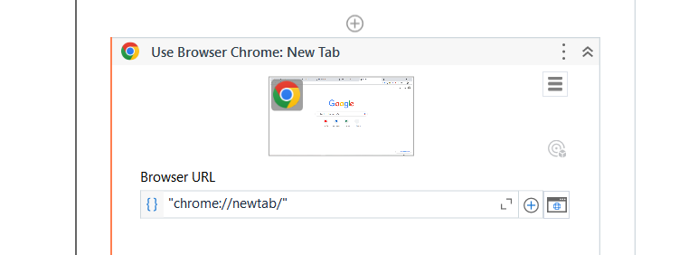

**Step 4:** Search for “Mouse Click” Activity in the Activities Panel and drag it inside the sequence workflow.Indicate the Element you want to click on and Click on Save & Close. Select Click Type as “Single”.

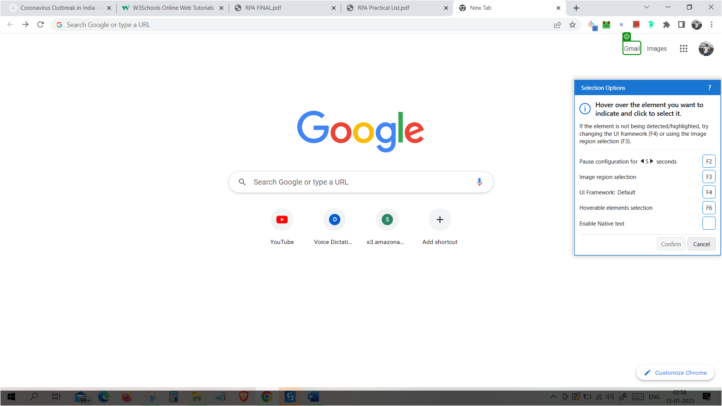

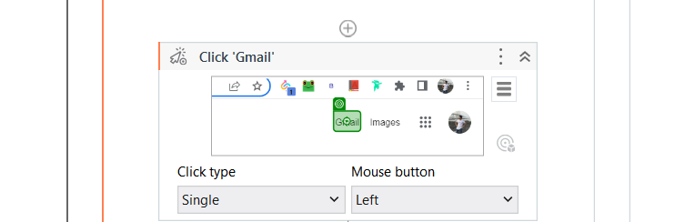

**Step 5:** Search for “Message Box” Activity in the Activities Panel and drag it inside the sequence.Enter the Output value.

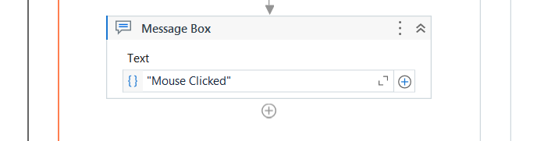

**Step 6:** Click the Run button and see the result.

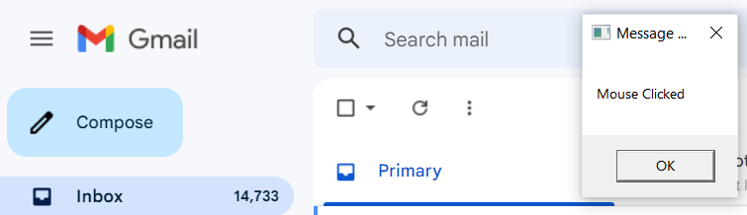

**[b] Double-Click**

**Step 1:** Open UiPath Studio and click on Blank to start a fresh project. Give it a meaningful name.



**Step 2:** Search for “Sequence” in the Activities panel and then drag and drop it onto the Designer Panel



**Step 3:** Search for “Use Browser/ Application” Activity in the Activities Panel and drag it inside the sequence workflow.Indicate the screen you want to include in the workflow.



**Step 4:** Search for “Mouse Click” Activity in the Activities Panel and drag it inside the sequence workflow.Indicate the Element you want to double-click on and Click on Save & Close. Select Click Type as “Double”.



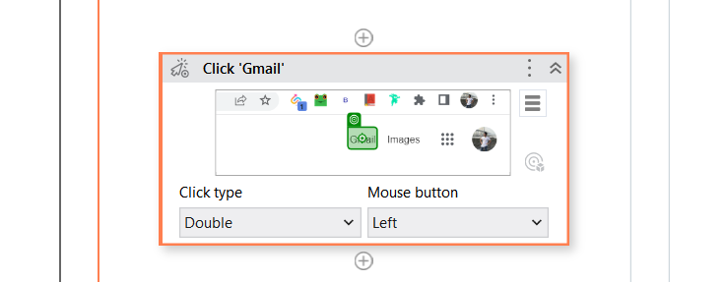

**Step 5:** Search for “Message Box” Activity in the Activities Panel and drag it inside the sequence.Enter the Output value.

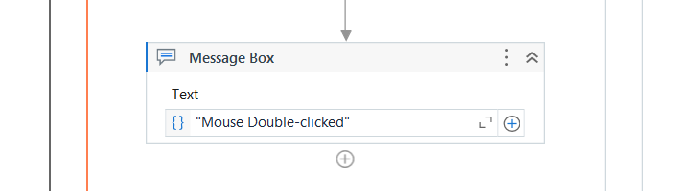

**Step 6:** Click the Run button and see the result.

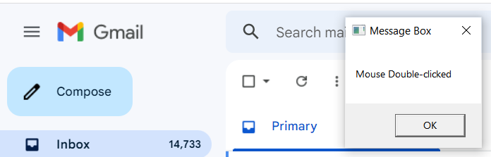

**[c] Hover**

**Step 1:** Open UiPath Studio and click on Blank to start a fresh project. Give it a meaningful name.



**Step 2:** Search for “Sequence” in the Activities panel and then drag and drop it onto the Designer Panel



**Step 3:** Search for “Use Browser/ Application” Activity in the Activities Panel and drag it inside the sequence workflow.Indicate the screen you want to include in the workflow.



**Step 4:** Search for “Mouse Click” Activity in the Activities Panel and drag it inside the sequence workflow.Indicate the Element you want to hover on and Click on Save & Close. Set Duration as 3 secs on any duration you want.



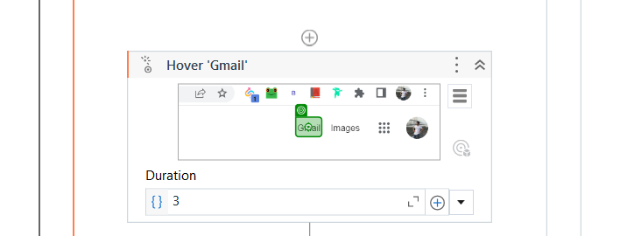

**Step 5:** Search for “Message Box” Activity in the Activities Panel and drag it inside the sequence.Enter the Output value.

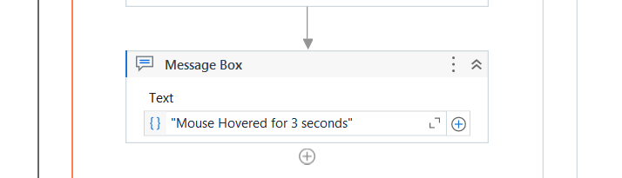

**Step 6:** Click the Run button and see the result.

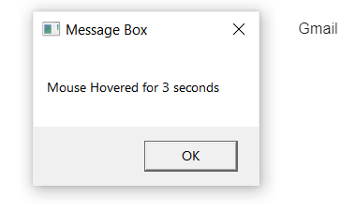

**[II] Type into**

**Step 1:** Open UiPath Studio and click on Blank to start a fresh project. Give it a meaningful name.



**Step 2:** Search for “Sequence” in the Activities panel and then drag and drop it onto the Designer Panel



**Step 3:** Search for “Input dialog” in the Search panel of the Activities panel. Drag and drop Input dialog activity inside the Sequence. Write the appropriate message on the Label of the Input dialog. Create a variable and specify the variable in the Result property of the Input dialog box.

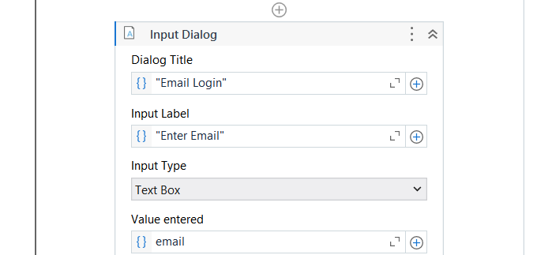

**Step 4:** Search for “Use Browser/ Application” Activity in the Activities Panel and drag it inside the sequence workflow.Indicate the screen you want to include in the workflow.

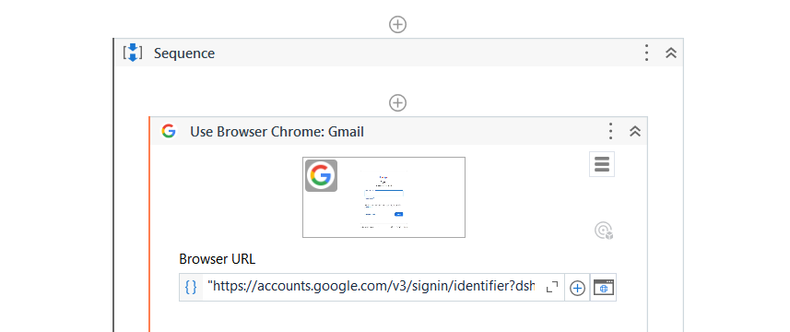

**Step 5:** Search for “Type Into” Activity in the Activities Panel and drag it inside the sequence workflow.Indicate the Element you want to click on and Click on Save & Close.

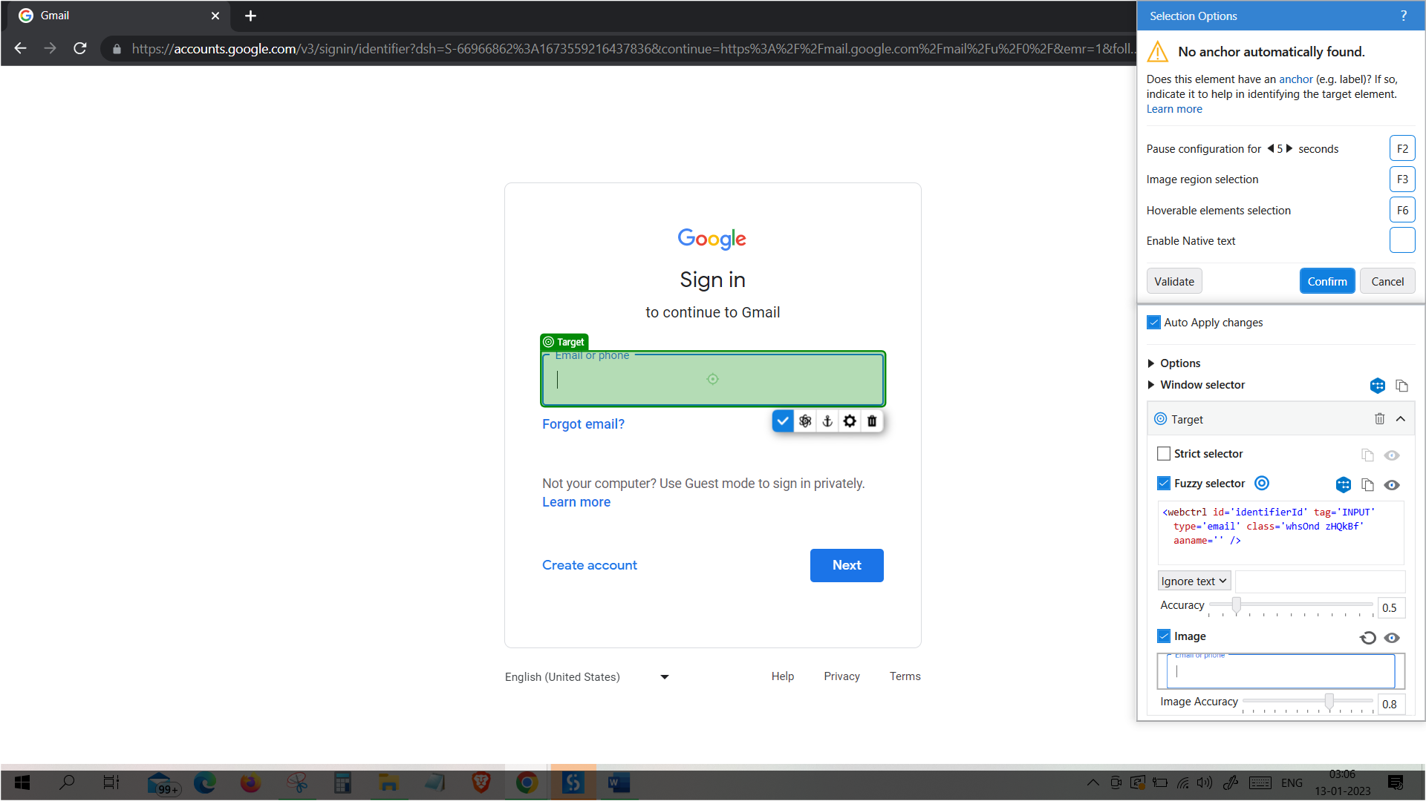

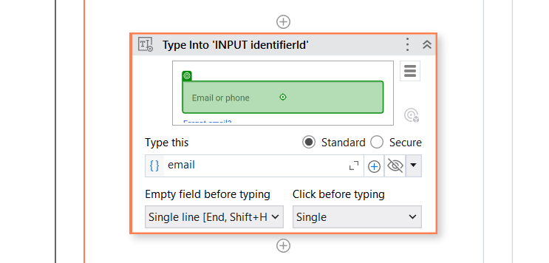

**Step 6:** Search for “Click” Activity in the Activities Panel and drag it inside the sequence. Indicate the “Next” button.

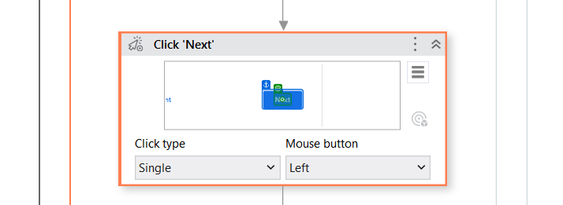

**Step 7:** Click the Run button and see the result.

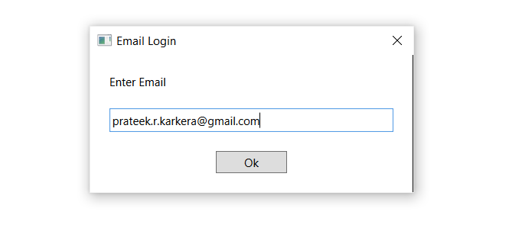



**[III] Type Secure Text**

**Step 1:** Open UiPath Studio and click on Blank to start a fresh project. Give it a meaningful name.



**Step 2:** Search for “Sequence” in the Activities panel and then drag and drop it onto the Designer Panel



**Step 3:** Search for “Input dialog” in the Search panel of the Activities panel. Drag and drop Input dialog activity inside the Sequence. Write the appropriate message on the Label of the Input dialog. Create a variable and specify the variable in the Result property of the Input dialog box. Check the IsPassword property.

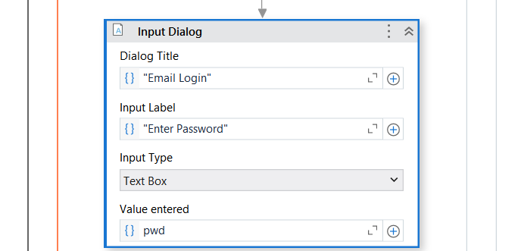

**Step 4:** Search for “Use Browser/ Application” Activity in the Activities Panel and drag it inside the sequence workflow.Indicate the screen you want to include in the workflow.



**Step 5:** Search for “Type Into” Activity in the Activities Panel and drag it inside the sequence workflow.Indicate the Element you want to click on and Click on Save & Close.

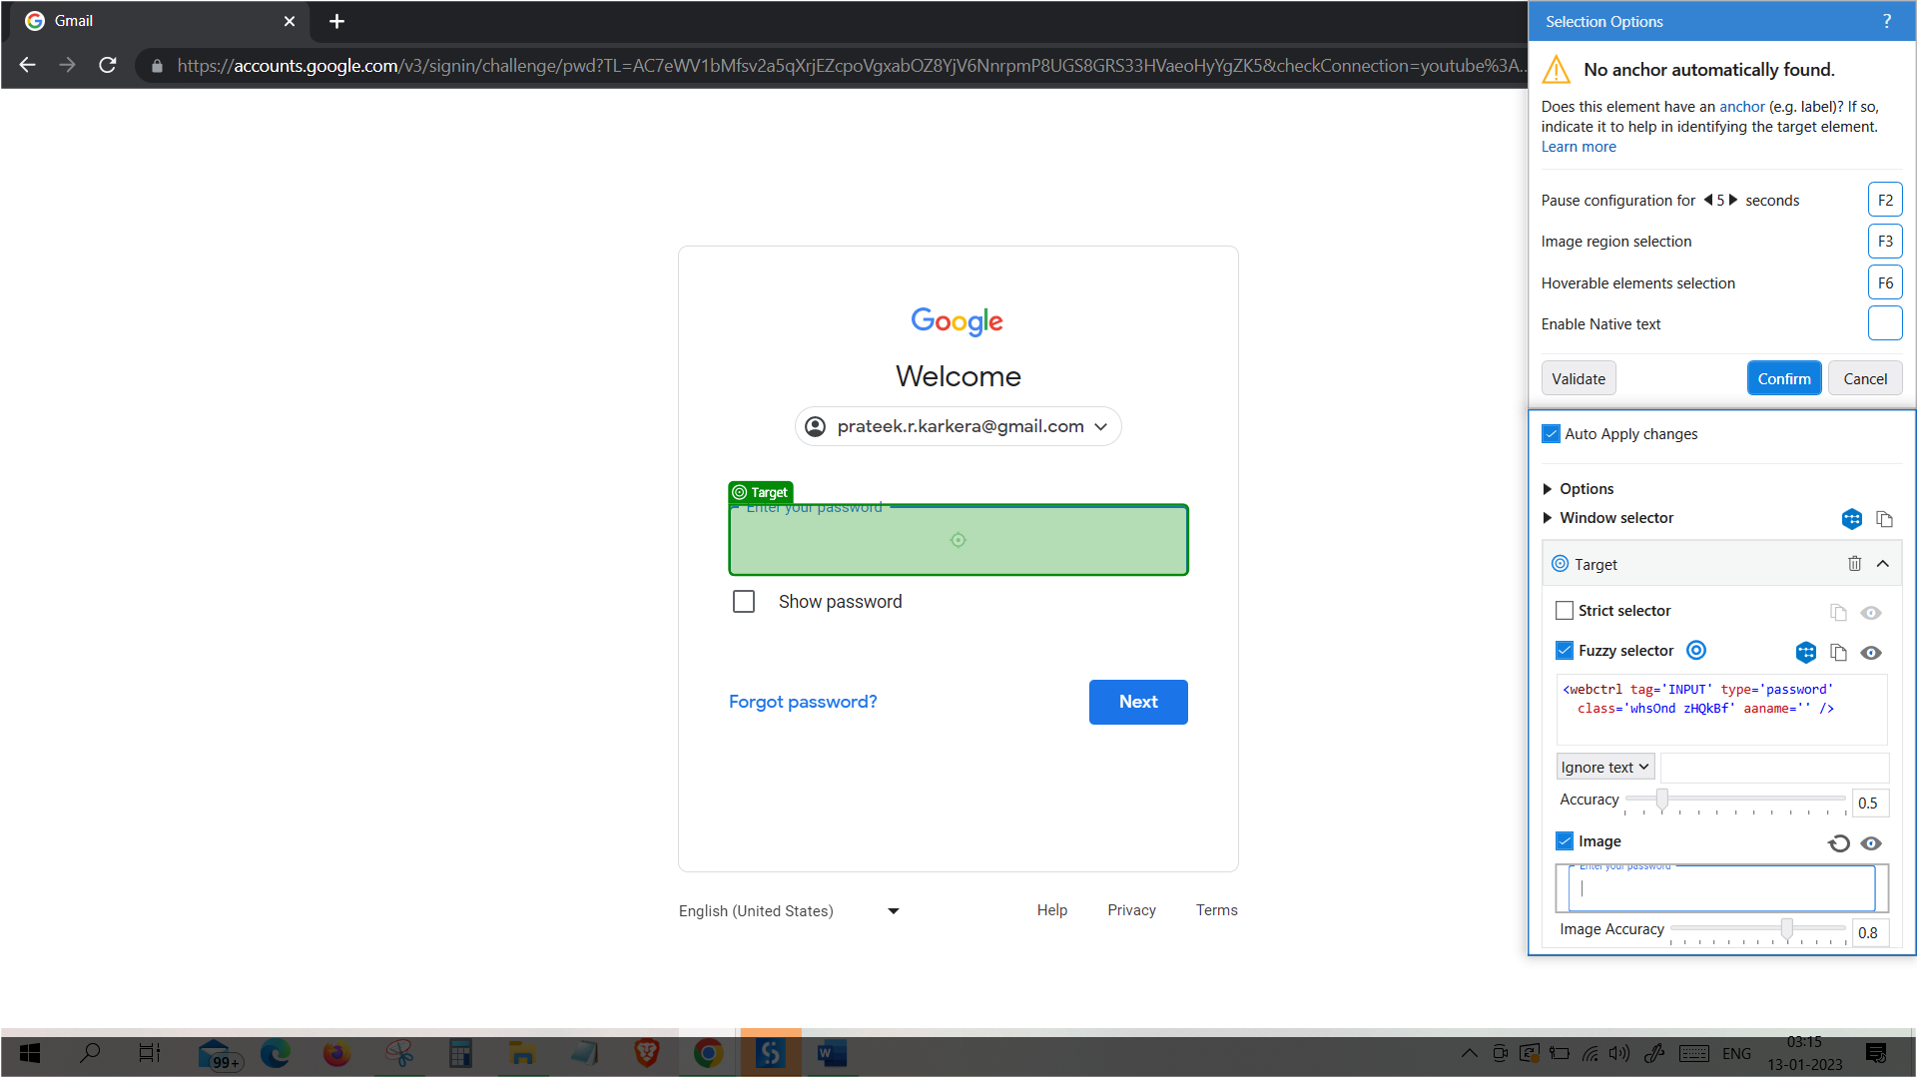

**Step 6:** Select the Secure Radio Button.Set the variable as Secure String using the code – “new System.Net.NetworkCredential(String.Empty, pwd).SecurePassword”.

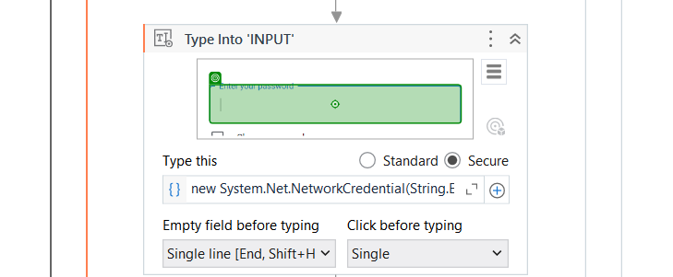

**Step 7:** Search for “Click” Activity in the Activities Panel and drag it inside the sequence. Indicate the “Next” button.



**Step 8:** Click the Run button and see the result.

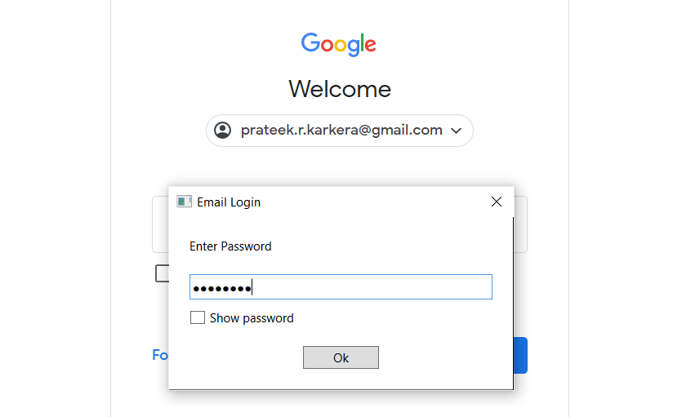

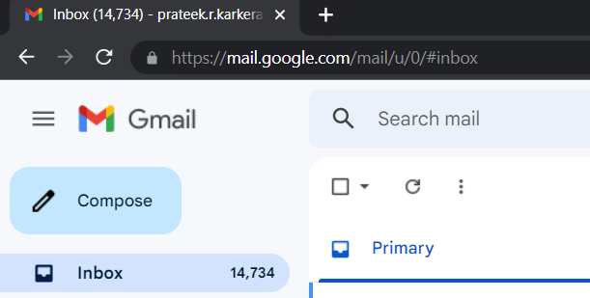

**Conclusion:** The practical to demonstrate the mouse, type into, type secure text activity using UiPath is successfully completed.

**PRACTICAL 8**

**[A] AIM:** Demonstrate the following events in UiPath.

**[I] Element Triggering Event**

**[a] Click Trigger**

**Step 1:** Open UiPath Studio and click on Blank to start a fresh project. Give it a meaningful name.



**Step 2:** Search for “Sequence” in the Activities panel and then drag and drop it onto the Designer Panel



**Step 3:** Search for “Use Browser/ Application” Activity in the Activities Panel and drag it inside the sequence workflow.Indicate the screen you want to include in the workflow.

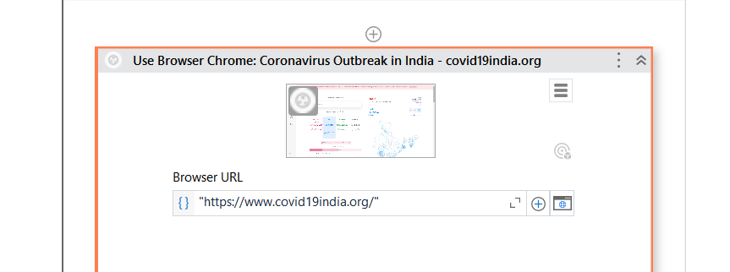

**Step 4:** Search for “Trigger Scope” Activity in the Activities Panel and drag it inside the sequence workflow. Search for “Click Trigger” in the Activities Panel and drag it inside the sequence.Indicate the Element you want to click on and Click on Save & Close.

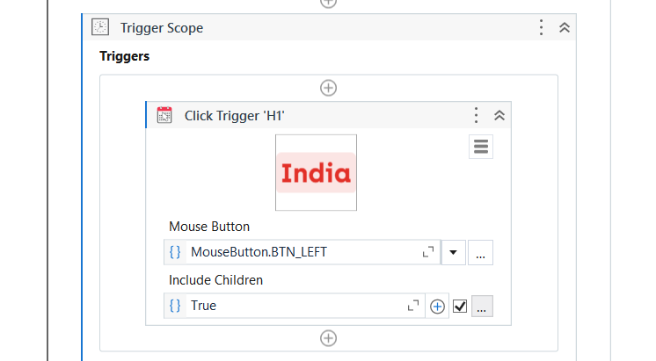

**Step 5:** Search for “Message Box” Activity in the Activities Panel and drag it inside the Action Section.Enter the Output value.

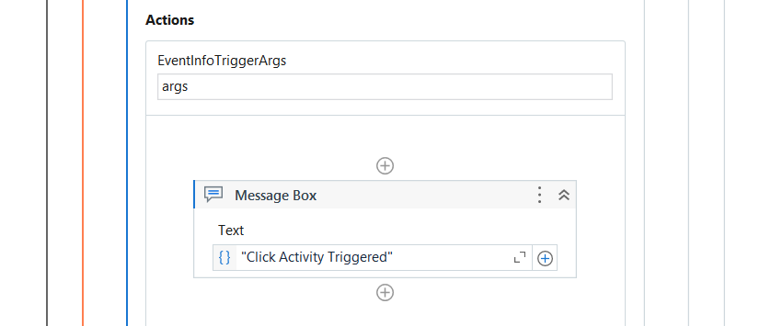

**Step 6:** Click the Run button and see the result.

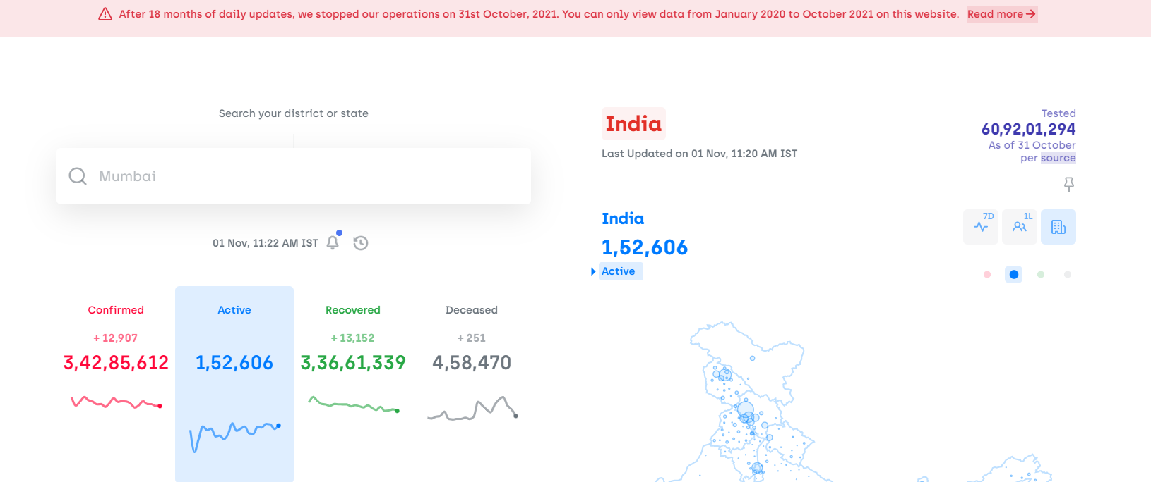

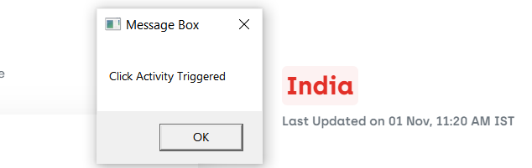

**[b] Key Press Trigger**

**Step 1:** Open UiPath Studio and click on Blank to start a fresh project. Give it a meaningful name.



**Step 2:** Search for “Sequence” in the Activities panel and then drag and drop it onto the Designer Panel



**Step 3:** Search for “Use Browser/ Application” Activity in the Activities Panel and drag it inside the sequence workflow.Indicate the screen you want to include in the workflow.

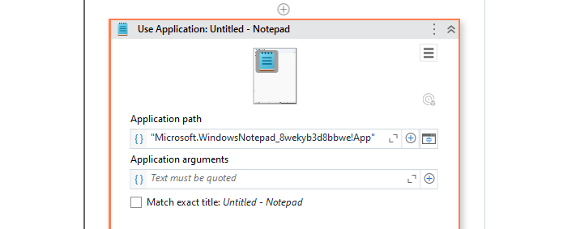

**Step 4:** Search for “Trigger Scope” Activity in the Activities Panel and drag it inside the sequence workflow. Search for “Key Press Trigger” in the Activities Panel and drag it inside the sequence.Indicate the Element you want to click on and select the Key Press combination to trigger.

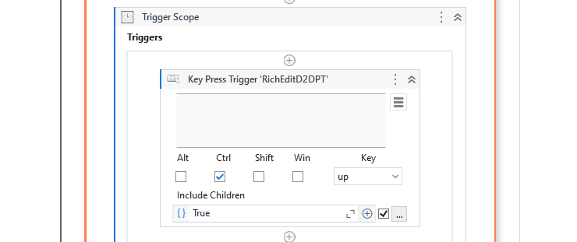

**Step 5:** Search for “Type Into” Activity in the Activities Panel and drag it inside the Action Section.Indicate the screen and enter the text to type.

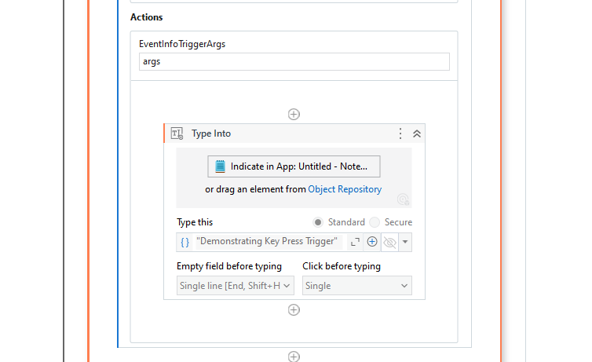

**Step 6:** Click the Run button and see the result.

After entering Key Press Combination.

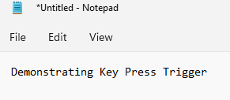

**[II] Image Triggering Event**

**Step 1:** Open UiPath Studio and click on Blank to start a fresh project. Give it a meaningful name.



**Step 2:** Search for “Sequence” in the Activities panel and then drag and drop it onto the Designer Panel



**Step 3:** Search for “Use Browser/ Application” Activity in the Activities Panel and drag it inside the sequence workflow.Indicate the screen you want to include in the workflow.

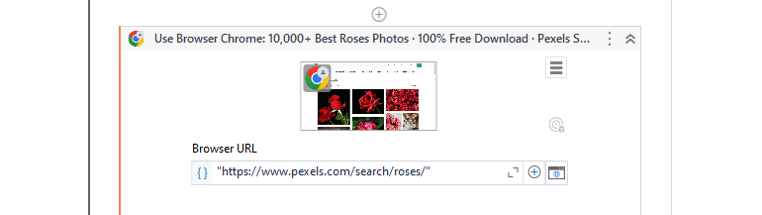

**Step 4:** Search for “Trigger Scope” Activity in the Activities Panel and drag it inside the sequence workflow. Search for “Click Image Trigger” in the Activities Panel and drag it inside the sequence.Indicate the Image you want to click on and Click on Save & Close.

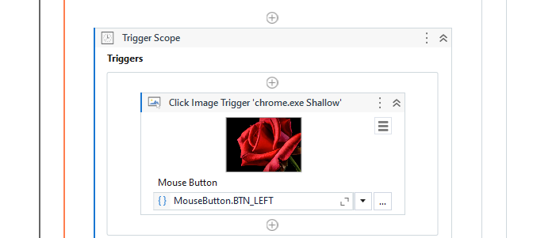

**Step 5:** Search for “Message Box” Activity in the Activities Panel and drag it inside the Action Section.Enter the Output value.

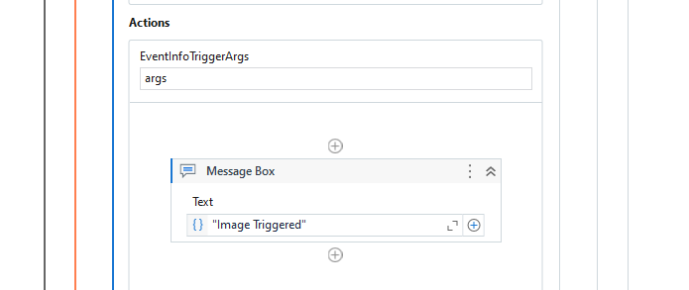

**Step 6:** Click the Run button and see the result.

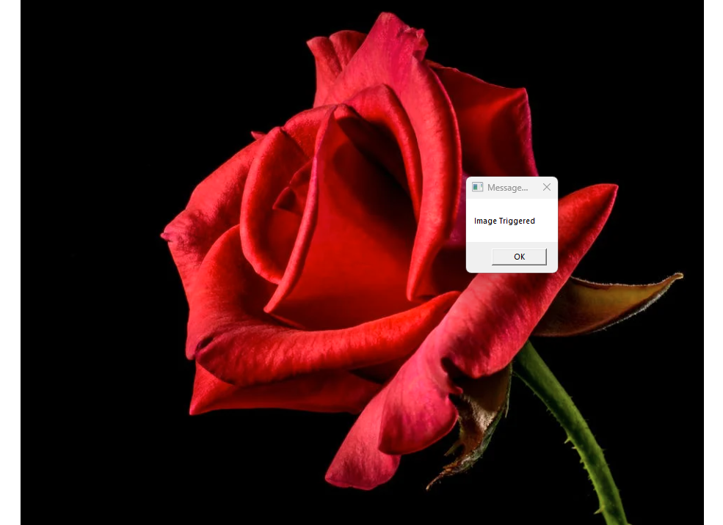

**[III] System Triggering Event**

**[a] Hotkey Trigger**

**Step 1:** Open UiPath Studio and click on Blank to start a fresh project. Give it a meaningful name.



**Step 2:** Search for “Sequence” in the Activities panel and then drag and drop it onto the Designer Panel



**Step 3:** Search for “Use Browser/ Application” Activity in the Activities Panel and drag it inside the sequence workflow.Indicate the screen you want to include in the workflow.



**Step 4:** Search for “Trigger Scope” Activity in the Activities Panel and drag it inside the sequence workflow. Search for “Hotkey Trigger” in the Activities Panel and drag it inside the sequence.Indicate the Element you want to click on and select the Hotkey combination to trigger.

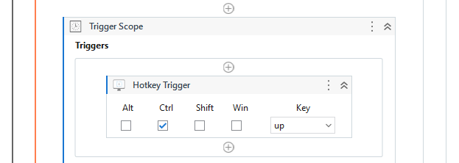

**Step 5:** Search for “Type Into” Activity in the Activities Panel and drag it inside the Action Section.Indicate the screen and enter the text to type.

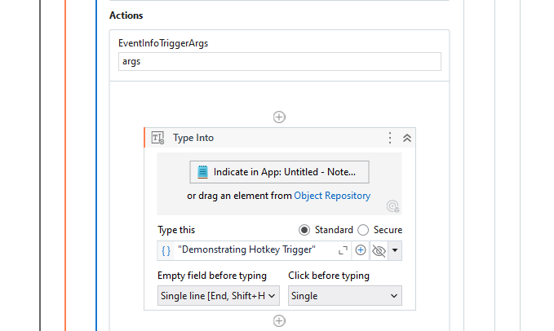

**Step 6:** Click the Run button and see the result.

After entering Hotkey Combination.

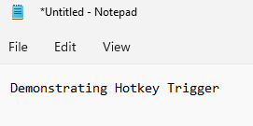

**[b] Mouse Trigger**

**Step 1:** Open UiPath Studio and click on Blank to start a fresh project. Give it a meaningful name.



**Step 2:** Search for “Sequence” in the Activities panel and then drag and drop it onto the Designer Panel



**Step 3:** Search for “Use Browser/ Application” Activity in the Activities Panel and drag it inside the sequence workflow.Indicate the screen you want to include in the workflow.

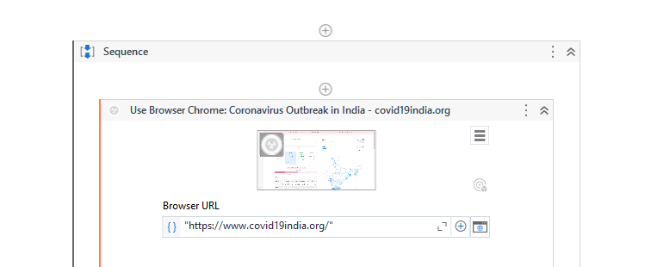

**Step 4:** Search for “Trigger Scope” Activity in the Activities Panel and drag it inside the sequence workflow. Search for “Mouse Trigger” in the Activities Panel and drag it inside the sequence.Indicate the Element you want to click on and select the Mouse Key combination to trigger.

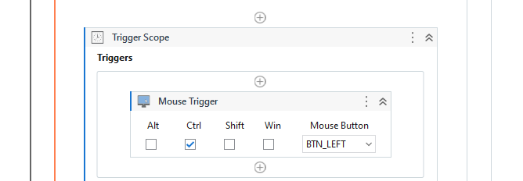

**Step 5:** Search for “Type Into” Activity in the Activities Panel and drag it inside the Action Section.Indicate the screen and enter the text to type.

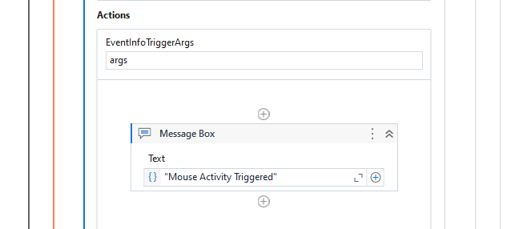

**Step 6:** Click the Run button and see the result.

After entering Mouse Key Combination.

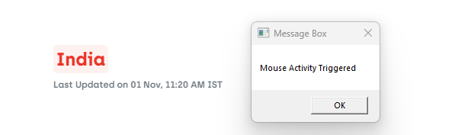

**Conclusion:** The practical to demonstrate Element Triggering, Image Triggering and System Triggering events in UiPath is successfully completed.

**[B] Aim:** Automate the following screen scraping methods using UiPath.

**[I] Full Text**

**Step 1:** Open UiPath Studio and click on Blank to start a fresh project. Give it a meaningful name.



**Step 2:** Search for “Sequence” in the Activities panel and then drag and drop it onto the Designer Panel



**Step 3:** Open a file with some text to scrape from.

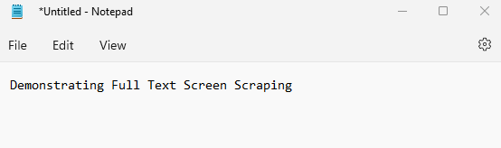

**Step 4:** Search for “Screen Scraping” in the Search panel of the Activities Panel and drag it inside the sequence. Set the Scraping method as Full Text. Create and set variable to store the output.

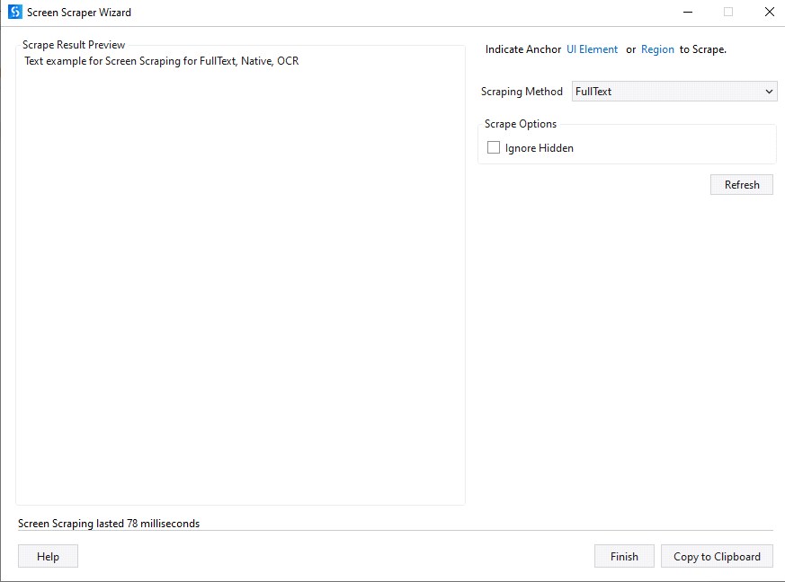

**Step 5:** Search for “Message Box” in Activities Panel and drag it inside the sequence workflow. Enter the output variable.

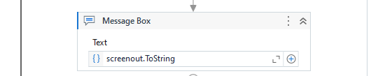

**Step 6:** Click on the Run button andsee the Results.

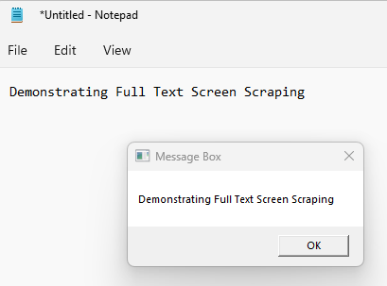

**[II] Native**

**Step 1:** Open UiPath Studio and click on Blank to start a fresh project. Give it a meaningful name.



**Step 2:** Search for “Sequence” in the Activities panel and then drag and drop it onto the Designer Panel



**Step 3:** Open a file with some text to scrape from.

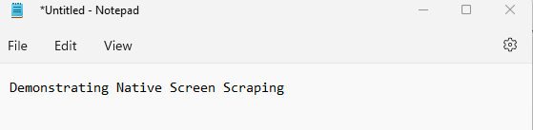

**Step 4:** Search for “Screen Scraping” in the Search panel of the Activities Panel and drag it inside the sequence. Set the Scraping method as Full Text. Select the “No Formatting” checkbox. Create and set variable to store the output.

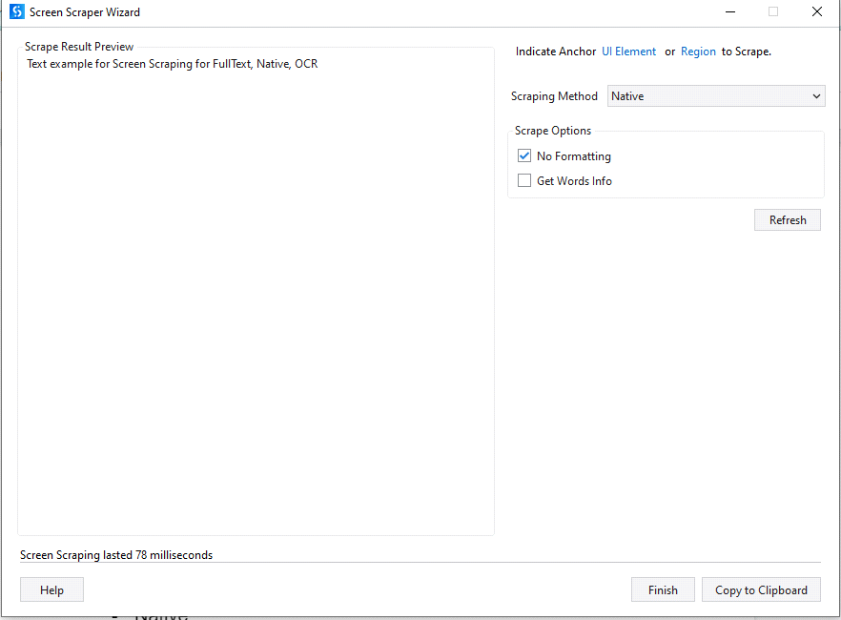

**Step 5:** Search for “Message Box” in Activities Panel and drag it inside the sequence workflow. Enter the output variable.



**Step 6:** Click on the Run button andsee the Results.

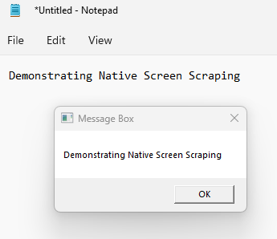

**[III] OCR**

**Step 1:** Open UiPath Studio and click on Blank to start a fresh project. Give it a meaningful name.



**Step 2:** Search for “Sequence” in the Activities panel and then drag and drop it onto the Designer Panel



**Step 3:** Open a file with some text to scrape from.

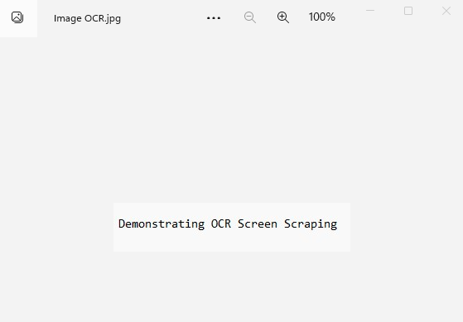

**Step 4:** Search for “Screen Scraping” in the Search panel of the Activities Panel and drag it inside the sequence. Set the Scraping method as OCR. Select Tesseract OCR Engine Create and set variable to store the output.

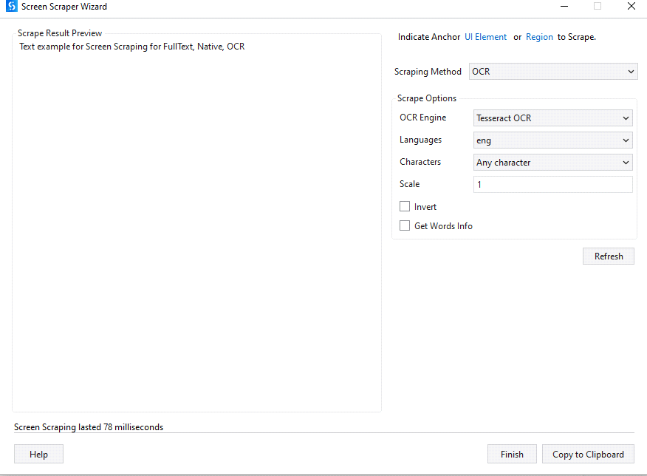

**Step 5:** Search for “Message Box” in Activities Panel and drag it inside the sequence workflow. Enter the output variable.



**Step 6:** Click on the Run button andsee the Results.

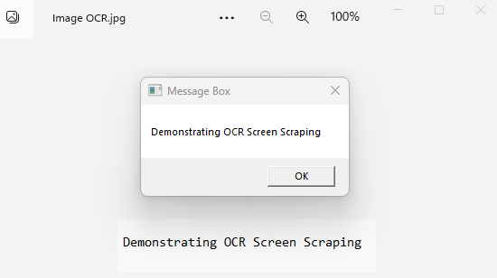

**Conclusion:** The practical to automate Full-Text, Native and OCR screen scraping methods using UiPath is successfully completed.

**[C] Aim:** Install and automate any process using UiPath with the following plug-ins:

**[I] Java Plugin**

**Step 1:** Open UiPath Studio and click on Blank to start a fresh project. Give it a meaningful name.



**Step 2:** Search for “Sequence” in the Activities panel and then drag and drop it onto the Designer Panel



**Step 3:** Search for “Java” in the Search panel of the Manage Packages Tab and install “UiPath.Java.Acitivites”.

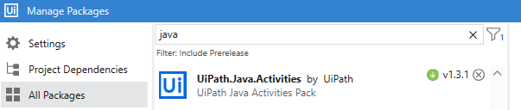

**[II] Mail Plugin**

**Step 1:** Open UiPath Studio and click on Blank to start a fresh project. Give it a meaningful name.



**Step 2:** Search for “Sequence” in the Activities panel and then drag and drop it onto the Designer Panel



**Step 3:** Search for “Mail” in the Search panel of the Manage Packages Tab and install “UiPath.Mail.Acitivites”.

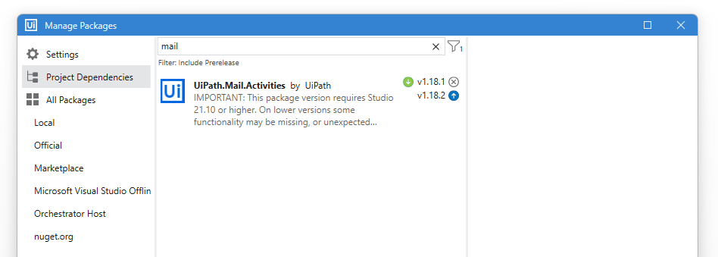

**Step 4:** Search for “Get Password” in Activities Panel and drag it inside the sequence workflow.Enter the password in the properties panel and assign it to variable pwd.

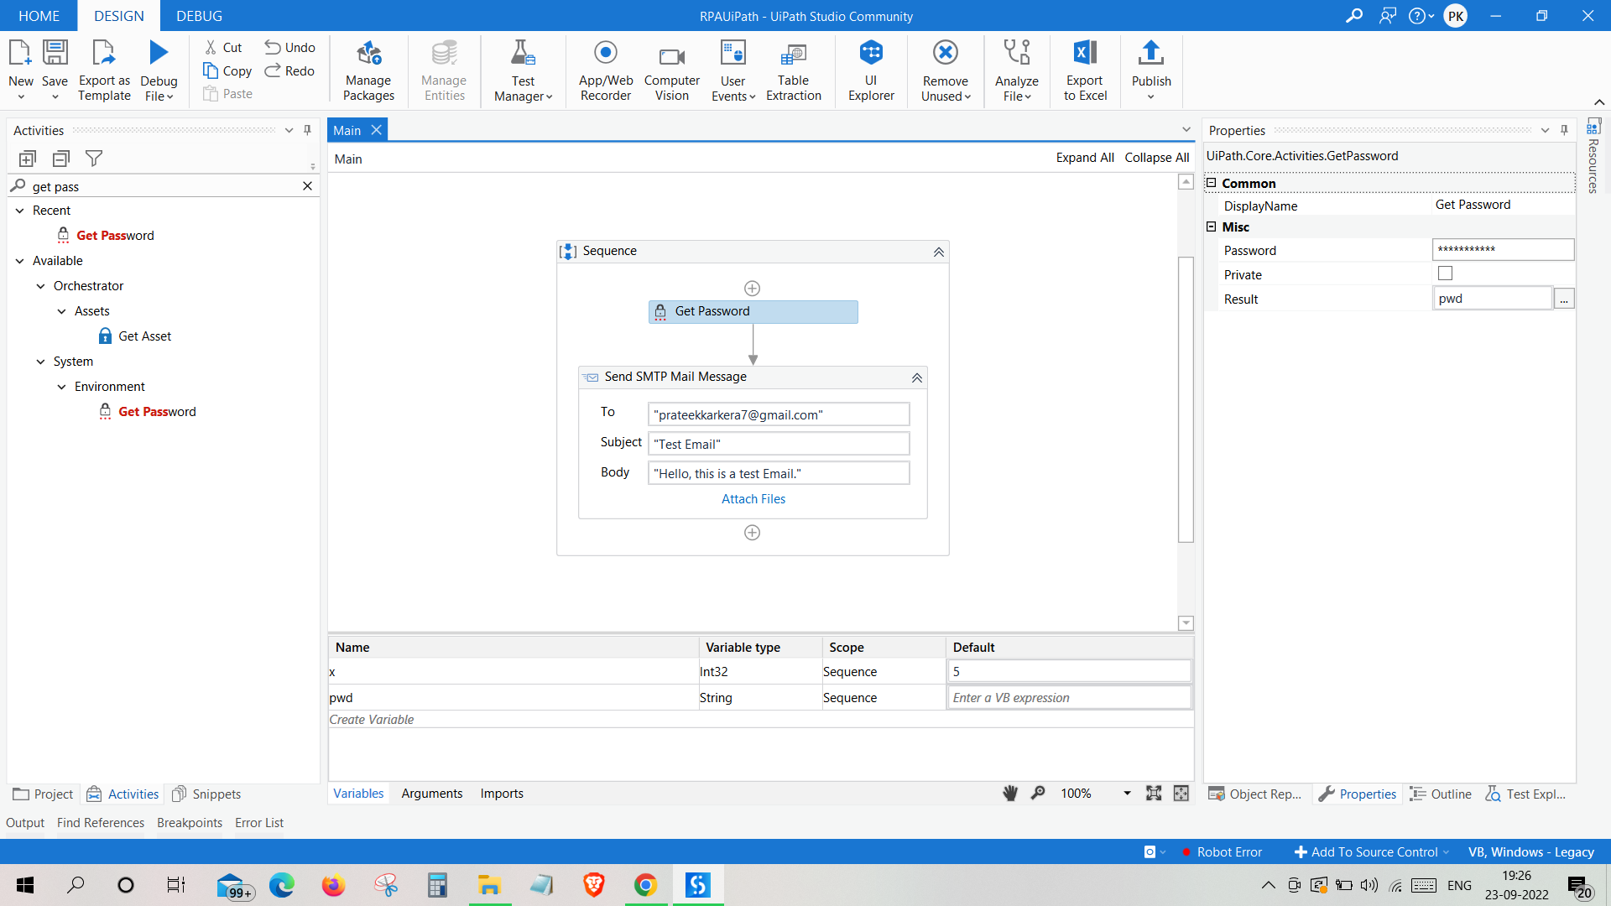

**Step 5:** Search for “Send SMTP Mail Message” in Activities Panel and drag it inside the sequence workflow. Enter the recipient’s email address, subject line and message.

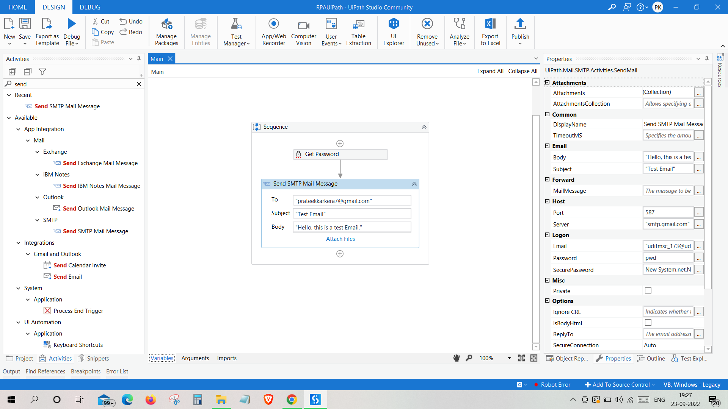

**Step 6:** Enter the password, port number, mail server name in the properties panel.



**Step 7:** Click on the Run button andcheck the output console. Done.



**[III] PDF Plugin**

**[a] Read PDF Text**

**Step 1:** Open UiPath Studio and click on Blank to start a fresh project. Give it a meaningful name.



**Step 2:** Search for “Sequence” in the Activities panel and then drag and drop it onto the Designer Panel



**Step 3:** Search for “PDF” in the Search panel of the Manage Packages Tab and install “UiPath.PDF.Acitivites”.

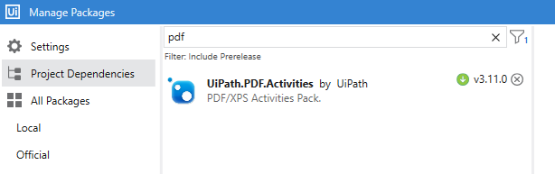

**Step 4:** Search for “Read PDF Text” in Activities Panel and drag it inside the sequence workflow.Enter the file location of the PDF to read from. Create and assign an output variable.

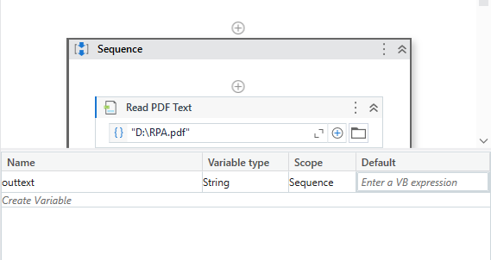

**Step 5:** Search for “Write Line” in Activities Panel and drag it inside the sequence workflow. Enter the output text variable.

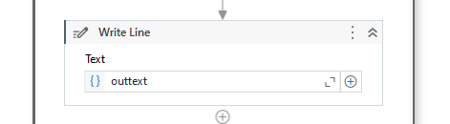

**Step 6:** Click on the Run button andsee the Results.

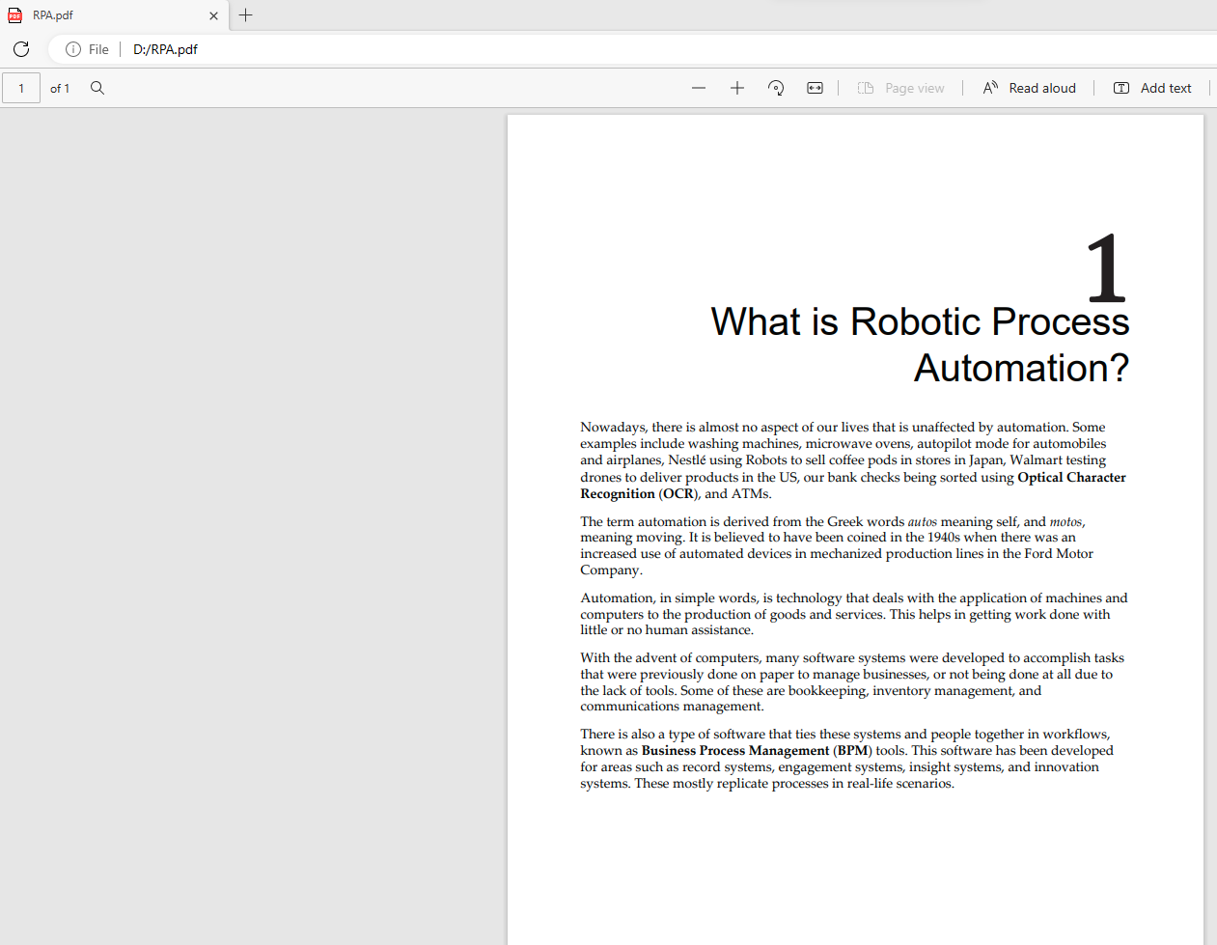

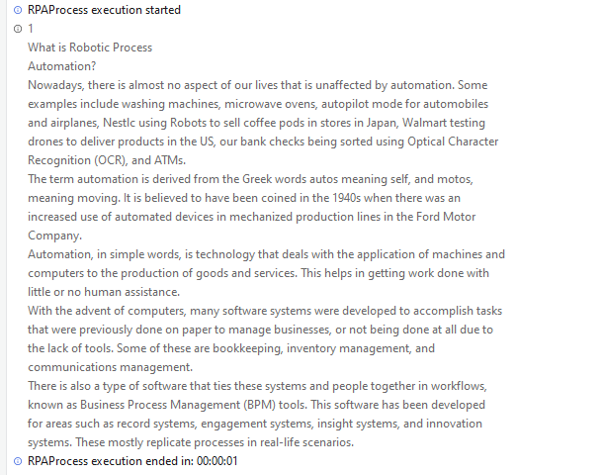

**[b] Read PDF with OCR**

**Step 1:** Open UiPath Studio and click on Blank to start a fresh project. Give it a meaningful name.



**Step 2:** Search for “Sequence” in the Activities panel and then drag and drop it onto the Designer Panel



**Step 3:** Search for “PDF” in the Search panel of the Manage Packages Tab and install “UiPath.PDF.Acitivites”.



**Step 4:** Search for “Read PDF with OCR” in Activities Panel and drag it inside the sequence workflow.Enter the file location of the PDF to read from. Search for “Tesseract Engine” in the activities panel and drag into the body to Assign OCR Engine. Create and assign an output variable.

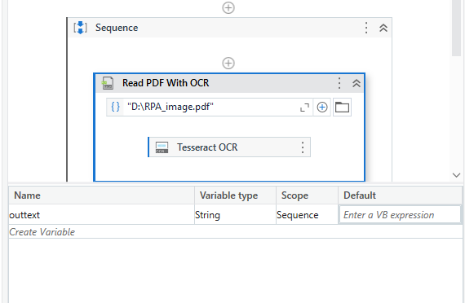

**Step 5:** Search for “Write Line” in Activities Panel and drag it inside the sequence workflow. Enter the output text variable.



**Step 6:** Click on the Run button andsee the Results.

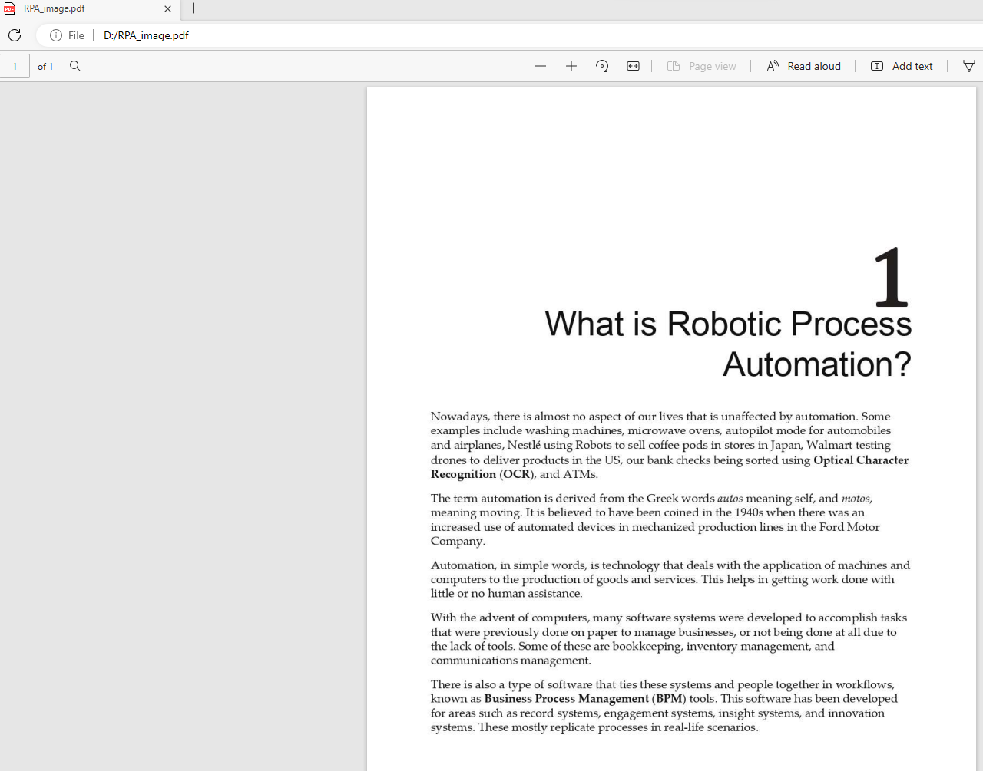



**[IV] Web Integration**

**Step 1:** Open UiPath Studio and click on Blank to start a fresh project. Give it a meaningful name.



**Step 2:** Search for “Sequence” in the Activities panel and then drag and drop it onto the Designer Panel



**Step 3:** Search for “Input dialog” in the Search panel of the Activities panel. Drag and drop Input dialog activity inside the Sequence. Write the appropriate message on the Label of the Input dialog. Create a variable and specify the variable in the Result property of the Input dialog box.



**Step 4:** Search for “Use Browser/ Application” Activity in the Activities Panel and drag it inside the sequence workflow.Indicate the screen you want to include in the workflow.



**Step 5:** Search for “Type Into” Activity in the Activities Panel and drag it inside the sequence workflow.Indicate the Element you want to click on and Click on Save & Close.





**Step 6:** Search for “Click” Activity in the Activities Panel and drag it inside the sequence. Indicate the “Next” button.



**Step 7:** Search for “Input dialog” in the Search panel of the Activities panel. Drag and drop Input dialog activity inside the Sequence. Write the appropriate message on the Label of the Input dialog. Create a variable and specify the variable in the Result property of the Input dialog box. Check the IsPassword property.



**Step 8:** Search for “Use Browser/ Application” Activity in the Activities Panel and drag it inside the sequence workflow.Indicate the screen you want to include in the workflow.



**Step 9:** Search for “Type Into” Activity in the Activities Panel and drag it inside the sequence workflow.Indicate the Element you want to click on and Click on Save & Close.



**Step 10:** Select the Secure Radio Button.Set the variable as Secure String using the code – “new System.Net.NetworkCredential(String.Empty, pwd).SecurePassword”.



**Step 11:** Search for “Click” Activity in the Activities Panel and drag it inside the sequence. Indicate the “Next” button.



**Step 12:** Click the Run Button and see the results.









**[V] Excel plugin**

**a] Read Cell**

**Step 1:** Open UiPath Studio and click on Blank to start a fresh project. Give it a meaningful name.



**Step 2:** Search for “Sequence” in the Activities panel and then drag and drop it onto the Designer Panel



**Step 3:** Search for “Excel” in the Search panel of the Manage Packages Tab and install “UiPath.Excel.Acitivites”.



**Step 4:** Search for “Excel Process Scope” in the Search panel of the Activities panel. Drag and drop the activity inside the Sequence. Search for “Use Excel File” in the Search panel of the Activities panel. Drag and drop the activity inside the Excel Process Scope. Enter the Target File location and provide a Reference name.



**Step 5:** Search for “Read Cell Value” in the Search panel of the Activities panel. Drag and drop the activity inside the Body. Enter the Sheet name and Cell Location to Read from. Create an output variable to store the value of the cell.



**Step 6:** Search for “Message Box” in the Search panel of the Activities panel. Drag and drop Message Box activity inside the Body. Enter the output variable to display the cell value.



**Step 7:** Click the Run button and see the result.





**b] Write Cell**

**Step 1:** Open UiPath Studio and click on Blank to start a fresh project. Give it a meaningful name.



**Step 2:** Search for “Sequence” in the Activities panel and then drag and drop it onto the Designer Panel



**Step 3:** Search for “Excel” in the Search panel of the Manage Packages Tab and install “UiPath.Excel.Acitivites”.



**Step 4:** Search for “Input dialog” in the Search panel of the Activities panel. Drag and drop two Input dialog activities inside the Sequence. Write the appropriate message on the Label of the Input dialogs. Create variables and specify the variables in the Result property of the Input dialog boxes.



**Step 5:** Search for “Excel Process Scope” in the Search panel of the Activities panel. Drag and drop the activity inside the Sequence. Search for “Use Excel File” in the Search panel of the Activities panel. Drag and drop the activity inside the Excel Process Scope. Enter the Target File location and provide a Reference name.



**Step 6:** Search for “Write Cell” in the Search panel of the Activities panel. Drag and drop the activity inside the Body. Enter the Sheet name and Cell Location to Write to. Enter the cell value variable.



**Step 7:** Click the Run button and see the result.









**c] Append Range**

**Step 1:** Open UiPath Studio and click on Blank to start a fresh project. Give it a meaningful name.



**Step 2:** Search for “Sequence” in the Activities panel and then drag and drop it onto the Designer Panel



**Step 3:** Search for “Excel” in the Search panel of the Manage Packages Tab and install “UiPath.Excel.Acitivites”.



**Step 4:** Search for “Build Data Table” in the Search panel of the Activities panel. Drag and drop the activity inside the Sequence. Enter the values for the DataTable and click “OK”.



**Step 5:** Create a DataTable variable for Output.



**Step 6:** Search for “Excel Process Scope” in the Search panel of the Activities panel. Drag and drop the activity inside the Sequence. Search for “Use Excel File” in the Search panel of the Activities panel. Drag and drop the activity inside the Excel Process Scope. Enter the Target File location and provide a Reference name.



**Step 7:** Search for “Write DataTable to Excel” in the Search panel of the Activities panel. Drag and drop the activity inside the Body. Enter the Sheet name and Range to Write To. Enter the output variable of “DataTable” type to write the range. Check “Append” and “Exclude Headers”.



**Step 8:** Click the Run button and see the result.





**[VI] Word plugin**

**[a] Read**

**Step 1:** Open UiPath Studio and click on Blank to start a fresh project. Give it a meaningful name.



**Step 2:** Search for “Sequence” in the Activities panel and then drag and drop it onto the Designer Panel



**Step 3:** Search for “Word” in the Search panel of the Manage Packages Tab and install “UiPath.Word.Acitivites”.

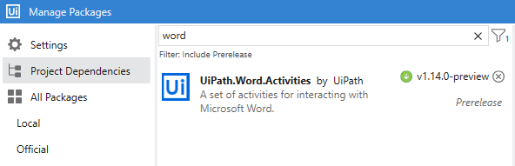

**Step 4:** Search for “Word Application Scope” in the Search panel of the Activities panel. Drag and drop the activity inside the Sequence. Enter the Target File location.

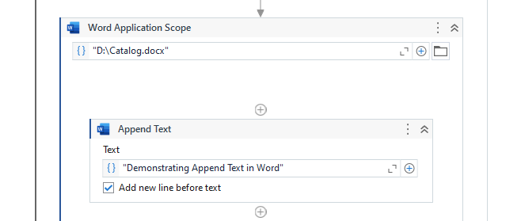

**Step 5:** Search for “Read Text” in the Search panel of the Activities panel. Drag and drop the activity inside the Word Application Scope. Create and save the value to a new output variable.

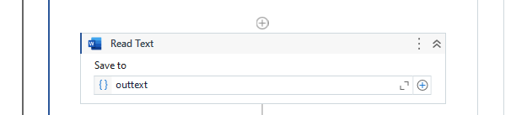

**Step 6:** Search for “Message Box” in the Search panel of the Activities panel. Drag and drop the activity inside the Word Application Scope and enter the output variable.

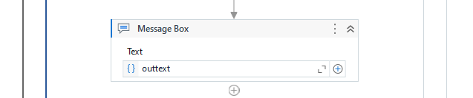

**Step 7:** Click the Run button and see the result.

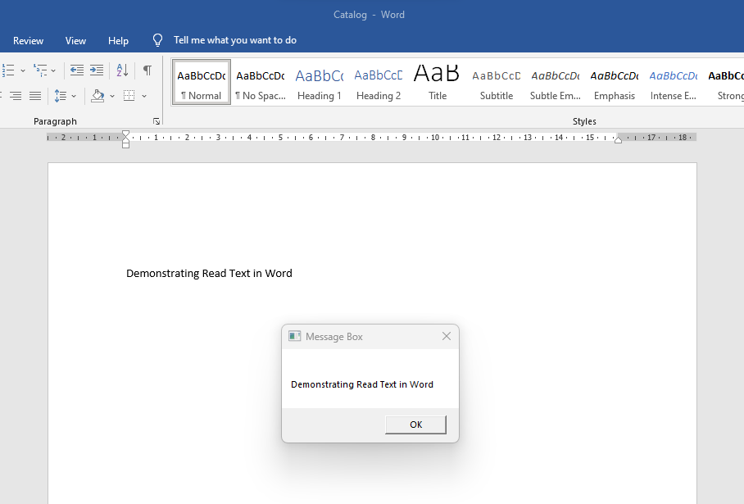

**[b] Append Text**

**Step 1:** Open UiPath Studio and click on Blank to start a fresh project. Give it a meaningful name.



**Step 2:** Search for “Sequence” in the Activities panel and then drag and drop it onto the Designer Panel



**Step 3:** Search for “Word” in the Search panel of the Manage Packages Tab and install “UiPath.Word.Acitivites”.



**Step 4:** Search for “Input dialog” in the Search panel of the Activities panel. Drag and drop Input dialog activity inside the Sequence. Write the appropriate message on the Label of the Input dialog. Create variables and specify the variables in the Result property of the Input dialog box.

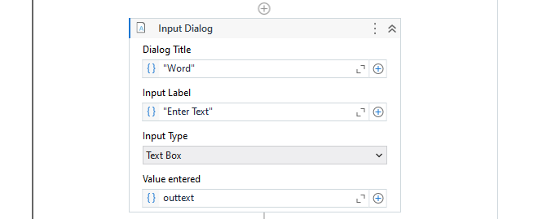

**Step 5:** Search for “Word Application Scope” in the Search panel of the Activities panel. Drag and drop the activity inside the Sequence. Enter the Target File location.



**Step 6:** Search for “Append Text” in the Search panel of the Activities panel. Drag and drop the activity inside the Word Application Scope and enter the output variable.



**Step 7:** Click the Run button and see the result.

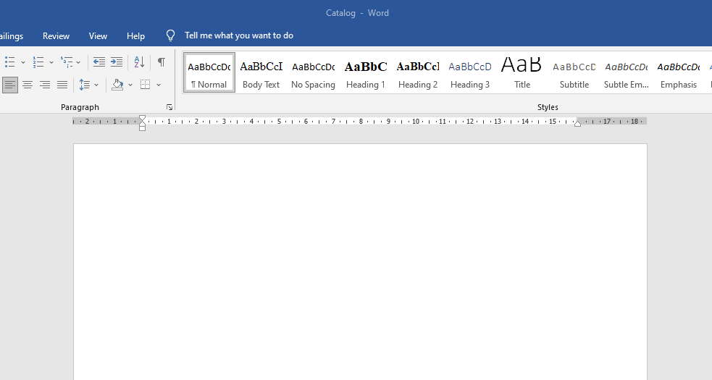

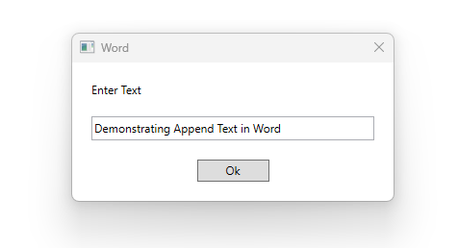

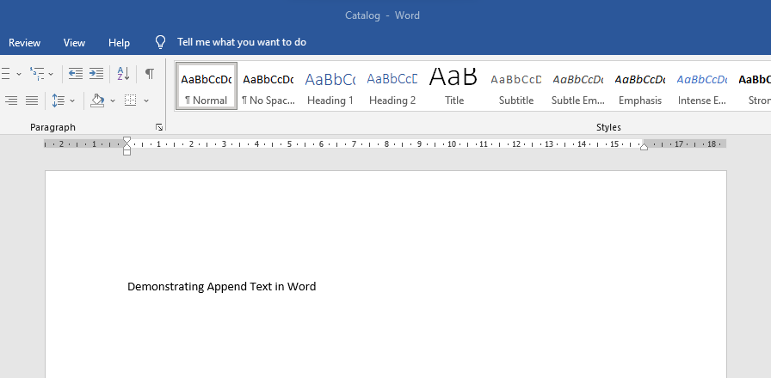

**[VII] Credential Management**

**[a] Set Credential**

**Step 1:** Open UiPath Studio and click on Blank to start a fresh project. Give it a meaningful name.



**Step 2:** Search for “Sequence” in the Activities panel and then drag and drop it onto the Designer Panel



**Step 3:** Create a new Credential in Orchestrator.

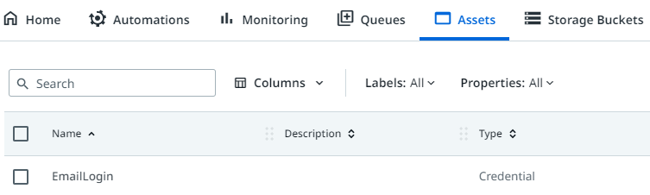

**Step 4:** Search for “Input Dialog Box” in the Search panel of the Activities panel. Drag and drop two Input dialog boxes inside the Sequence. Set one input Dialog box for the username and with output variable as “email” and the other input Dialog box for the Password with the output variable as “pwd” and isPassword Property checked.

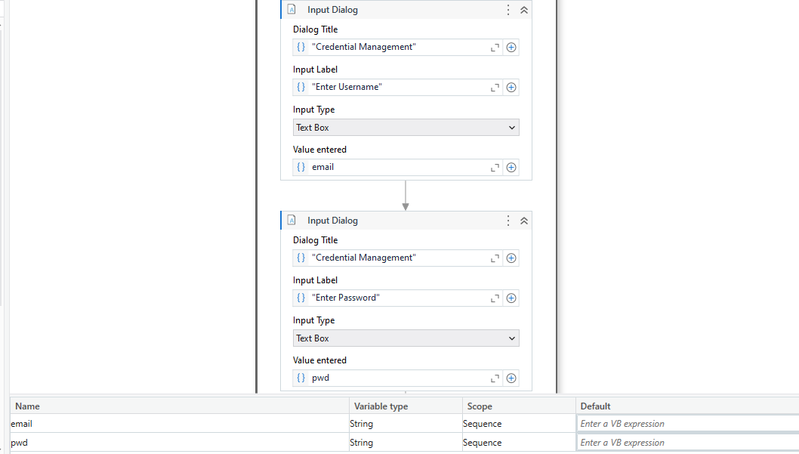

**Step 5:** Search for “Set Credential” in the Search panel of the Activities panel. Drag and drop the activity inside the Sequence. Select the Orchestrator Folder Path and the Credential name. Enter the Username and Password Variables.

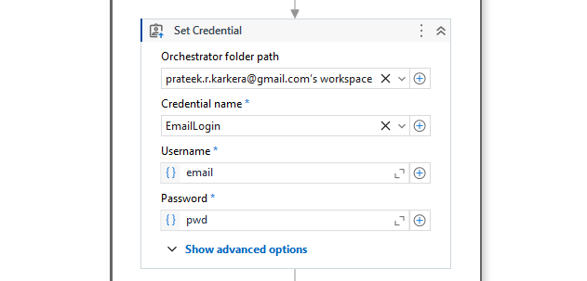

**Step 6:** Search for “Message Box” in the Search panel of the Activities panel. Drag and drop the activity inside the body and enter the output statement.

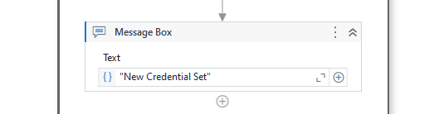

**Step 7:** Click the Run button and see the result.



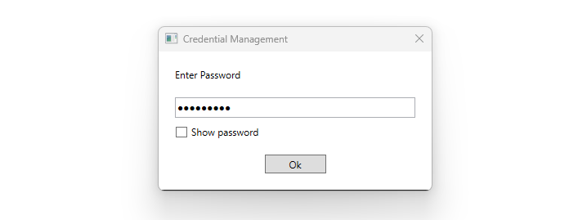



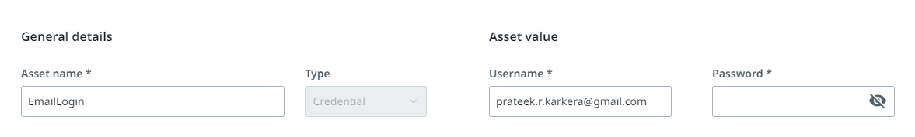

**[b] Get Credential**

**Step 1:** Open UiPath Studio and click on Blank to start a fresh project. Give it a meaningful name.



**Step 2:** Search for “Sequence” in the Activities panel and then drag and drop it onto the Designer Panel



**Step 3:** Search for “Get Credential” in the Search panel of the Activities panel. Drag and drop the activity inside the Sequence. Select the Orchestrator Folder Path and the Credential name. Create new variables for username and password and map the Username and Password Outputs.

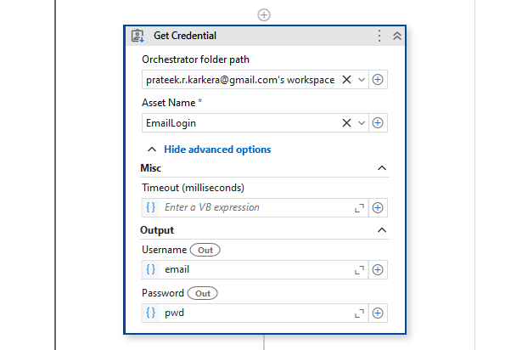

**Step 4:** Search for “Use Browser/ Application” Activity in the Activities Panel and drag it inside the sequence workflow.Indicate the screen you want to include in the workflow.



**Step 5:** Search for “Type Into” Activity in the Activities Panel and drag it inside the sequence workflow.Indicate the Element you want to click on and Click on Save & Close.





**Step 6:** Search for “Click” Activity in the Activities Panel and drag it inside the sequence. Indicate the “Next” button.



**Step 7:** Search for “Input dialog” in the Search panel of the Activities panel. Drag and drop Input dialog activity inside the Sequence. Write the appropriate message on the Label of the Input dialog. Create a variable and specify the variable in the Result property of the Input dialog box. Check the IsPassword property.



**Step 8:** Search for “Use Browser/ Application” Activity in the Activities Panel and drag it inside the sequence workflow.Indicate the screen you want to include in the workflow.



**Step 9:** Search for “Type Into” Activity in the Activities Panel and drag it inside the sequence workflow.Indicate the Element you want to click on and Click on Save & Close.



**Step 10:** Select the Secure Radio Button.Set the variable as Secure String using the code – “new System.Net.NetworkCredential(String.Empty, pwd).SecurePassword”.



**Step 11:** Search for “Click” Activity in the Activities Panel and drag it inside the sequence. Indicate the “Next” button.



**Step 12:** Click the Run Button and see the results.









**[c] Set Asset**

**Step 1:** Open UiPath Studio and click on Blank to start a fresh project. Give it a meaningful name.



**Step 2:** Search for “Sequence” in the Activities panel and then drag and drop it onto the Designer Panel



**Step 3:** Create a new Asset in Orchestrator.

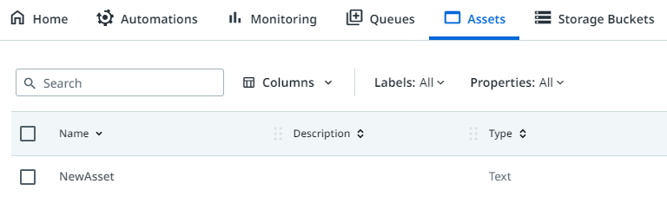

**Step 4:** Search for “Input Dialog Box” in the Search panel of the Activities panel. Drag and drop Input dialog box inside the Sequence. Give appropriate label to the Input Dialog box. Create a new variable to store Asset Value.

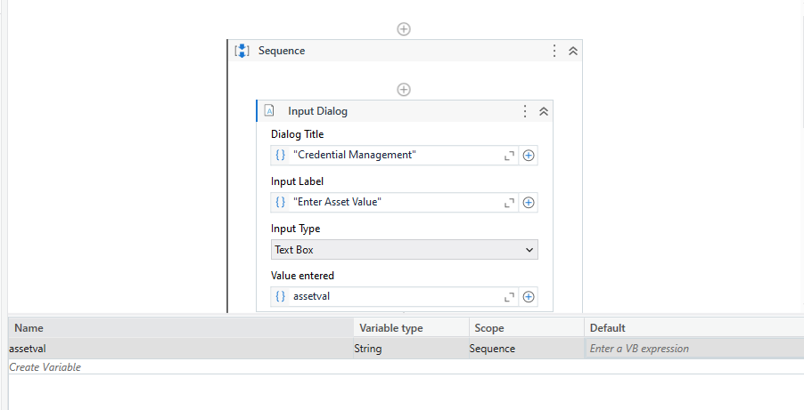

**Step 5:** Search for “Set Asset” in the Search panel of the Activities panel. Drag and drop the activity inside the Sequence. Select the Orchestrator Folder Path and the Asset name. Enter the Asset Value Variable.

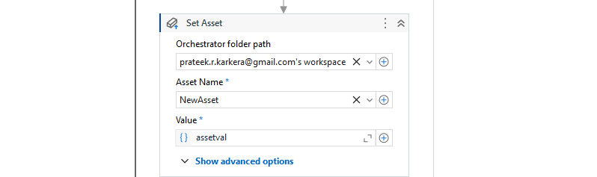

**Step 6:** Search for “Message Box” in the Search panel of the Activities panel. Drag and drop the activity inside the body and enter the output statement.

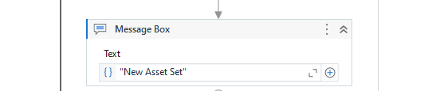

**Step 7:** Click the Run button and see the result.

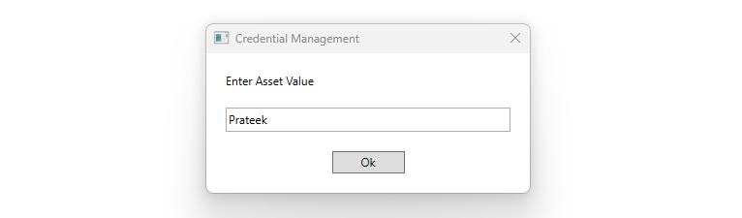

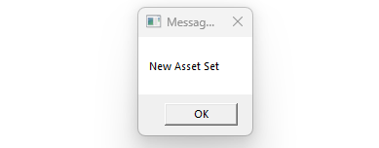

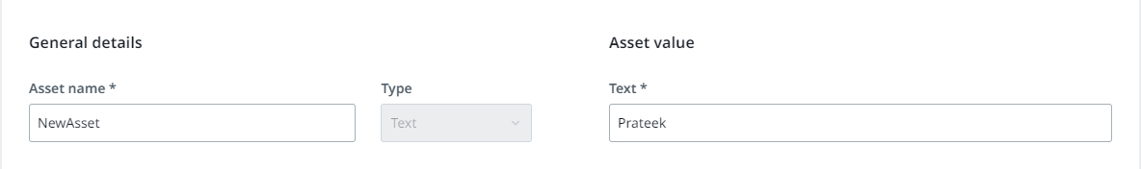

**[d] Get Asset**

**Step 1:** Open UiPath Studio and click on Blank to start a fresh project. Give it a meaningful name.



**Step 2:** Search for “Sequence” in the Activities panel and then drag and drop it onto the Designer Panel



**Step 3:** Search for “Get Asset” in the Search panel of the Activities panel. Drag and drop the activity inside the Sequence. Select the Orchestrator Folder Path and the Asset name. Create new variables for Asset Value and map Get Asset Output.

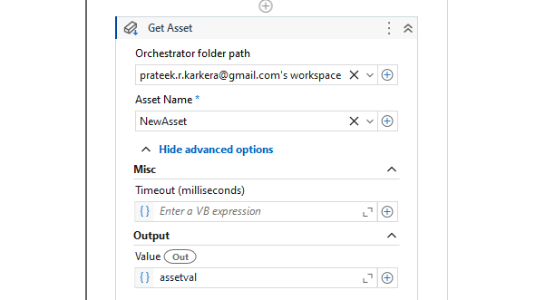

**Step 4:** Search for “Message Box” in the Search panel of the Activities panel. Drag and drop the activity inside the body and enter the output variable.

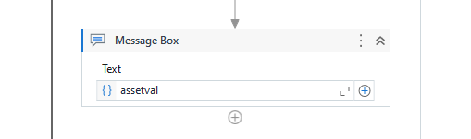

**Step 7:** Click the Run button and see the result.



**Conclusion:** The practical to install and demonstrate the processes using plug-ins in UiPath is successfully completed.

**PRACTICAL 9**

**[A] AIM:** Automate the process of launching an assistant bot on keyboard event.

**Step 1:** Open UiPath Studio and click on Blank to start a fresh project. Give it a meaningful name.



**Step 2:** Search for “Sequence” in the Activities panel and then drag and drop it onto the Designer Panel



**Step 3:** Search for Get Password in Activities Panel and drag it inside the sequence workflow.Enter the password in the properties panel and assign it to variable pwd.



**Step 4:** Search for Send SMTP Mail Message in Activities Panel and drag it inside the sequence workflow. Enter the recipient’s email address, subject line and message.



**Step 5:** Enter the password, port number, mail server name in the properties panel.



**Step 6:** Click on the Run button andcheck the output console. Done.



**Conclusion:** The practical to automate the process of send mail event (on any email) was performed successfully.

**[B] AIM:** Automate the process of launching an assistant bot on keyboard event.

**Step 1:** Open UiPath Studio and click on Blank to start a fresh project. Give it a meaningful name.



**Step 2:** Search for “Sequence” in the Activities panel and then drag and drop it onto the Designer Panel



**Step 3:** Search for “Trigger Scope” in the Search panel of the Activities Panel and then drag and drop into the Sequence. Search for “Hotkey Trigger” in the activities panel and drag it inside the Trigger Scope Activity. Select the Hotkey combination “Ctrl + Up” in the Trigger Section.

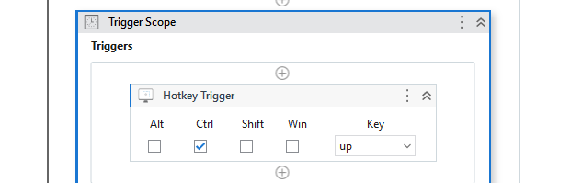

**Step 4:** Search for “Message Box” in the Search panel of the Activities panel. Drag and drop Message Box activity inside the Action Section. Enter the output statement.

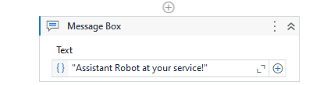

**Step 5:** Click the Run button and see the result.



**Conclusion:** The practical to automate the process of launching an assistant bot on a keyboard event was performed successfully.

**[C] AIM:** Demonstrate the Exception handing in UiPath.

**Step 1:** Open UiPath Studio and click on Blank to start a fresh project. Give it a meaningful name.



**Step 2:** Search for “Sequence” in the Activities panel and then drag and drop it onto the Designer Panel



**Step 3:** Search for “Try Catch” in the Search panel of the Activities Panel and then drag and drop into the Sequence. Search for “Read Cell Workbook” in the activities panel and drag it inside the Try Section. Enter the sheet location, sheet name and cell location to read the value from. Create an Output variable to store the value.

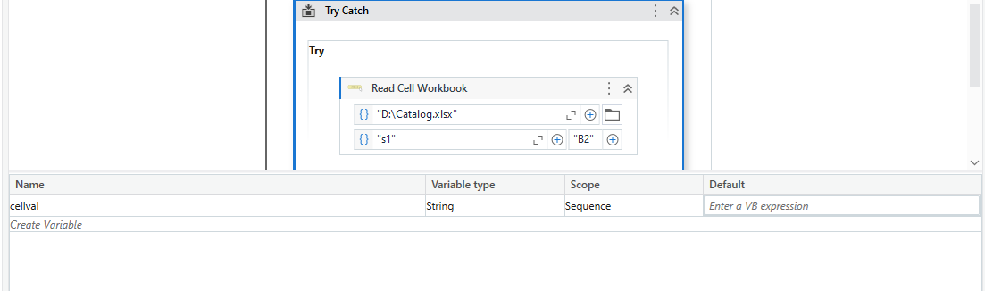

**Step 4:** Expand the Catch section and select “System.Exception”. Search for “Message Box” in the Search panel of the Activities panel. Drag and drop Message Box activity inside the Catch Section. Enter the output statement in case the Exception occurs.

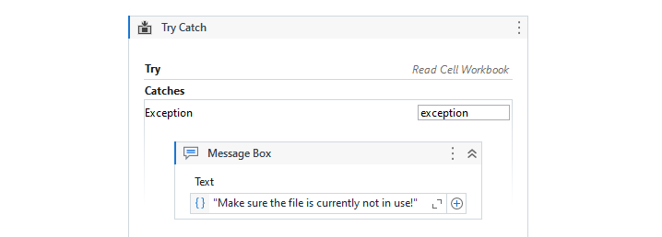

**Step 5:** Expand the Finally section and drag and drop another Message Box activity inside the Finally Section. Enter the output variable to read the value.



**Step 5:** Click the Run button and see the result.

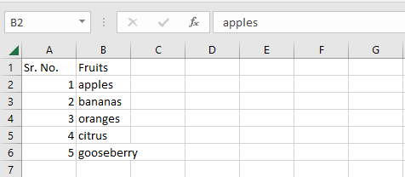



After closing the app.



**Conclusion:** The practical to demonstrate the Exception handing in UiPath was performed successfully.

**PRACTICAL 10**

**[A] AIM:** Automate the process of logging and taking screenshots in UiPath.

**Step 1:** Open UiPath Studio and click on Blank to start a fresh project. Give it a meaningful name.



**Step 2:** Search for “Sequence” in the Activities panel and then drag and drop it onto the Designer Panel



**Step 3:** Search for “Read Cell Workbook” in the activities panel and drag it inside the Sequence. Enter the sheet location, sheet name and cell location to write the value to and the cell value.



**Step 4:** Search for “Log Message” in the activities panel and drag it inside the Sequence. Set Log type as “Info” and enter the Log Message.

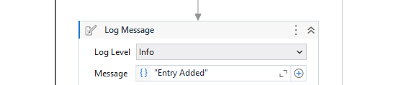

**Step 5:** Search for “Message Box” in the activities panel. Drag it inside the Sequence and enter the output message.

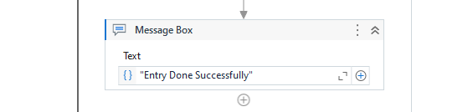

**Step 6:** Click the Run button and see the result.

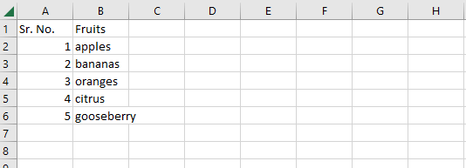

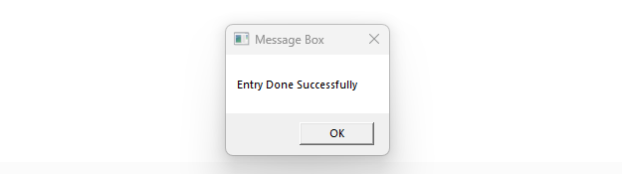

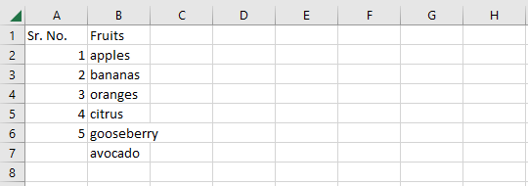

**Conclusion:** The practical to automate the process of logging and taking screenshots in UiPath was performed successfully.

**[B] AIM:** Automate any process using State Machine in UiPath.

**Step 1:** Open UiPath Studio and click on Blank to start a fresh project. Give it a meaningful name.



**Step 2:** Search for “State Machine” in the Activities panel and then drag and drop it onto the Designer Panel.

**Step 3:** Create 3 variables for your State Machine Current_Temp set to default value of 24, Desired_Temp, and a Boolean Variable named IDLE with default value as True.

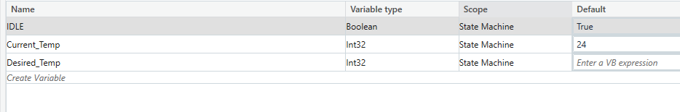

**Step 4:** Create the State Machine Frame.

Search for “State” and “Final State” in the activities panel and drag it inside the Sequence.

Add 1 State connected to the flow and label it as IDLE, 2 more state named COOLING and HEATING connected to and from the IDLE State and the Final State labelled “POWER OFF” connected to the main IDLE State.

Name the Condition from IDLE state to COOLING state as DT<CT, name the Condition from IDLE state to HEATING state as DT>CT, name the Condition from IDLE state to POWER OFF state as Exit.

Now, name the Condition from COOLING state to IDLE state as Cooled and name the Condition from HEATED state to IDLE state as Heated.

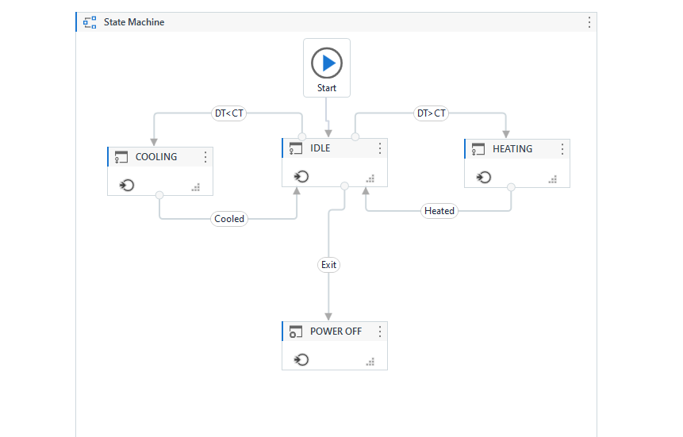

**Step 5:** In the Entry Section of IDLE State. Add a WriteLine Activity from the Activities Panel describing the current temperature with the output as "Current Temp is " + Current_Temp.ToString + " Degree Celsius".

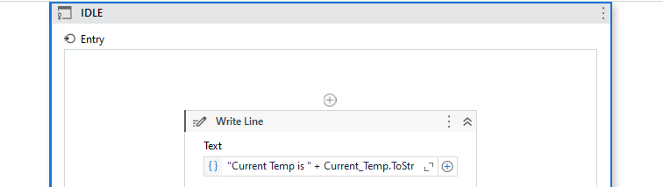

**Step 5:** Below the WriteLine Activity add an Input Dialog Box to take the user input for temperature and store it in the Desired_Temp variable.

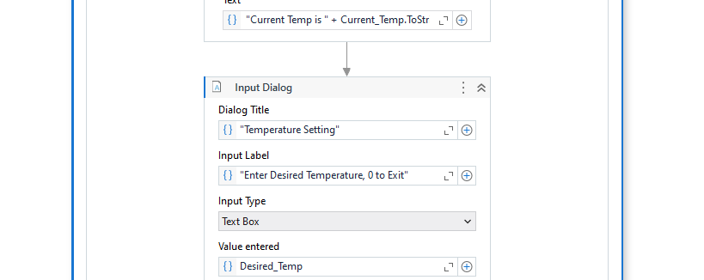

**Step 6:** Now, use the If Activity and enter the condition as “Desired_Temp<1”. In the Then Section, Use the Assign Activity to set the IDLE state to False.

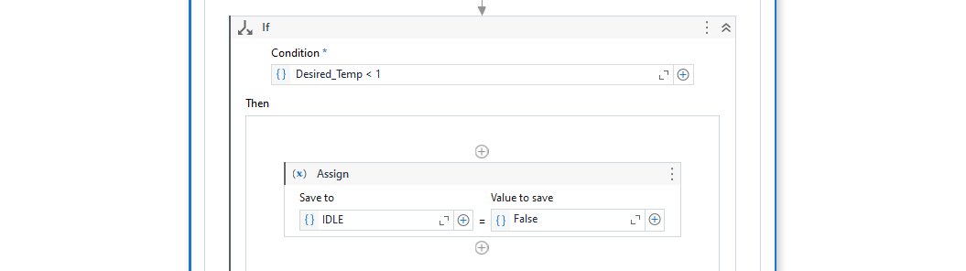

**Step 7:** In the Else Section, Use the Multiple Assign Activity to set the Out of scope Conditions for Cooling and Heating. Set Desired_Temp = If(Desired_Temp<15, 15, Desired_Temp) and Desired_Temp = If(Desired_Temp>30, 30, Desired_Temp) for cooling and heating respectively.

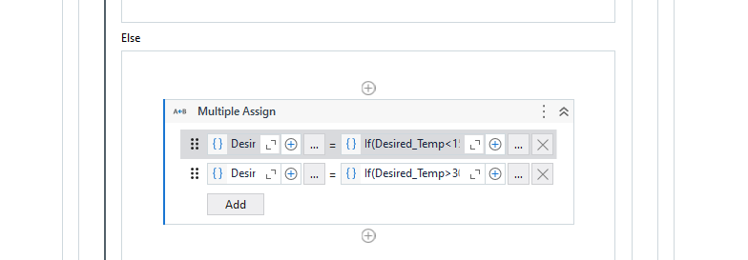

**Step 8:** In the Entry section of COOLING State. Add a WriteLine Activity notifying about the Cooling Process and use the Assign Activity to Set the Current Temperature as the Desired Temperature.

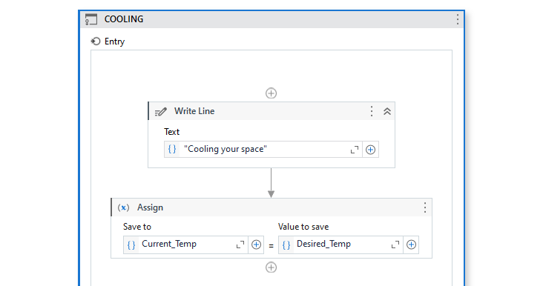

**Step 9:** In the Entry section of HEATING State. Add a WriteLine Activity notifying about the Heating Process and use the Assign Activity to Set the Current Temperature as the Desired Temperature.

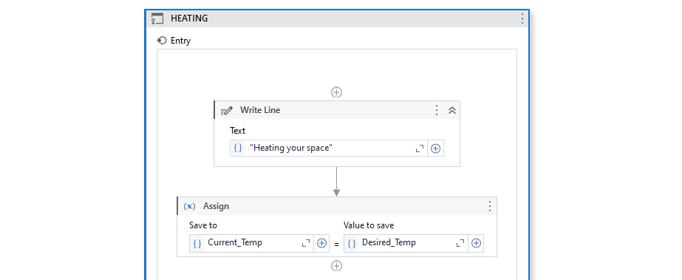

**Step 10:** In the Entry section of HEATING State. Add a WriteLine Activity notifying about the AC Shutting Down.

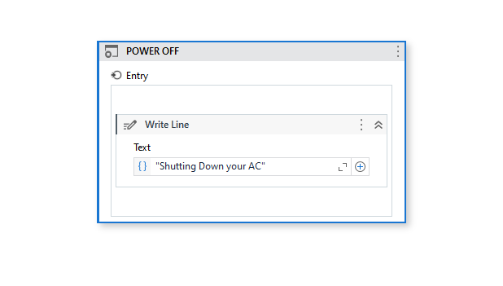

**Step 10:** For the Cooling Transition DT<CT. Set the Triggering Condition as Desired_Temp < Current_Temp.

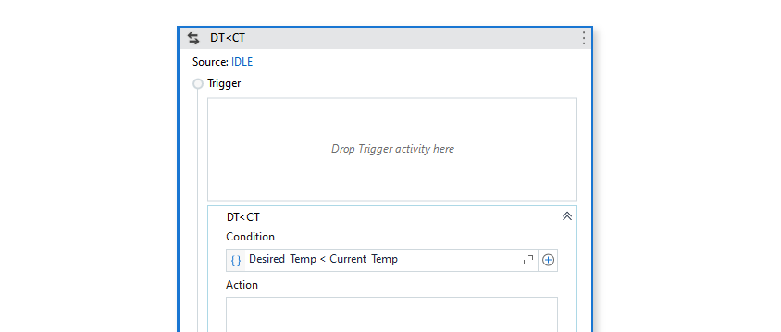

**Step 11:** For the Heating Transition DT>CT. Set the Triggering Condition as Desired_Temp > Current_Temp.

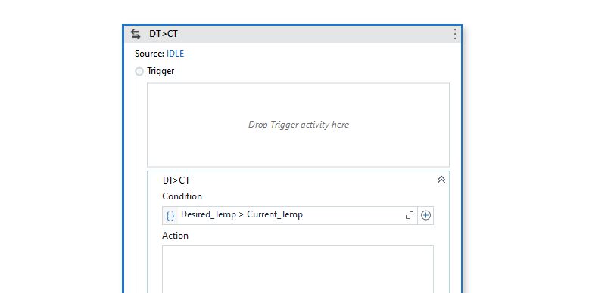

**Step 12:** For the Cooled and Heated Transition DT>CT. Set the Triggering Condition as Current_Temp.Equals(Desired_Temp).

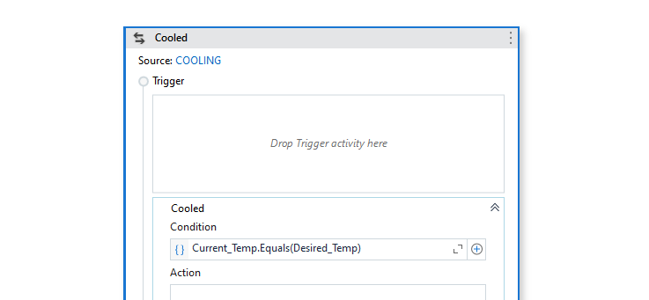

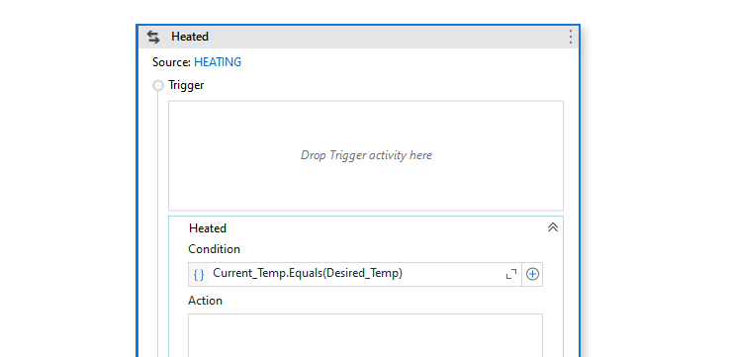

**Step 13:** For the Exit Transition. Set the Triggering Condition as IDLE.Equals(False).

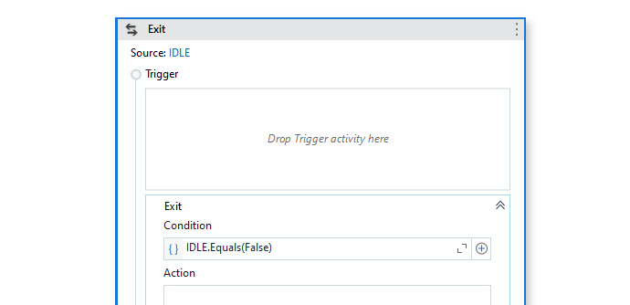

**Step 14:** For the Exit Transition. Set the Triggering Condition as IDLE.Equals(False).



**Step 14:** Click the Run button and see the result.

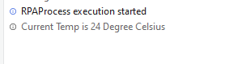

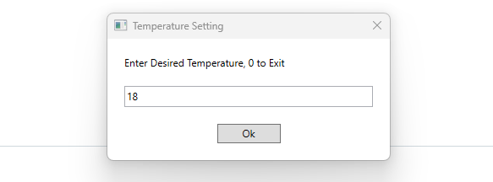

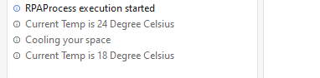

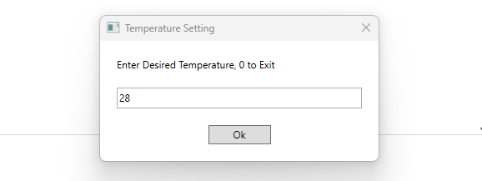

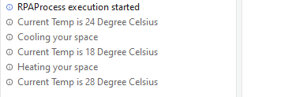

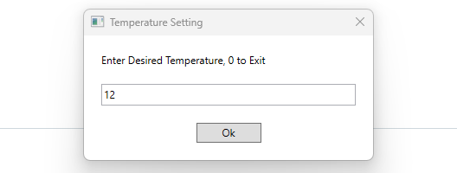

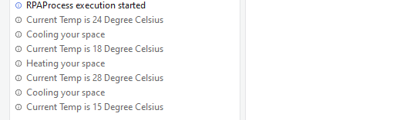

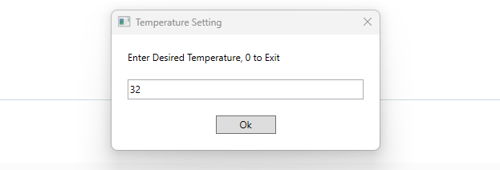

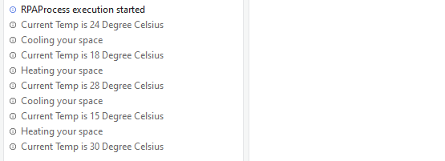

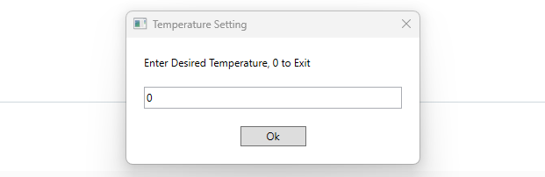

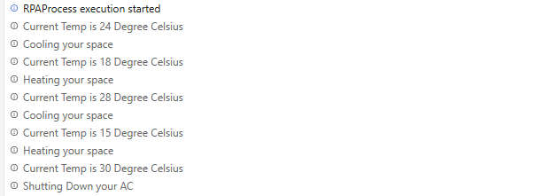

**Conclusion:** The practical to automate any process using State Machine in UiPath was performed successfully.

**[C] AIM:** Demonstrate the use of publish utility.

**Step 1:** Open UiPath Studio and click on Blank to start a fresh project. Give it a meaningful name.



**Step 2:** Search for “Sequence” in the Activities panel and then drag and drop it onto the Designer Panel



**Step 3:** Search for “Input dialog” in the Search panel of the Activities panel. Drag and drop Input dialog activity inside the Sequence. Write the appropriate message on the Label of the Input dialog. Create a variable and specify the variable in the Result property of the Input dialog box.

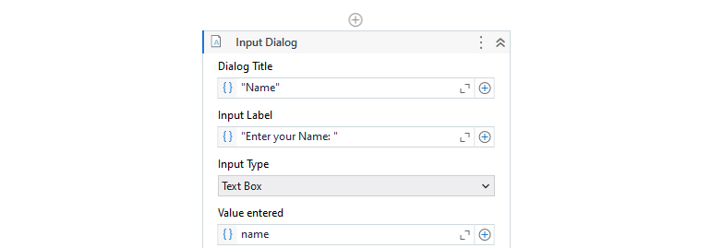

**Step 4:** Search for “Message Box” in the activities panel. Drag it inside the Sequence and enter the output message.

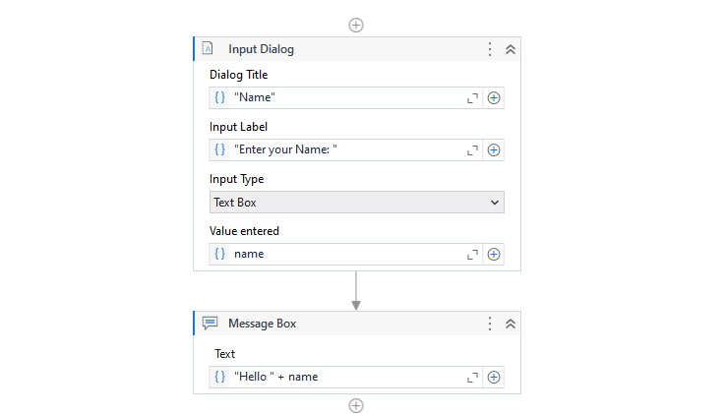

**Step 5:** To Publish this automation, Click on the Publish Button in the Design tab of the Ribbon and give a suitable name to the package.

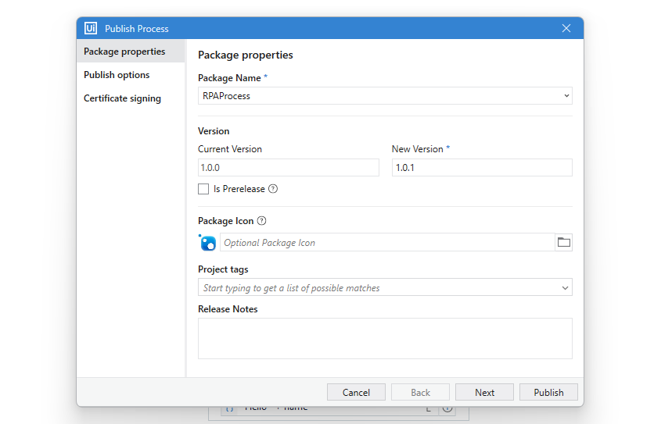

**Step 6:** Make appropriate Changes to the package as per your requirements before Clicking Publish button to publish the utility.

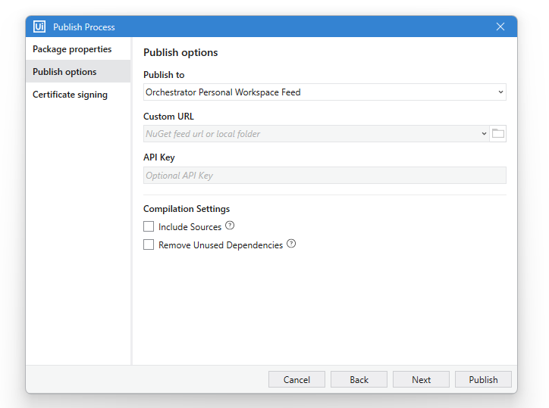

**Step 7:** The Project has been published successfully.

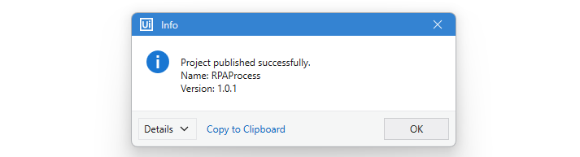

**Conclusion:** The practical to demonstrate the use of publish utility was performed successfully.

**[D] AIM:** Create and provision Robot using Orchestrator.

**Step 1:** Open UiPath Studio and click on Blank to start a fresh project. Give it a meaningful name.



**Step 2:** Search for “Sequence” in the Activities panel and then drag and drop it onto the Designer Panel



**Step 3:** Search for “Input dialog” in the Search panel of the Activities panel. Drag and drop Input dialog activity inside the Sequence. Write the appropriate message on the Label of the Input dialog. Create a variable and specify the variable in the Result property of the Input dialog box.



**Step 4:** Search for “Message Box” in the activities panel. Drag it inside the Sequence and enter the output message.



**Step 5:** To Publish this automation, Click on the Publish Button in the Design tab of the Ribbon and give a suitable name to the package.

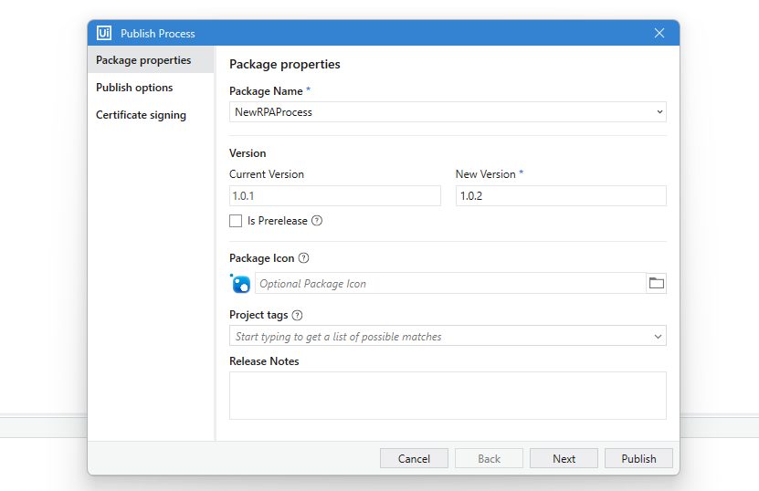

**Step 6:** Make appropriate Changes to the package as per your requirements before Clicking Publish button to publish the utility.



**Step 7:** The Project has been published successfully.



**Step 8:** Log into UiPath Orchestrator and find the process in the processes tab.

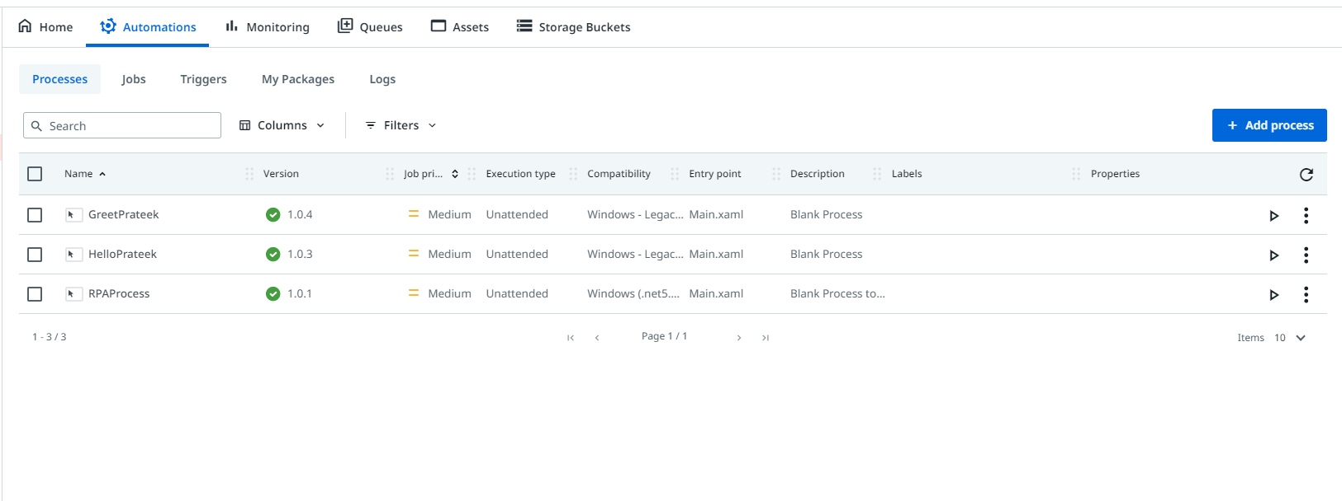

**Step 9:** You could upload packages by clicking on the “Add Packages” button and entering the appropriate details. Finally Click on “Create” to create the Process.

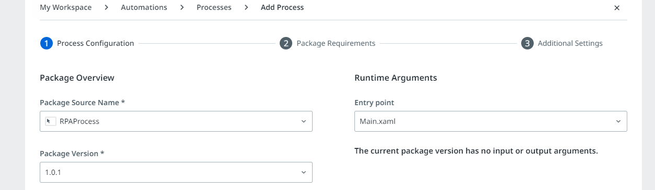

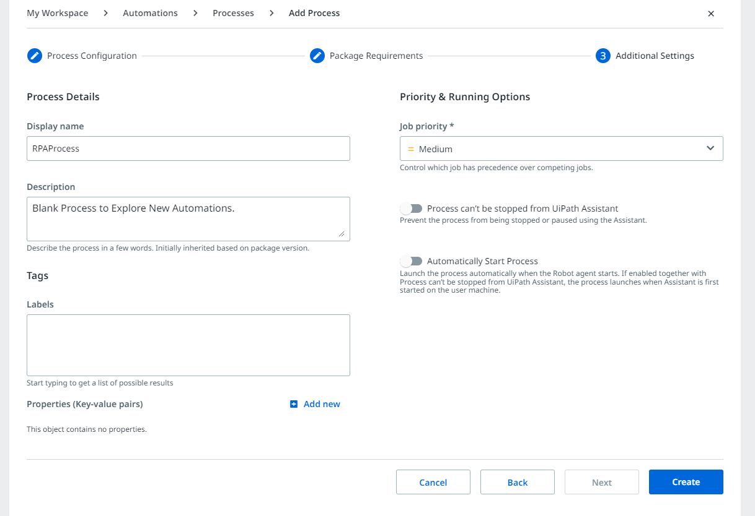

**Step 10:** Go to Tenants -> Manage Access -> Accounts and Groups -> Robot Account -> Click on the Add Robot Account to create a Robot Account if not created yet.

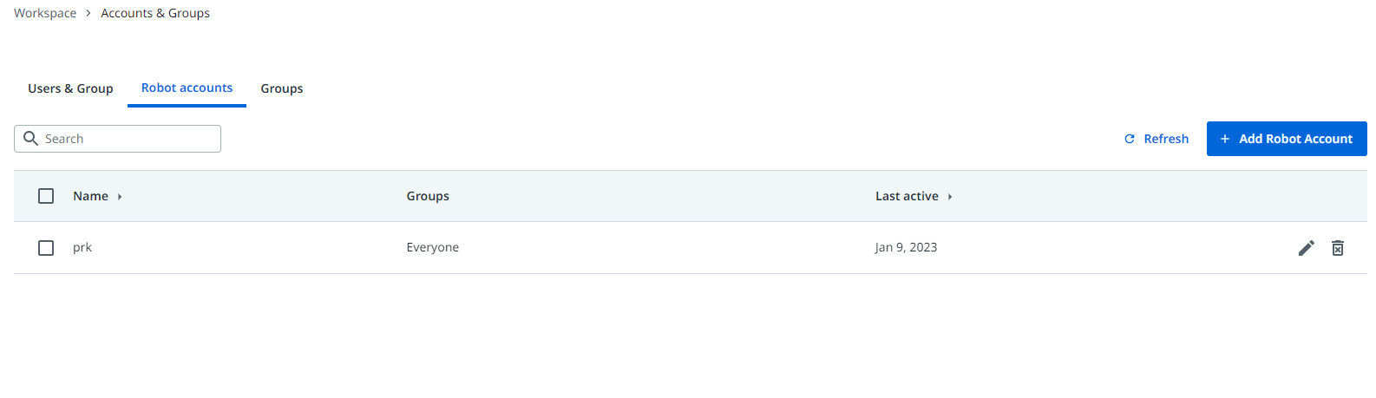

**Step 11:** Go to Tenants -> Machines -> Add Machine -> Machine Template to add a New Machine.

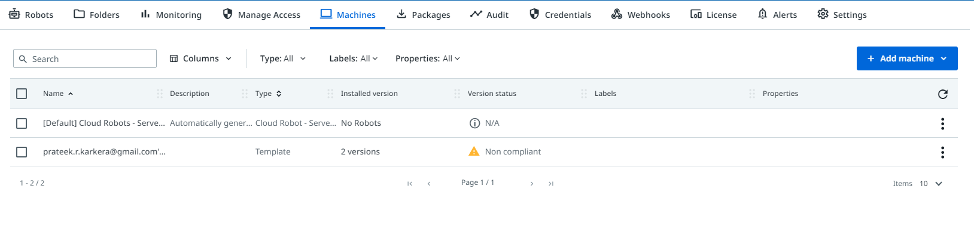

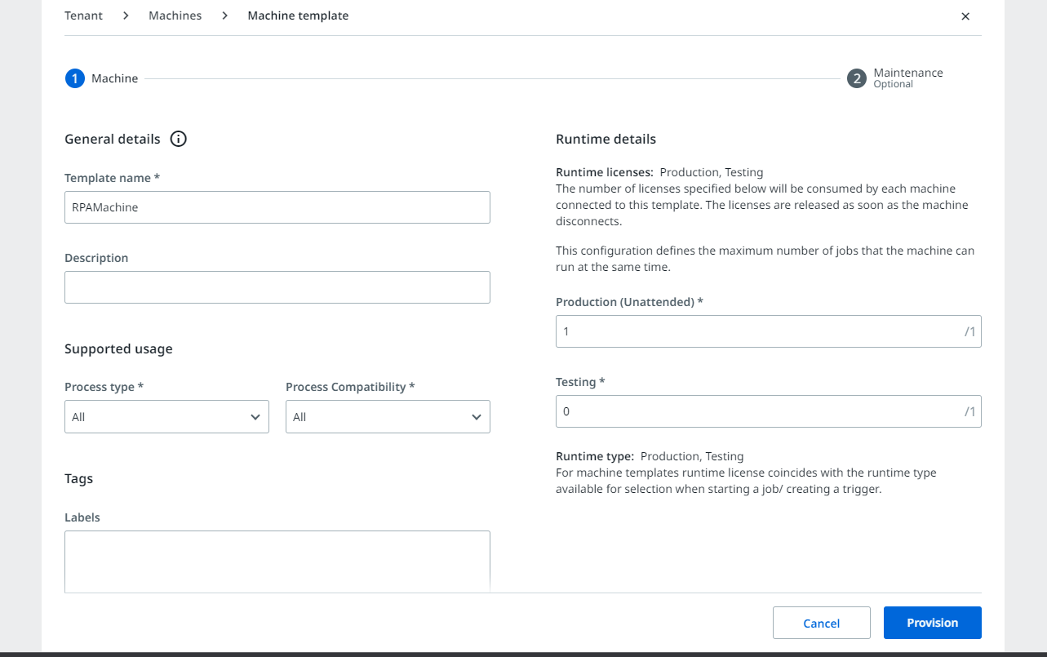

**Step 12:** Click on Provision to add the Machine and Note down the Machine Key.

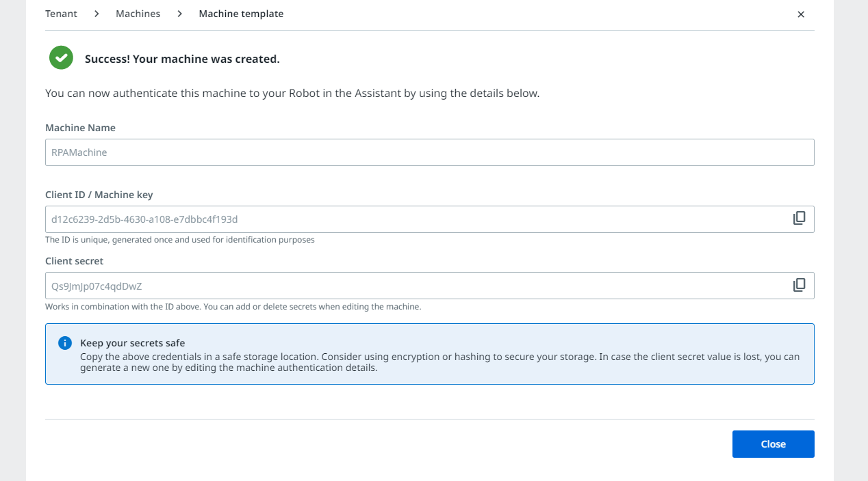

**Step 13:** Connect the Host Machine using the Licence and the Machine Key/ Client ID and Start the Process.

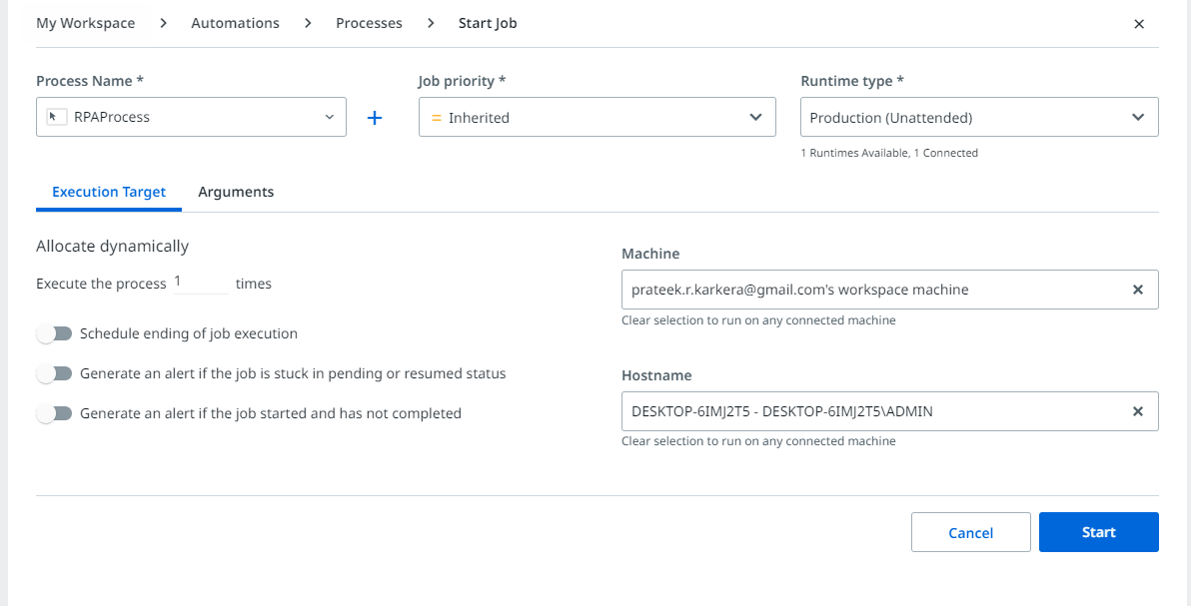

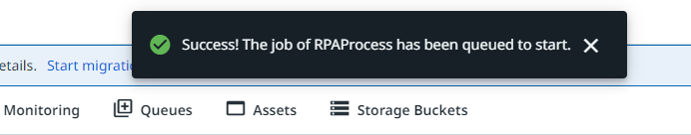

After the process runs successfully you should see the green light toward the bottom right of your UiPath Designer Panel, connected to the Orchestrator Workspace, which in my case is “[prateek.r.karkera@gmail.com’s Workspace](mailto:prateek.r.karkera@gmail.com’s%20Workspace)”.



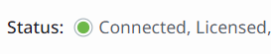

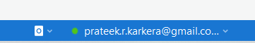

**Conclusion:** The practical to create and provision Robot using Orchestrator was performed successfully.